Additional File 1

Gel point of SBP CNFs
Table 1: Calculated gel point and aspect ratios of SBP CNFs
Sample | Ø_{g} (% w/w) | Aspect ratio
SBP CNF | 0.18 ±0.008 | 142.0 ± 6.2
SC-CNF | 0.13 ± 0.007 | 167.5 ± 9.2
PAA CNF | 0.15 ± 0.007 | 153.8 ± 6.6
HP.F CNF | 0.13 ± 0.005 | 163.1 ± 5.7

AFM Characterisation of dilute SBP CNF suspensions
Table 2: Lengths and apparent widths of visible fibrils along with standard deviation as measured directly from AFM images, n = 20
Sample | Length (nm) | Width (nm) | Height (nm)
SBPe CNF | 993 ± 260 | 11.8 ± 2.6 | 2.6 ± 0.8
SC-CNF | 753 ± 501 | 24.7 ± 16 | 1.3 ± 1.4
PAA-CNF | 1195 ± 824 | 25.4 ± 7.5 | 1.6 ± 1.6
HP.F | 752± 458 | 10.2 ± 3.8 | 2.5 ± 0.9

Statistics
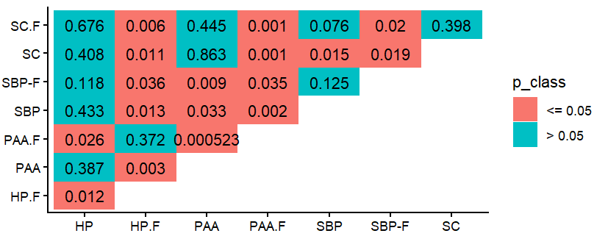
Figure 1: Student T.Testing (unequal variance, 2 tailed, n = 3) of pulp brightnesses from Table 3
(note: SBP here is “SBPe”)

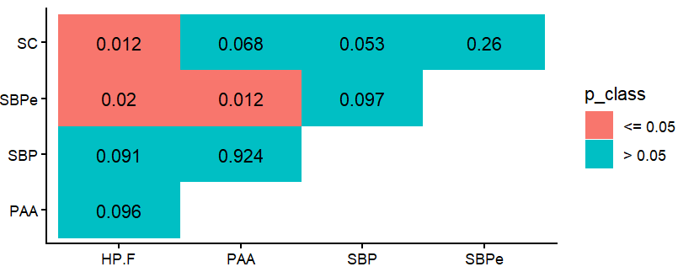
Figure 2: Student T.Testing (unequal variance, 2 tailed, n = 3) of acetyl bromide lignin assay from Table 4

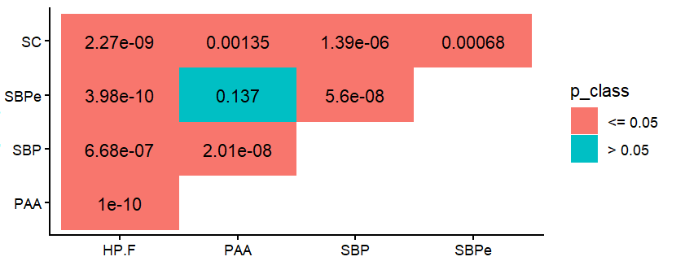
Figure 3. Student T.Testing (unequal variance, 2 tailed, n = 4) of LM12 binding assay from Figure 2
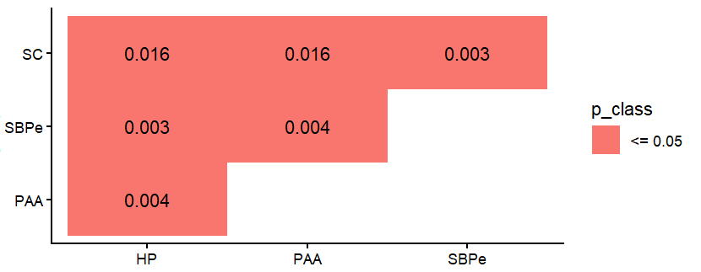
Figure 4: Student T.Testing (unequal variance, 2 tailed, n = 3) of zeta potential measurements from Table 5

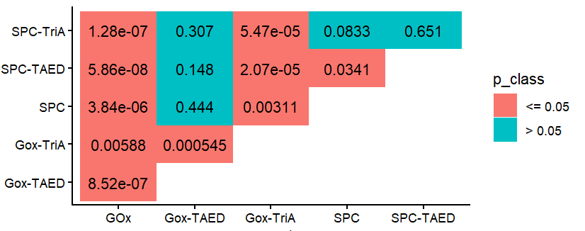
Figure 5: Student T.Testing (unequal variance, 2 tailed, n = 3) of pulp brightnesses from Table 7
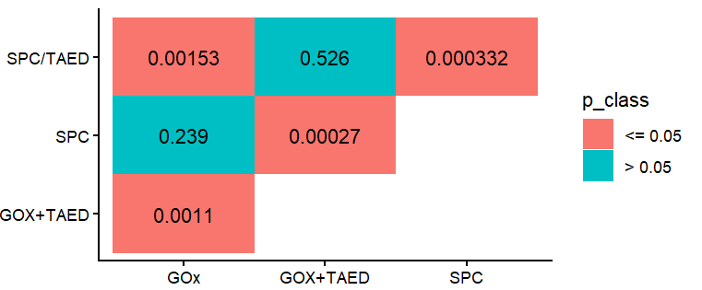
Figure 6: Student T.Testing (unequal variance, 2 tailed, n = 4) of LM12 binding assay from Figure 6 C

Broader AMSA analysis of bleached SBP CNFs
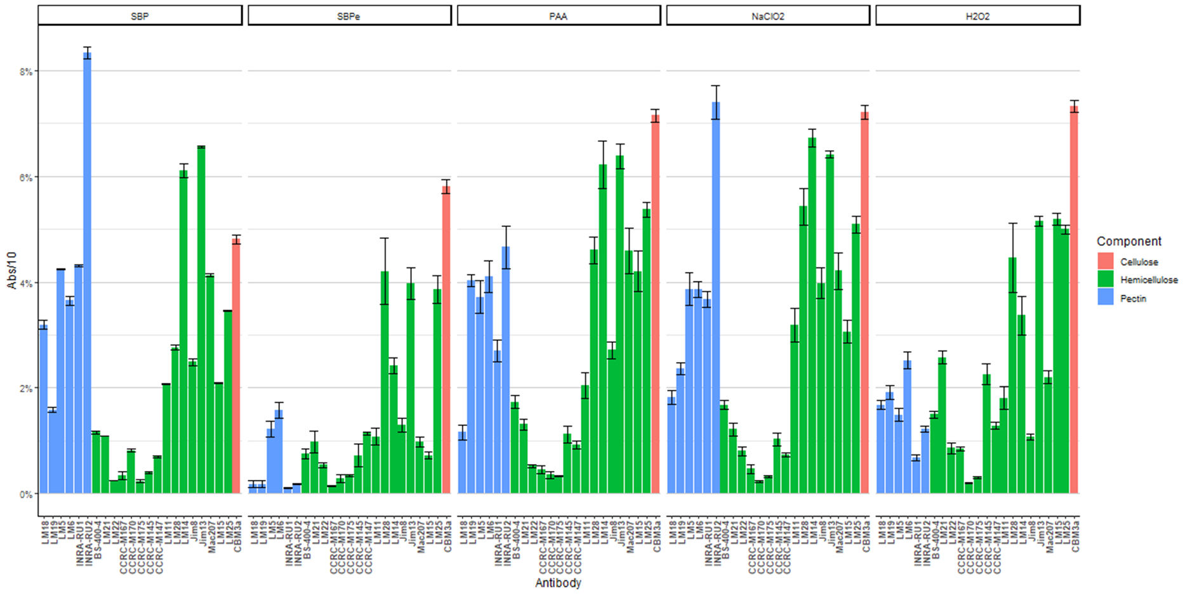
Figure 7: Surface-available polysaccharide composition of SBP CNFs as measured via AMSA. Binding is measured as a % of the max possible amount of binding. Antibodies and their epitopes are listed in Table 0.3
Table 3 : List of antibodies and their epitopes used in the AMSA analysis of SBP CNFs
ANTIBODY | EPITOPE
LM18 | Homogalacturonanon
LM19 | Homogalacturonanon
LM5 | beta-1,4-galactan
LM6 | alpha-1,5-arabinan
INRA-RU1 | RG-I
INRA-RU2 | RG-I
BS-400-4 | (1→4)-β-mannan/galacto-(1→4)-β-mannan
LM21 | Heteromannan
LM22 | glucomannan
CCRC-M167 | Xylan-3
CCRC-M170 | Xylan-4.
CCRC-M175 | (1,4)-β-D-xylosyl
CCRC-M145 | Xylan-3
CCRC-M147 | Xylan-4.
LM11 | (1,4)-β-D-xylosyl
LM28 | glucuronosyl xylan
LM14 | Arabinogalactan
Jim8 | Arabinogalactan
Jim13 | Arabinogalactan
Mac207 | Arabinogalactan w. GlcA
LM15 | XXXG - xyloglucan
LM25 | XLLG, XXLG, XXXG* - xyloglucan
CBM3a | Celllulose

