Supporting Information
Figures:

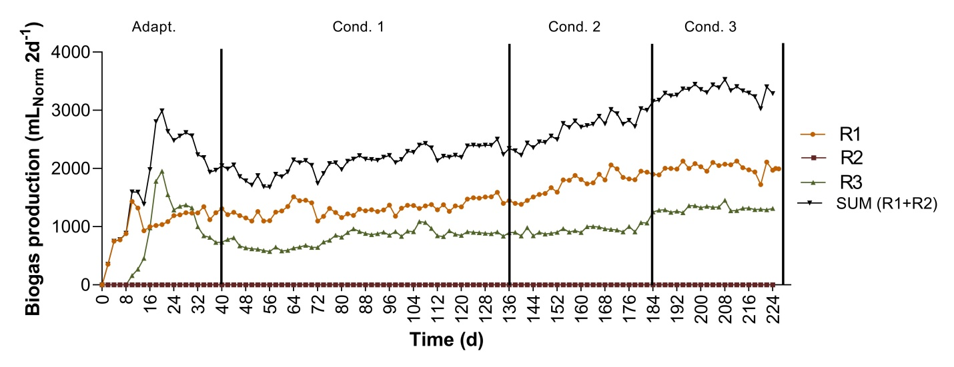
Figure S1. Biogas production in R1, R3 and sum of R1 and R3 during the 224 days of reactor operation.

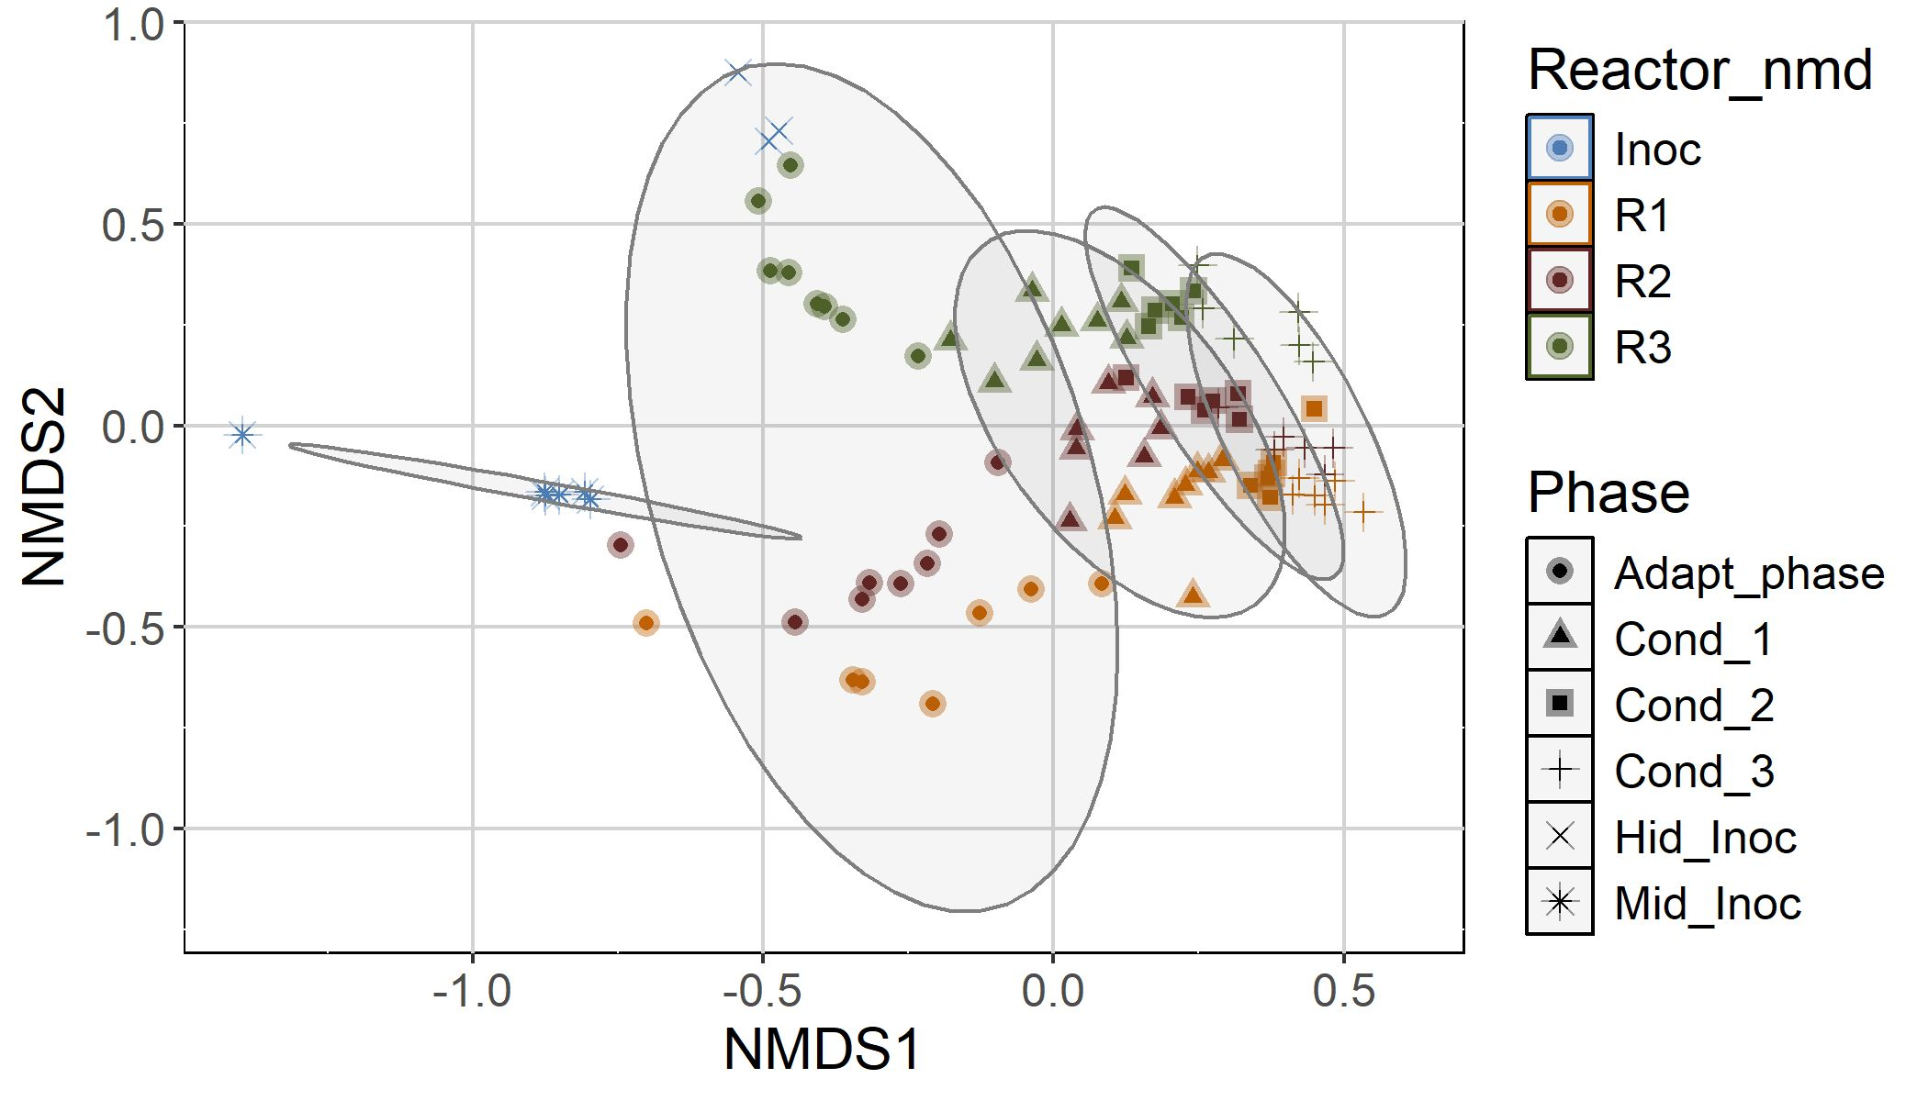

Figure S2. Beta-diversity visualized using non-metric multidimensional scaling (NMDS) plot with Bray–Curtis dissimilarity distances. NMDS plot based on community structures of bacteria described by amplicon sequencing of the 16S rRNA gene.

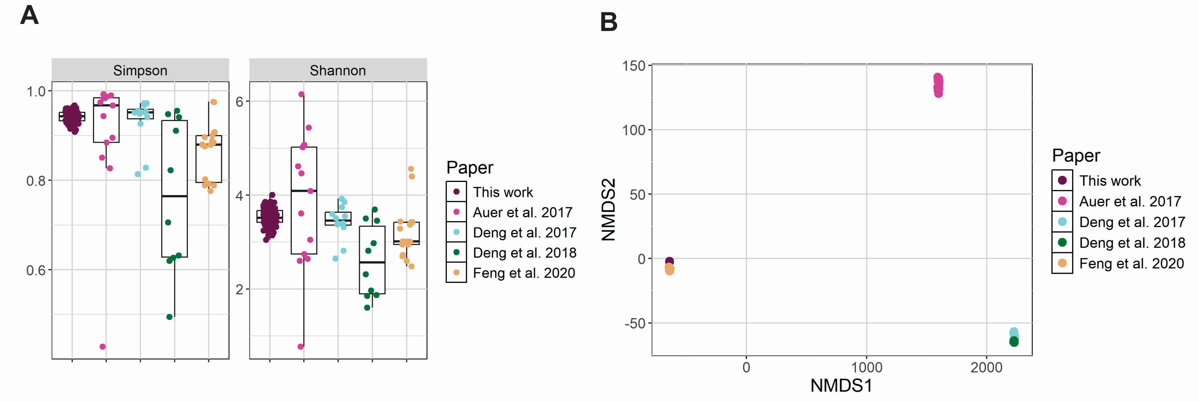
Figure S3. Bacterial community dynamics and structure comparing this work with other four anaerobic digestion systems. (A) Simpson and Shannon diversity indices; (B) The non-metric multidimensional scaling (NMDS) based on Bray–Curtis dissimilarity index showing the relationships among different anaerobic digestion systems.

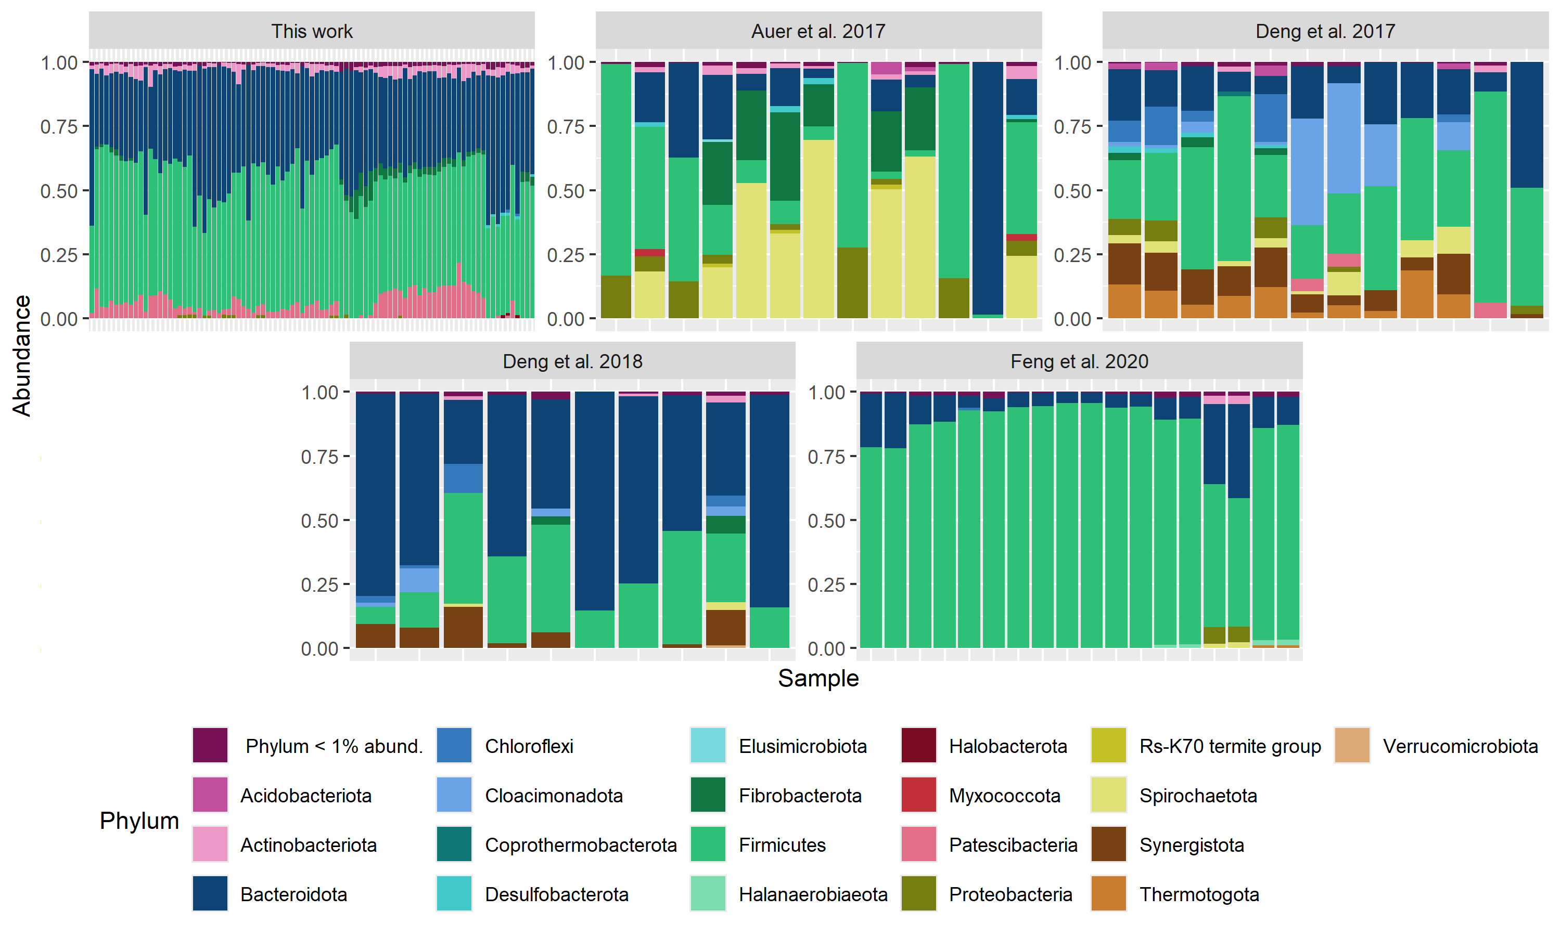

Figure S4. Relative abundance of the bacterial community at phylum level; (A) This work; (B) Auer et al. 2017 [1]; (C) Deng et al. 2017 [2]; (D) Deng et al. 2018 [3]; (E) Feng et al. 2020 [4].
Tables:
Table S1. Average of the physical-chemical parameters measured during the reactor operation for each reactor during the adaptation phase and the three different conditions applied to the system.
 | R1 |  |  |  | R2 |  |  |  | R3 |  |  |  | Total_R1+R2+R3
 | Adapt. | Cond. 1 | Cond. 2 | Cond. 3 | Adapt. | Cond. 1 | Cond. 2 | Cond. 3 | Adapt. | Cond. 1 | Cond. 2 | Cond. 3 | Adapt. | Cond. 1 | Cond. 2 | Cond. 3
Specific CH4 production (mL_{Norm} g⁻¹_{VS}) | 51 | 63 | 56 | 49 | 0 | 0 | 0 | 0 | 94 | 85 | 70 | 52 | 145 | 148 | 126 | 101
Specific biogas production (mL_{Norm} g⁻¹_{VS}) | 108 | 131 | 115 | 99 | 0 | 0 | 0 | 0 | 169 | 145 | 125 | 96 | 277 | 276 | 240 | 195
Biogas production (mL_{Norm} 2d⁻¹) | 1105 | 1332 | 1749 | 2004 | 0 | 0 | 0 | 0 | 850 | 413 | 484 | 657 | 1955 | 1745 | 2233 | 2661
CH₄ (%) | 44 | 48 | 48 | 50 | 11 | 20 | 28 | 48 | 41 | 59 | 56 | 54
O₂ (%) | 2 | 1 | 1 | 1 | 8 | 3 | 4 | 1 | 1 | 1 | 1 | 1
CO₂ (%) | 34 | 42 | 44 | 44 | 14 | 10 | 4 | 22 | 22 | 29 | 31 | 35
H₂ (%) | 0 | 0 | 0 | 0 | 0 | 0 | 0 | 0 | 0 | 0 | 0 | 0
N₂ (%) | 21 | 9 | 7 | 6 | 67 | 67 | 65 | 29 | 35 | 11 | 12 | 11
pH | 7 | 7 | 8 | 8 | 9 | 9 | 9 | 8 | 8 | 8 | 8 | 8
Ethanol (mg L⁻¹) | 5 | 4 | 5 | 1 | 12 | 5 | 6 | 1 | 3 | 1 | 0 | 0
Lactate (mg L⁻¹) | 0 | 12 | 0 | 1 | 0 | 19 | 137 | 81 | 0 | 13 | 6 | 5
Acetate (mg L⁻¹) | 325 | 338 | 141 | 194 | 1323 | 1835 | 1730 | 1193 | 189 | 69 | 82 | 98
Propionate (mg L⁻¹) | 774 | 218 | 97 | 85 | 1038 | 748 | 537 | 463 | 56 | 13 | 0 | 12
iso-Butyrate (mg L⁻¹) | 7 | 4 | 0 | 0 | 34 | 25 | 0 | 0 | 0 | 0 | 0 | 0
n-Butyrate (mg L⁻¹) | 19 | 4 | 0 | 24 | 116 | 41 | 13 | 18 | 18 | 57 | 4 | 3
iso-Valerate (mg L⁻¹) | 7 | 1 | 0 | 5 | 39 | 19 | 12 | 31 | 4 | 0 | 1 | 3
n-Valerate (mg L⁻¹) | 7 | 1 | 0 | 5 | 12 | 7 | 2 | 6 | 0 | 0 | 0 | 2
Total VFAs production (mg L⁻¹) | 1139 | 566 | 239 | 312 | 2462 | 2699 | 2437 | 1794 | 270 | 153 | 92 | 121 | 3871 | 3418 | 2768 | 2228
Volatile solids (%_{TS}) | 70 | 73 | 80 | 80 | 55 | 65 | 72 | 75 | 36 | 53 | 61 | 69
Volatile solids fed (g⁻¹_{VS} d⁻¹) | 5 | 5 | 8 | 10 | 3 | 3 | 5 | 7 | 2 | 3 | 4 | 7
Total volatile solids degradation (%) |  |  |  |  |  |  |  |  |  |  |  |  | 66 (±18.1) | 44 (±7.5) | 45 (±4.1) | 28 (±9.1)

Table S2. Experimental conditions of this study and in the studies used as comparison.

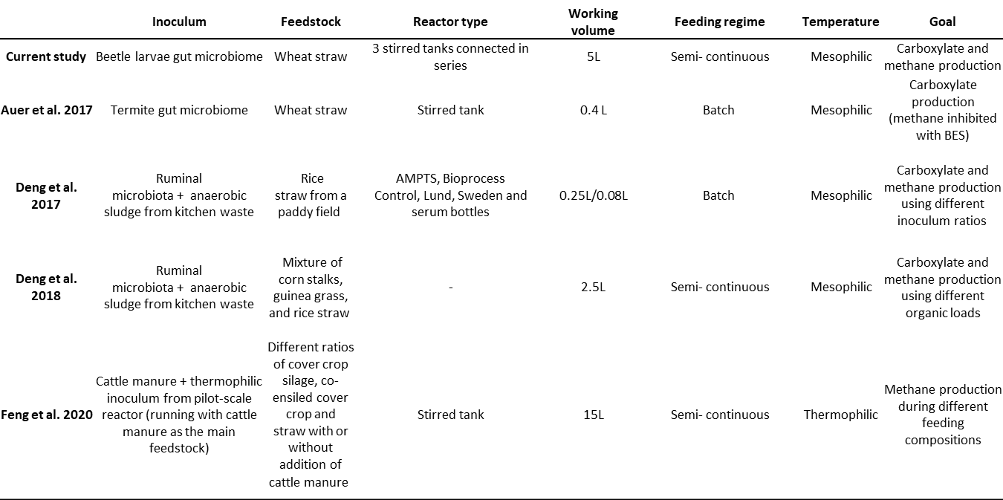

References
1. Auer, L.; Lazuka, A.; Sillam-dussès, D.; Miambi, E.; Donohue, M. O.; Hernandez-raquet, G. Uncovering the Potential of Termite Gut Microbiome for Lignocellulose Bioconversion in Anaerobic Batch Bioreactors. Front. Microbiol. 2017, 8 (December), 1–14. https://doi.org/10.3389/fmicb.2017.02623.
2. Deng, Y.; Huang, Z.; Ruan, W.; Zhao, M. Co-Inoculation of Cellulolytic Rumen Bacteria with Methanogenic Sludge to Enhance Methanogenesis of Rice Straw. Int. Biodeterior. Biodegradation 2017, 117, 224–235. https://doi.org/10.1016/j.ibiod.2017.01.017.
3. Deng, Y.; Huang, Z.; Ruan, W.; Miao, H.; Shi, W.; Zhao, M. Enriching Ruminal Polysaccharide-Degrading Consortia via Co-Inoculation with Methanogenic Sludge and Microbial Mechanisms of Acidification across Lignocellulose Loading Gradients. Appl. Microbiol. Biotechnol. 2018, 102 (8), 3819–3830. https://doi.org/10.1007/s00253-018-8877-9.
4. Feng, L.; Perschke, Y. M. L.; Fontaine, D.; Nikolausz, M.; Ward, A. J.; da Rocha, U. N.; Corrêa, F. B.; Eriksen, J.; Sørensen, P.; Møller, H. B. Anaerobic Digestion of Co-Ensiled Cover Crop and Barley Straw: Effect of Co-Ensiling Ratios, Manure Addition and Impact on Microbial Community Structure. Ind. Crops Prod. 2020, 144. https://doi.org/10.1016/j.indcrop.2019.112025.

