Fig. S1 RNA-seq sequencing and quality-control metrics. Data volume, clean-read retention, Q20 and Q30 scores, GC content, and sequencing error rate were shown for eight RNA-seq libraries, comprising four biological replicates per treatment.

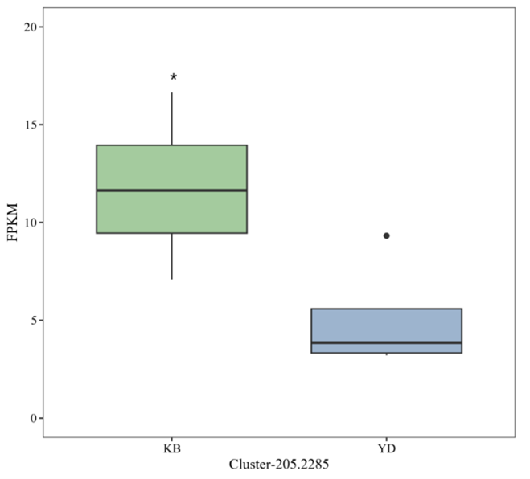
Fig. S2 Expression of Cluster-205.2285 in the CK and pCA-treated groups. Box plots showed FPKM values from four biological replicates per group. Center lines indicated medians, boxes indicated interquartile ranges, and whiskers extended to 1.5 times the interquartile range. Differential expression was assessed from raw read counts using DESeq2; *adjusted P < 0.05.

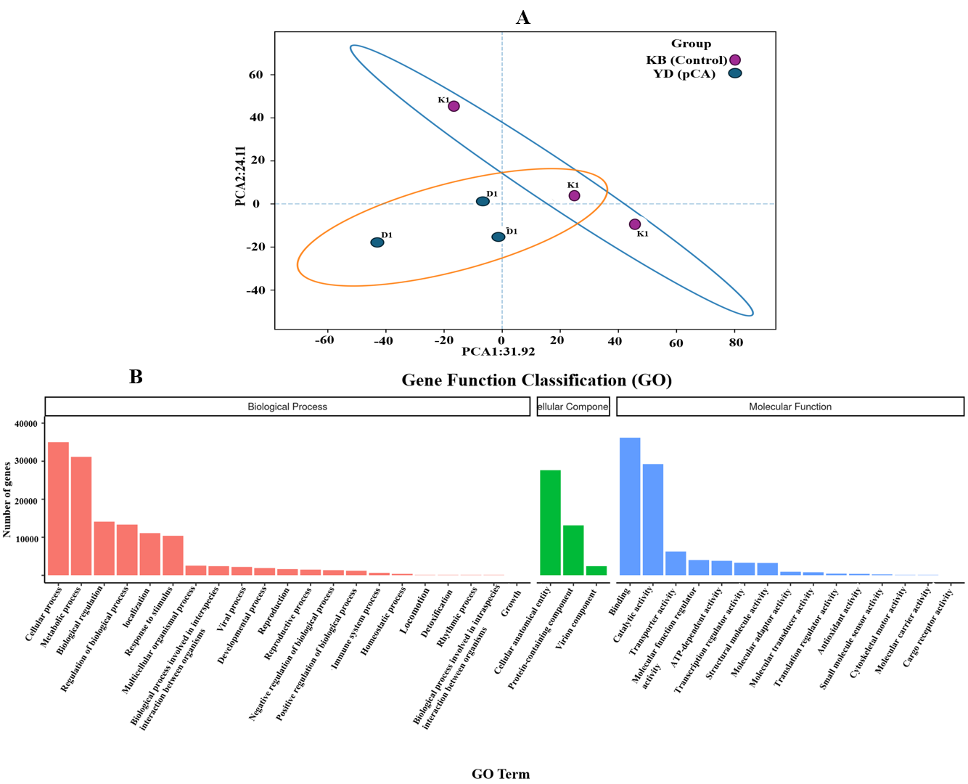
Fig. S3 Global transcriptomic overview and GO functional classification of F. trogii. (A) Principal component analysis of the RNA-seq expression profiles. Each point represented an independent RNA-seq library, with four biological replicates per treatment. Ellipses indicated within-group sample dispersion. (B) GO functional classification of the annotated unigenes into biological process, cellular component, and molecular function categories. Bar heights indicated the numbers of unigenes assigned to the corresponding GO terms.

