Epidemiological surveys of, and research on, the soil-transmitted helminths in Southeast Asia: a systematic review

Additional File 1
PRISMA Checklist
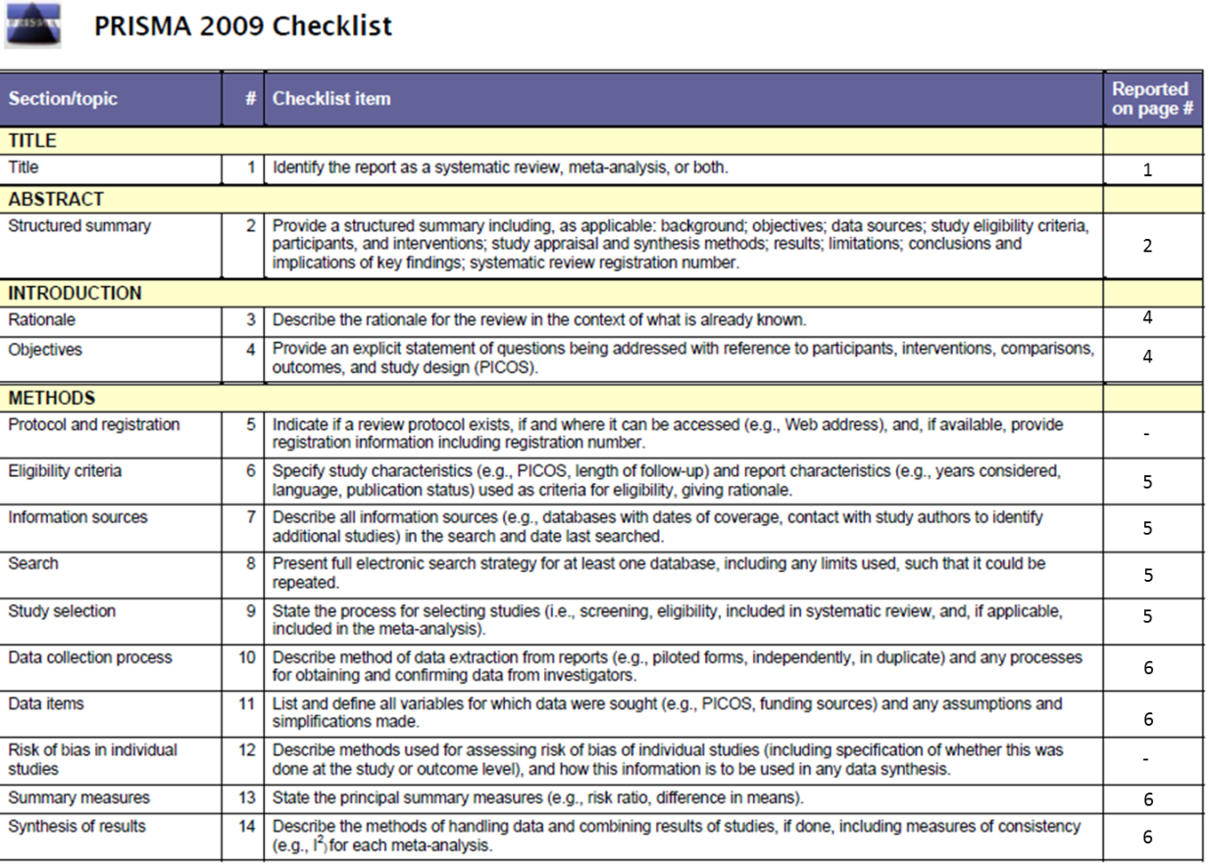
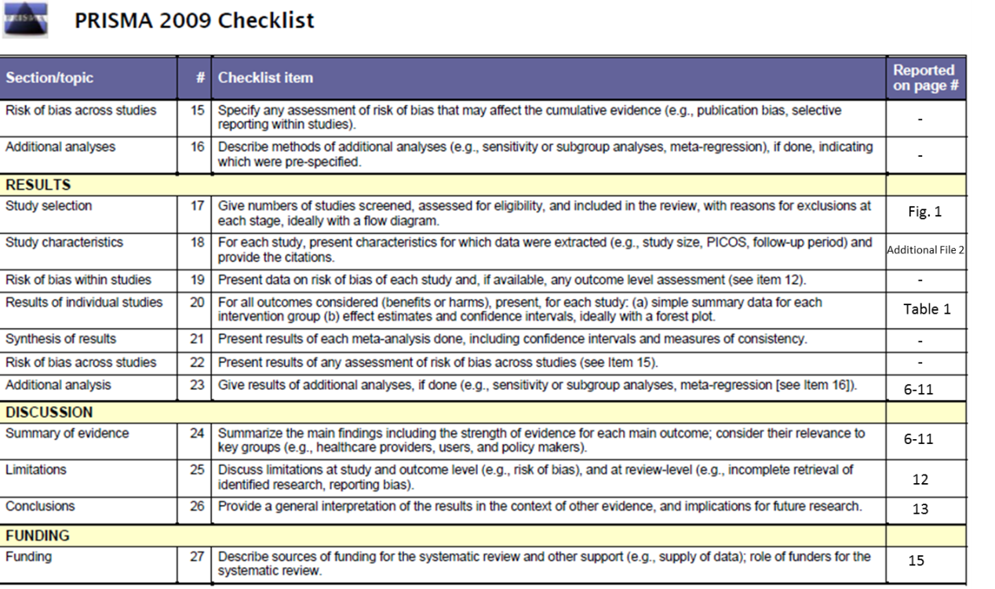
Full list of search terms:
sth
soil-transmitted helminth
ascaris
trichuris
hookworm
helmint*
parasit*
necator
ancylostoma
deworm*
(country name)
NOT plasmodium

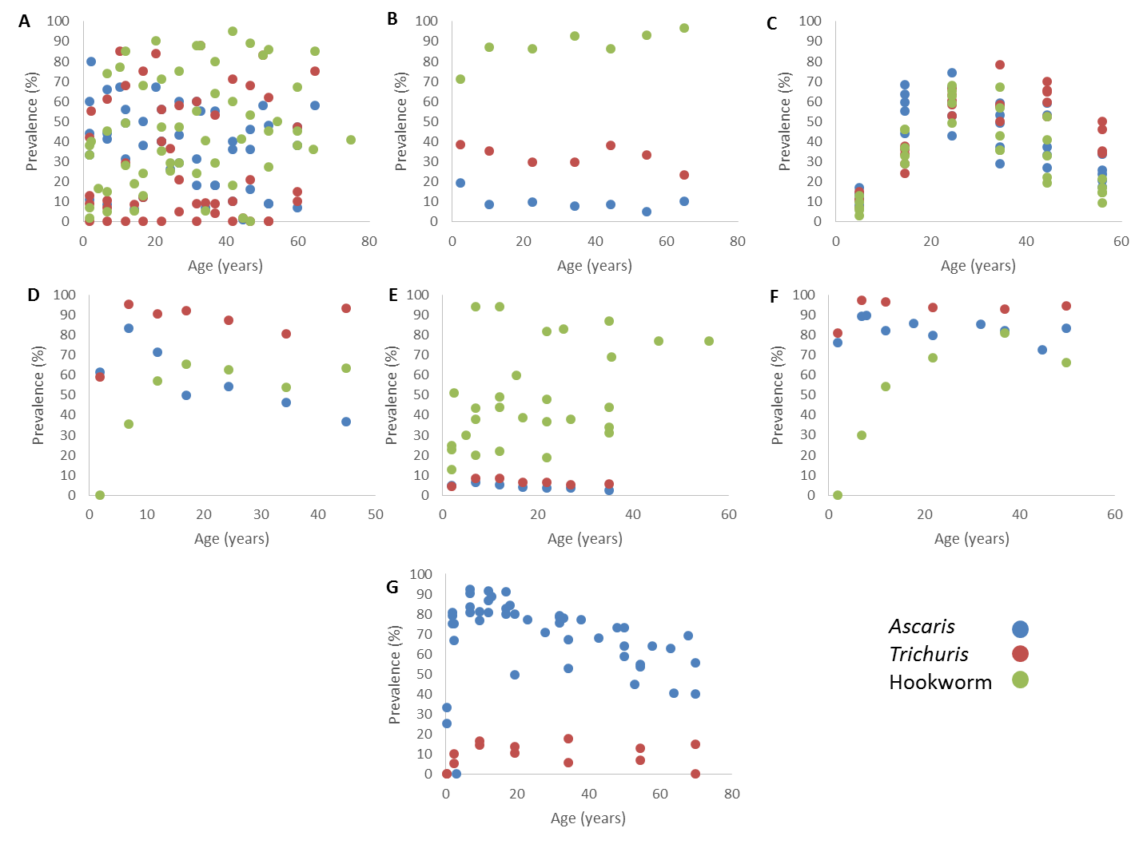
Supporting Figure 1: Age distribution of prevalence for studies that measured intensity and prevalence across all age groups. Data points were plotted against the mid-point of the reported age group. A=Indonesia, B=Lao PDR, C=Malaysia, D=Philippines, E=Thailand, F=Vietnam, G=Myanmar. Blue=Ascaris lumbricoides, Red=Trichuris trichiura, Green=Hookworm.

