Additional Figures

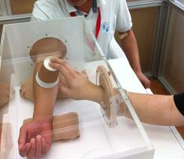

Additional file 1: Figure S1. Patient’s arm inside a glove-box during feeding experiments.

