Comparative alignment of a specific target region in the β-tubulin isotype 1 gene.

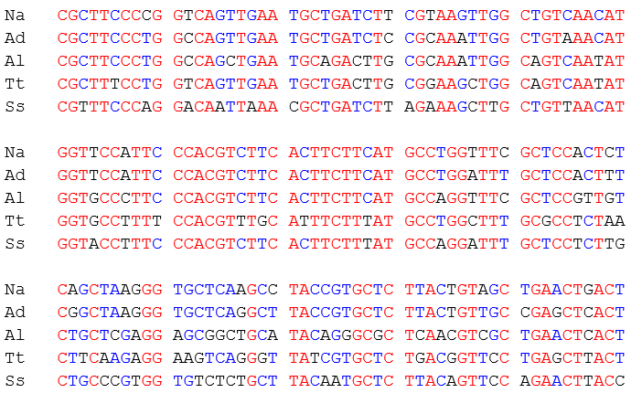

Additional file 1: Fig. S1. Species-specific SmartAmp2 primer sets were designed based on the sequence divergence between N. americanus (Na), A. duodenale (Ad), A. lumbricoides (Al), T. trichiura (Tt) and S. stercoralis (Ss).

