Additional file 1: Table S1 Detail virus titers of tested F1 mosquitoes
Samples tested | Virus titers (mean±SD)
Samples tested | dpi | 10°C |  | 16°C |  | 22°C |  | 28°C |  | 34°C
Thorax-abdomen of F1 field-collected Aedes aegypti | 0 | 10^{2.84±0.41} |  | 10^{2.86±0.40} |  | 10^{2.70±0.56} |  | 10^{2.84±0.33} |  | 10^{2.72±0.44}
Thorax-abdomen of F1 field-collected Aedes aegypti | 5 | 10^{2.36±0.26} |  | 10^{2.73±0.21} |  | 10^{2.80±0.53} |  | 10^{3.25±0.53} |  | 10^{3.38±0.58}
Thorax-abdomen of F1 field-collected Aedes aegypti | 10 | 10^{2.41±0.33} |  | 10^{2.81±0.41} |  | 10^{3.21±0.70} |  | 10^{3.67±0.73} |  | 10^{3.66±0.54}
Thorax-abdomen of F1 field-collected Aedes aegypti | 15 | - |  | 10^{2.93±0.43} |  | 10^{3.49±0.47} |  | 10^{4.05±0.86} |  | 10^{4.09±0.71}
Thorax-abdomen of F1 field-collected Aedes aegypti | 20 | - |  | - |  | 10^{3.01±0.15} |  | 10^{3.81±0.66} |  | 10^{3.96±0.40}
Thorax-abdomen of F1 field-collected Aedes aegypti | 25 | - |  | - |  | 10^{3.25} |  | 10^{3.70±0.63} |  | 10^{3.75±0.58}
Thorax-abdomen of F1 field-collected Aedes aegypti | 30 | - |  | - |  | - |  | 10^{3.66±0.63} |  | 10^{3.83±0.35}
Salivary glands of F1 field-collected Aedes aegypti | 0 | - |  | - |  | - |  | - |  | -
Salivary glands of F1 field-collected Aedes aegypti | 5 | - |  | - |  | - |  | - |  | -
Salivary glands of F1 field-collected Aedes aegypti | 10 | - |  | 10^{1.54} |  | 10^{2.09±0.08} |  | 10^{2.67±0.33} |  | 10^{2.96±0.52}
Salivary glands of F1 field-collected Aedes aegypti | 15 | - |  | 10^{1.82} |  | 10^{2.69±0.43} |  | 10^{3.38±0.49} |  | 10^{3.64±0.37}
Salivary glands of F1 field-collected Aedes aegypti | 20 | - |  | - |  | 10^{2.54±0.31} |  | 10^{3.81±0.82} |  | 10^{3.76±0.41}
Salivary glands of F1 field-collected Aedes aegypti | 25 | - |  | - |  | 10^{2.38} |  | 10^{3.68±0.77} |  | 10^{3.65±0.44}
Salivary glands of F1 field-collected Aedes aegypti | 30 | - |  | - |  | - |  | 10^{3.89±0.58} |  | 10^{3.80±0.26}
Head of F1 field-collected Aedes aegypti | 0 | - |  | - |  | - |  | - |  | -
Head of F1 field-collected Aedes aegypti | 5 | - |  | - |  | - |  | - |  | -
Head of F1 field-collected Aedes aegypti | 10 | - |  | - |  |  |  | 10^{2.17±0.13} |  | 10^{2.46±0.11}
Head of F1 field-collected Aedes aegypti | 15 | - |  | 10^{1.95} |  |  |  | 10^{2.47±0.44} |  | 10^{2.54±0.35}
Head of F1 field-collected Aedes aegypti | 20 | - |  | - |  |  |  | 10^{2.44±0.31} |  | 10^{2.56±0.31}
Head of F1 field-collected Aedes aegypti | 25 | - |  | - |  |  |  | 10^{2.44±0.45} |  | 10^{2.56±0.37}
Head of F1 field-collected Aedes aegypti | 30 | - |  | - |  |  |  | 10^{2.35±0.43} |  | 10^{2.39±0.03}
Thorax-abdomen of F1 field-collected Aedes albopictus | 0 |  | 10^{3.19±0.42} |  | 10^{3.33±0.64} |  | 10^{2.98±0.30} |  | 10^{3.04±0.51} |  | 10^{3.24±0.42}
Thorax-abdomen of F1 field-collected Aedes albopictus | 5 |  | 10^{1.73±0.41} |  | 10^{0.52±0.48} |  | 10^{1.02±0.10} |  | 10^{1.15±0.87} |  | 10^{0.90±0.63}
Thorax-abdomen of F1 field-collected Aedes albopictus | 10 |  | 10^{0.82±0.62} |  | 10^{0.57±0.16} |  | 10^{1.01±1.02} |  | 10^{2.39±1.31} |  | 10^{0.70±0.45}
Thorax-abdomen of F1 field-collected Aedes albopictus | 15 |  | 10^{1.05±0.52} |  | - |  | 10^{0.23} |  | 10^{1.08±0.58} |  | 10^{0.99±0.67}
Thorax-abdomen of F1 field-collected Aedes albopictus | 20 |  | 10^{1.66±0.13} |  | - |  | 10^{0.81±0.59} |  | 10^{0.70} |  | -
Thorax-abdomen of F1 field-collected Aedes albopictus | 25 |  | 10^{1.07} |  | - |  | - |  | 10^{1.08} |  | -
Thorax-abdomen of F1 field-collected Aedes albopictus | 30 |  | - |  | - |  | - |  | - |  | -
Salivary glands of F1 field-collected Aedes albopictus | 0 |  | - |  | - |  | - |  | - |  | -
Salivary glands of F1 field-collected Aedes albopictus | 5 |  | - |  | - |  | - |  | 10^{1.51±0.31} |  | 10^{0.89±0.76}
Salivary glands of F1 field-collected Aedes albopictus | 10 |  | - |  | - |  | 10^{0.85±0.81} |  | 10^{1.20±0.58} |  | 10^{1.01±0.19}
Salivary glands of F1 field-collected Aedes albopictus | 15 |  | - |  | - |  | 10^{0.88} |  | 10^{0.91} |  | -
Salivary glands of F1 field-collected Aedes albopictus | 20 |  | - |  | - |  | 10^{0.49±0.47} |  | 10^{0.14} |  | -
Salivary glands of F1 field-collected Aedes albopictus | 25 |  | - |  | - |  | - |  | 10^{0.18±0.19} |  | -
Salivary glands of F1 field-collected Aedes albopictus | 30 |  | - |  | - |  | - |  | 10^{0.12±0.05} |  | -
Head of F1 field-collected Aedes albopictus | 0 |  | - |  | - |  | - |  | - |  | -
Head of F1 field-collected Aedes albopictus | 5 |  | - |  | - |  | 10^{0.38±0.21} |  | 10^{0.42±0.28} |  | 10^{0.37±0.34}
Head of F1 field-collected Aedes albopictus | 10 |  | - |  | - |  | 10^{0.80±1.10} |  | 10^{1.69±1.32} |  | 10^{0.60±0.16}
Head of F1 field-collected Aedes albopictus | 15 |  | - |  | - |  | - |  | 10^{0.22} |  | -
Head of F1 field-collected Aedes albopictus | 20 |  | - |  | - |  | - |  | - |  | -
Head of F1 field-collected Aedes albopictus | 25 |  | - |  | - |  | - |  | - |  | -
Head of F1 field-collected Aedes albopictus | 30 |  | - |  | - |  | - |  | 10^{0.80±0.98} |  | -

Additional file 1: Table S2 Detail virus titers of tested Wolbachia free F4 mosquitoes
Samples tested
Samples tested | 0 dpi | 5 dpi | 10 dpi | 15 dpi |  | 20 dpi |  | 25 dpi |  | 30 dpi
Thorax-abdomen | 10^{2.98±0.34} | 0 | 10^{2.29±0.37} | 10^{4.26±0.58} |  | 10^{3.92±0.43} |  | 10^{3.70±0.32} |  | 10^{3.59±0.77}
Salivary glands | 0 | 0 | 10^{1.02±0.12} | 10^{2.51±0.99} |  | 10^{2.94±0.50} |  | 10^{2.95±0.23} |  | 10^{3.11±0.45}
Head | 0 | 0 | 10^{1.52±0.26} | 10^{2.05±0.63} |  | 10^{2.46±0.26} |  | 10^{2.41±0.68} |  | 10^{2.22±0.26}

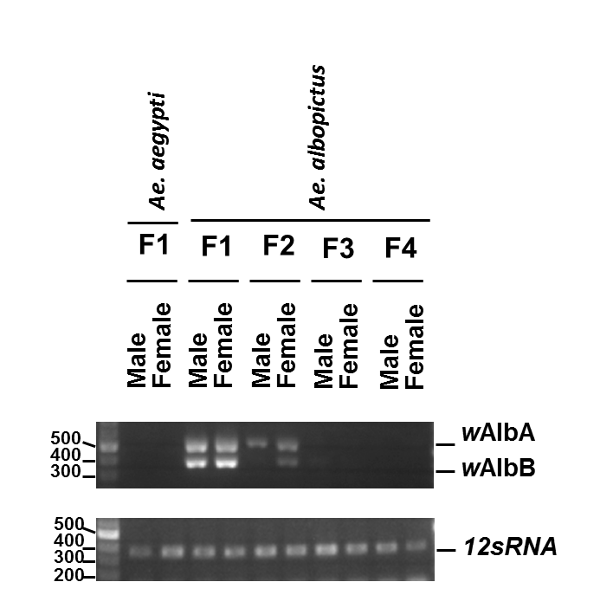
Additional file 1: Figure S1 Generations of the Wolbachia-free Ae. albopictus mosquitoes. PCR was conducted to confirm the Wolbachia infection (wAblA and wAblB) with field captured mosquitoes. Ae. albopictus were treated with 1mg tetracycline for 3 generations. 12sRNA was used as internal control. Representative Agarose gel was shown.

