Additional file 4: Figure S2. Maps of Bihar showing burden of identified VL cases in the 8 study districts for January 2012 - June 2013 at (a) district level and (b) block level.

a
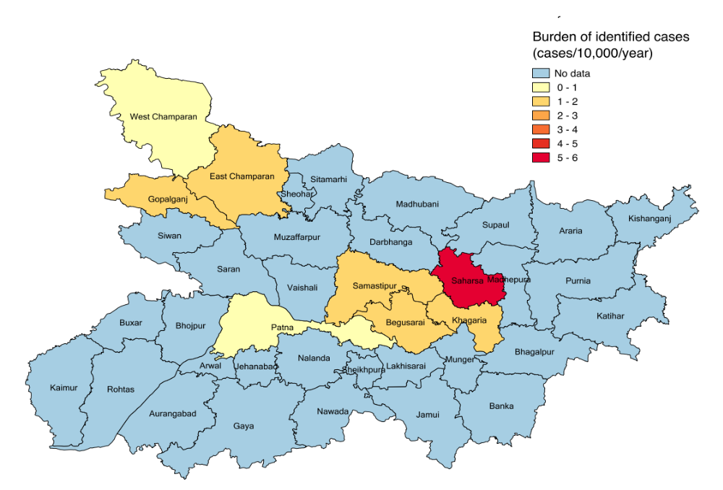
b
