Additional file 4: Figure S1. Motility standardized residual histogram of the motility
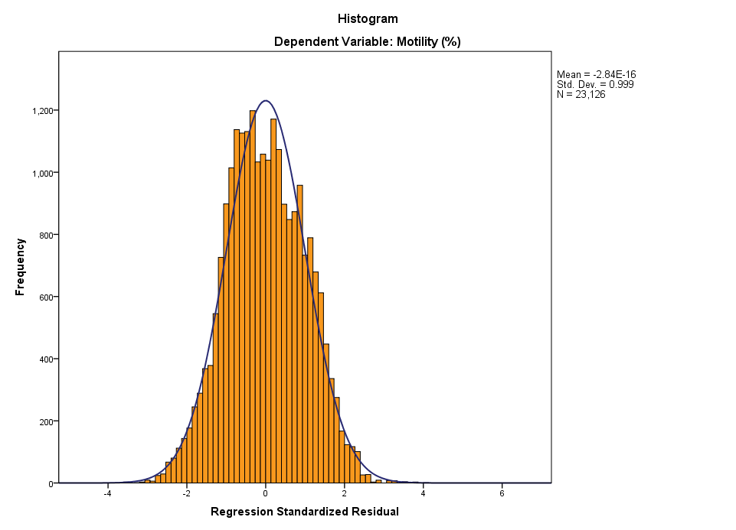

The histogram of the residuals (errors) in the model was used to check if they are normally distributed. Although not perfect, the frequency distribution of the residuals has a shape close to that of the normal Gauss curve, indicating evidence of normal distribution. P-P plot was used for further check.

