Additional file 5: Figure S2. Gaussian regression P-P plot of predicted motility
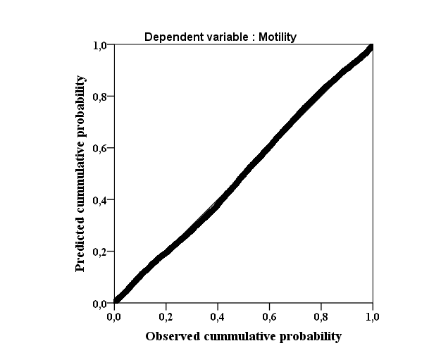

Additionally, the normal distribution was check using a P-P plot. Here, the expected and observed cumulative probabilities were closed suggesting that the assumption of normal distribution of the residual was far to be not violated.

