Additional file 6: Figure S3. Scatterplot of standardized residuals against standardized predicted values

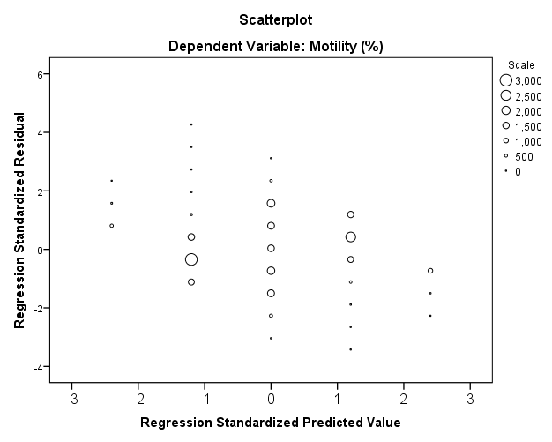
In this scatterplot of standardized residuals against standardized predicted values, the points are randomly spread out indicating that the assumption of homoscedasticity is likely to be safe

