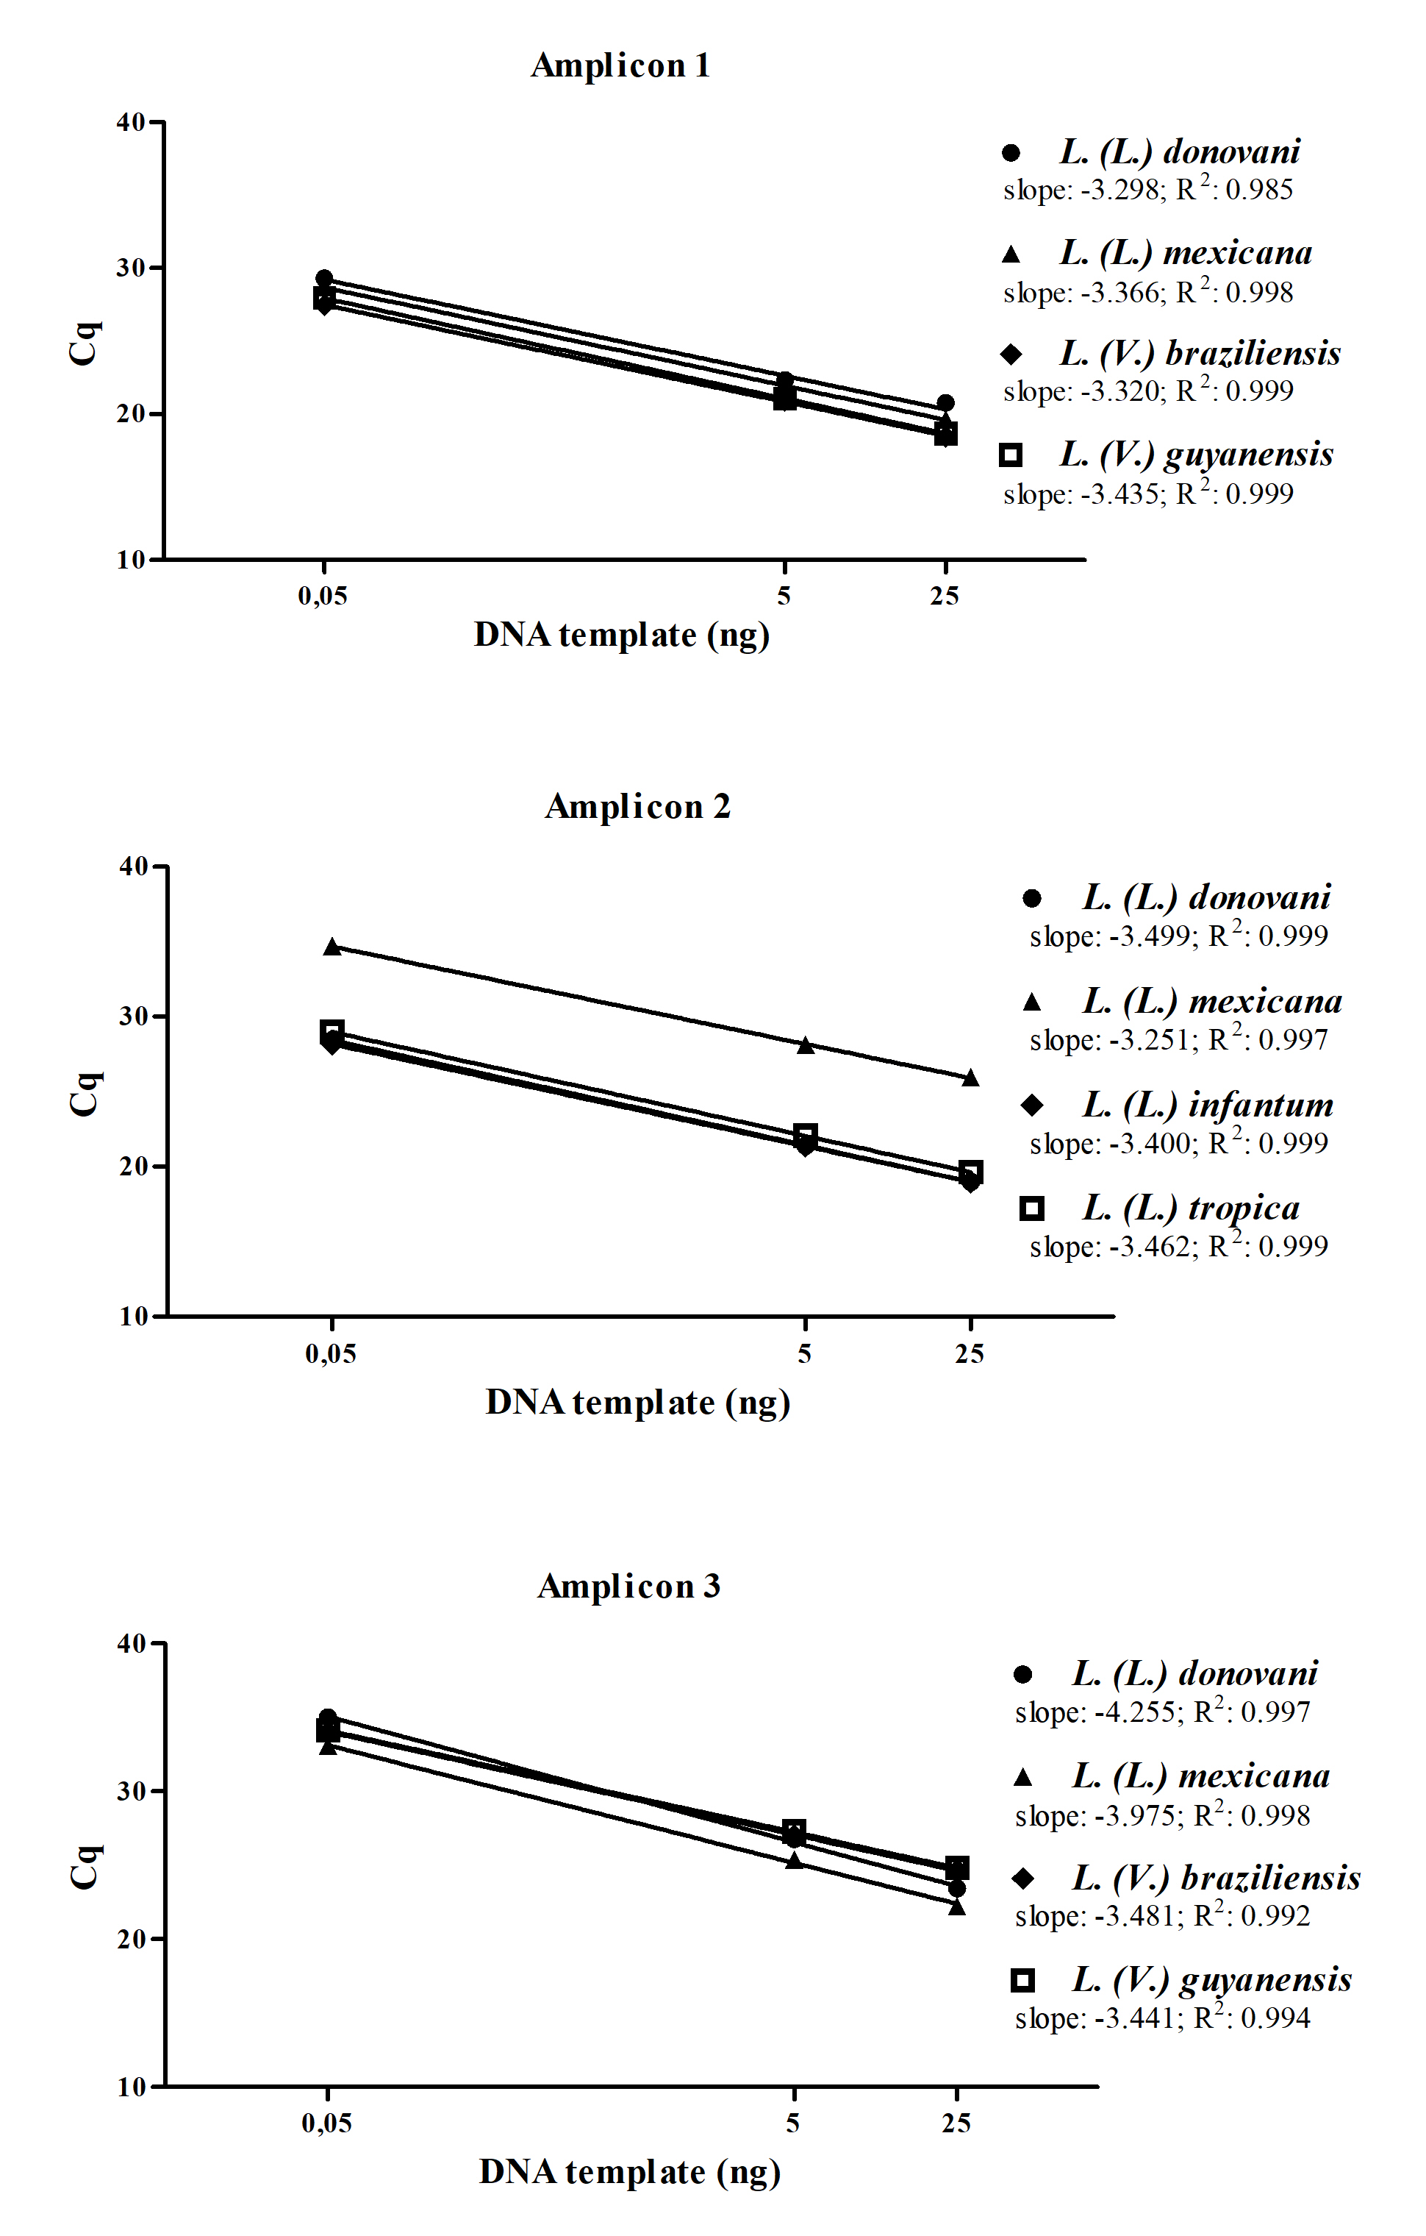

Additional file 4: Figure S3: Efficiency curves for all amplicons.
Efficiency curves, slopes and R² were calculated from four species for each amplicon using 25 ng, 5 ng and 5 pg of DNA from each Leishmania species. For amplicon 1 and 3 two species of L. (Leishmania) and two of L. (Viannia) subgenus were selected. Amplicon 2 only amplified L. (Leishmania), and strains from this subgenus were therefore selected.

