Additional file 7. Homogeneity and phylogenetic analyses

Figure S4 Maximum likelihood phylogram constructed using PCGRT dataset with partition model (see Table S1 for partitioning scheme).
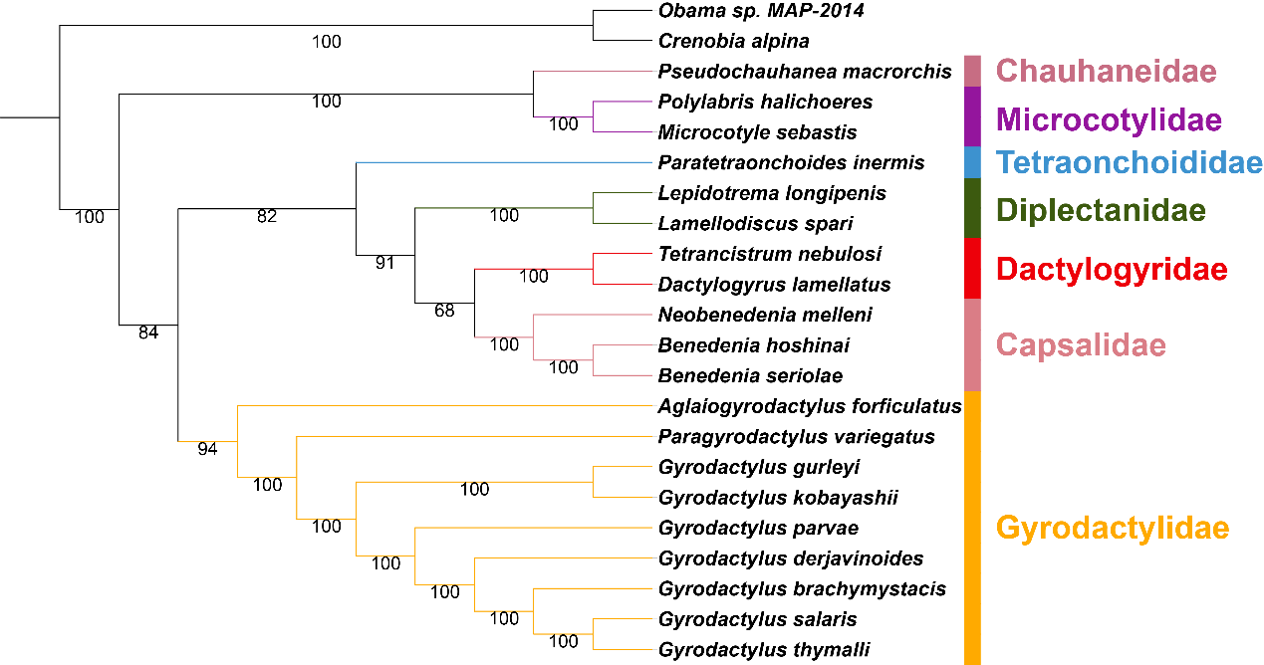

Figure S5 Maximum likelihood phylogram constructed using PCGAA dataset with partition model (see Table S1 for partitioning scheme).
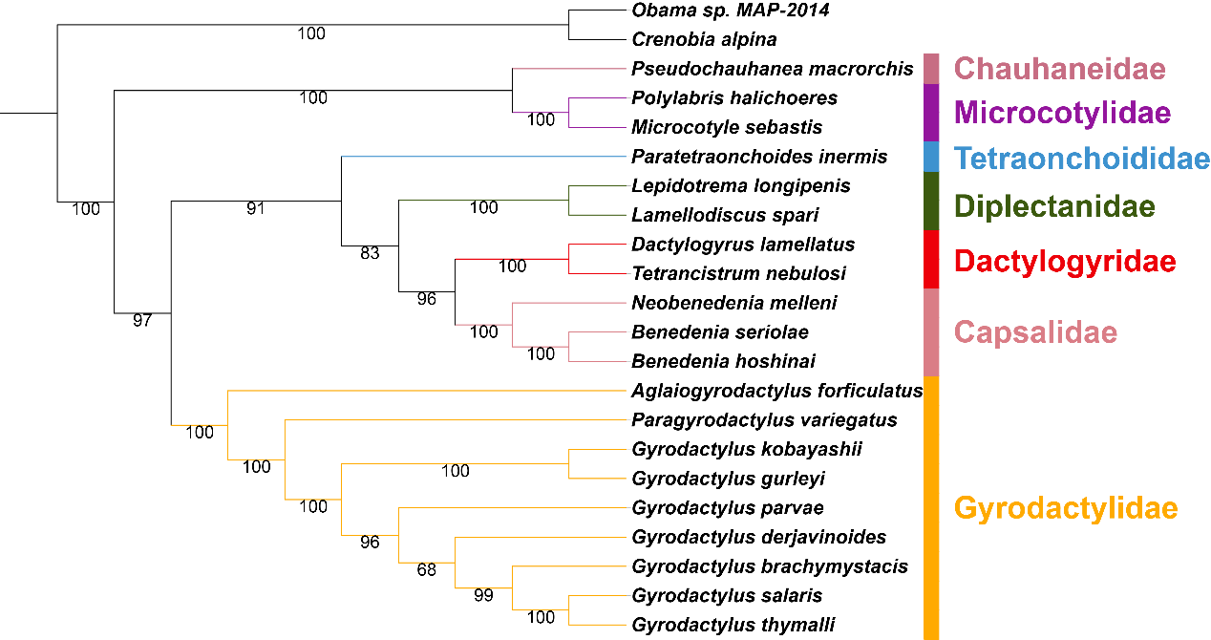

Figure S6 AliGROOVE analysis for three data sets. The obtained mean similarity score between sequences is represented by a colored square. Red indicates that ambiguously aligned sequence positions dominate between two sequences (i.e. heterogeneity), while blue indicates the opposite. PCGAA: amino acid alignment of 12 protein-coding genes; PCGNUC: codon-based alignment of 12 protein-coding genes; PCGRT: PCGNUC + nucleotide alignment of RNAs (22tRNA + 2rRNA).
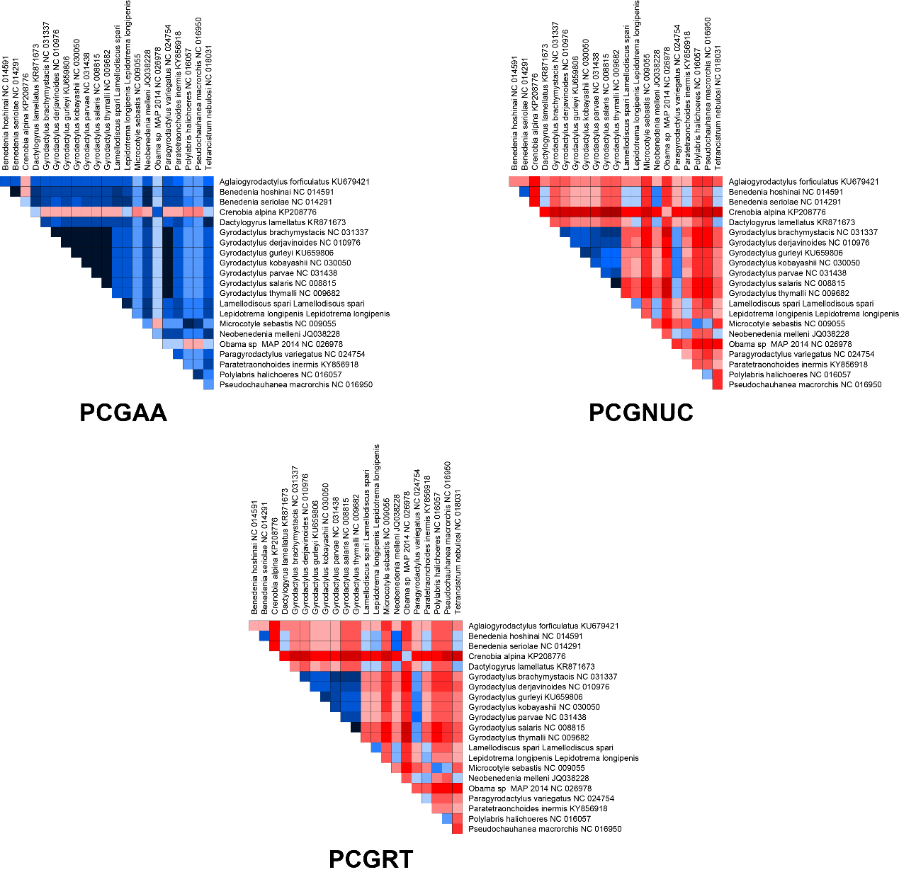

Table S3 The best partitioning scheme selected by PartitionFinder for PCGRT and PCGAA datasets (see Fig. S1 for abbreviations).
Dataset | Subset Partitions | Best Model
PCGRT | P1: (cox3_codon1, atp6_codon1) | GTR+I+G
PCGRT | P2: (atp6_codon2, nad3_codon2, nad4_codon2) | GTR+I+G
PCGRT | P3: (nad4L_codon3, atp6_codon3) | GTR+G
PCGRT | P4: (cox1_codon1) | GTR+I+G
PCGRT | P5: (cox1_codon2) | GTR+I+G
PCGRT | P6: (cox1_codon3, nad1_codon3) | GTR+I+G
PCGRT | P7: (cox2_codon1) | GTR+I+G
PCGRT | P8: (cox3_codon2, cox2_codon2) | GTR+I+G
PCGRT | P9: (cox2_codon3, cytb_codon3) | GTR+I+G
PCGRT | P10: (cox3_codon3, nad3_codon3) | GTR+I+G
PCGRT | P11: (cytb_codon1) | GTR+I+G
PCGRT | P12: (cytb_codon2) | GTR+I+G
PCGRT | P13: (nad1_codon1) | GTR+I+G
PCGRT | P14: (nad1_codon2) | GTR+G
PCGRT | P15: (nad2_codon1) | GTR+I+G
PCGRT | P16: (nad2_codon2) | GTR+I+G
PCGRT | P17: (nad2_codon3, nad6_codon3, nad4_codon3, nad5_codon3) | GTR+I+G
PCGRT | P18: (nad5_codon1, nad4_codon1, nad3_codon1) | GTR+I+G
PCGRT | P19: (nad4L_codon1, nad6_codon1) | GTR+I+G
PCGRT | P20: (nad4L_codon2) | GTR+G
PCGRT | P21: (nad5_codon2, nad6_codon2) | GTR+I+G
PCGRT | P22: (rrnS, rrnL) | GTR+I+G
PCGRT | P23: (tRNAs) | GTR+I+G
PCGAA | P1: (atp6, cox2, cox3, cytb) | VT+I+G+F
PCGAA | P2: (cox1) | MtArt+G
PCGAA | P3: (nad1, nad2, nad3, nad4L, nad4, nad5, nad6) | MtArt+I+G+F

