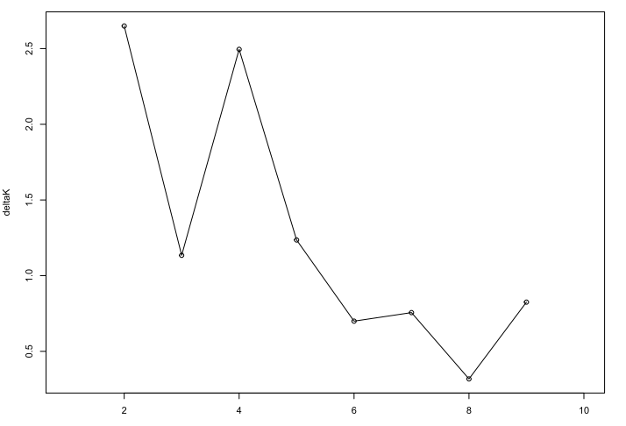
Additional file 3: Figure S1. ΔK-values calculated by Evanno’s method detecting K = 2 and K = 4 subpopulations as the most genetically probable within the 14 loci analyzed

