Additional file 1
Higher risk of malaria transmission outdoors than indoors by Nyssorhynchus darlingi in the Mazán District in the Peruvian Amazon

Marlon P. Saavedra, Jan E. Conn, Freddy Alava, Gabriel Carrasco, Catharine Prussing, Sara A. Bickersmith, Jorge Sangama, Carlos Fernandez-Miñope, Mitchel Guzman, Carlos Tong, Carlos Valderrama, Joseph Vinetz, Dionicia Gamboa, Marta Moreno

Table S1. Animal host census in SAL, URC, LIB and VIB, Mazan district, Peru, performed in November 2016.
 | Host
Site | Chicken | Dog | Cat | Duck | Cow | Pig | Monkey
SAL | 967 | 38 | 17 | 188 | 22 | 8 | 0
URC | 333 | 92 | 18 | 80 | 7 | 31 | 0
LIB | 783 | 77 | 29 | 72 | 23 | 25 | 4
VIB | 191 | 10 | 14 | 51 | 4 | 16 | 0

Table S2. Summary of Anophelinae specimens collected indoors/outdoors (peridomestic).
 | Site
 | SAL |  | URC |  | LIB |  | VIB
Date | In | Out | In | Out | In | Out | In | Out
March | 1 | 4 | 5 | 12 | 136 | 133 | 119 | 270
June | 33 | 33 | 149 | 476 | 263 | 1179 | 457 | 2273
September | 2 | 0 | 3 | 16 | 17 | 56 | 18 | 124
November | 0 | 0 | 0 | 0 | 0 | 4 | 1 | 3
March | 0 | 0 | 7 | 11 | 77 | 218 | 53 | 212
Total (%) | 36 (49.3) | 37 (50.7) | 164 (24.2) | 515 (75.8) | 493 (23.7) | 1590 (76.3) | 648 (18.4) | 2882 (81.6)

Table S3. Forage ratio (w_{i}) and host selection index (B_{i}) of Ny. darlingi in Mazán District sites between 2016 -2017.
Host | Blood meal ID (n) | Host Abundance (n) | ¹Forage Ratio A (wi) | Selection index (Bi) | ²Forage Ratio B (wi)
SAL
Human | 10 | 188 | 0.53 | 0.06 | 1.21
Chicken | 0 | 0 | 0 | 0 | 0
Cow | 4 | 22 | 1.94 | 0.23 | 6.73
Pig | 3 | 8 | 3.56 | 0.43 | 2.99
Dog | 4 | 38 | 2.25 | 0.27 | 0.59
URC
Human | 88 | 164 | 1.78 | 0.09 | 0.78
Chicken | 35 | 333 | 0.52 | 0.01 | 9.93
Cow | 25 | 7 | 17.63 | 0.02 | 2.02
Pig | 5 | 31 | 1.8 | 0.04 | 0.25
Dog | 4 | 92 | 0.16 | 0.84 | 0.18
LIB
Human | 77 | 167 | 3.35 | 0.24 | 1.05
Chicken | 34 | 783 | 0.32 | 0.03 | 4.42
Cow | 27 | 23 | 8.21 | 0.02 | 0.67
Pig | 6 | 25 | 1.74 | 0.12 | 0.31
Dog | 3 | 77 | 0.38 | 0.59 | 0.4
VIB
Human | 320 | 35 | 4.76 | 0.8 | 1.5
Chicken | 126 | 191 | 0.44 | 0.03 | 6.08
Cow | 3 | 4 | 0.5 | 0.07 | 0.16
Pig | 1 | 16 | 0.04 | 0.01 | 0.04
Dog | 3 | 10 | 0.2 | 0.08 | 0.01
¹Forage Ratio A was calculated using the number of hosts. ²Forage Ratio B was calculated using the biomass of hosts. Mean weight of hosts was: human (65 kg), dog (25kg), chicken (1.5kg), pig (90kg), cow (250 kg).

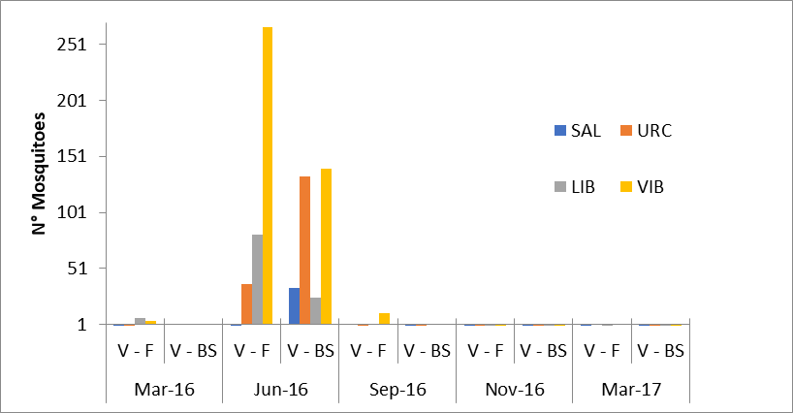

Figure S1. Number of Anophelinae mosquitoes collected with Barrier Screen by position in Salvador (SAL), Urcomiraño (URC), Libertad (LIB) and Visto Bueno (VIB). V-F: village-forest; V-BS: village-breeding site.

