Additional file 1: Table S1. Primer sequences of the 12 transcripts selected for qRT-PCR.
Transcript id | Primer sequence (5'→3') | Amplicon length (bp)
SLC13A2 | F:CGGGCTCTGAAGGGAAA | 235
SLC13A2 | R:CTAATACGGCGGTGGATGT | 235
FABP1_1 | F:GTAGTGAGGGATTCGACAAGG | 170
FABP1_1 | R:ACCCAAACGGAAGCAGG | 170
ADK | F:AGCGGTAAGGGCACTCAA | 277
ADK | R:GGGCAACCTCTTTTTCAAA | 277
ACSl4 | F:GAGGGGGGATGAGGGTGTTA | 175
ACSl4 | R:GTTGTGTGGATTGAAGTGCG | 175
CBR3 | F:TTTGGGAAAGGAGGCTGT | 125
CBR3 | R:CGGGGTAGTTCTGTTTAGTGA | 125
GALK1 | F:TGCTTGTCTCGGAGGTGTT | 293
GALK1 | R:GCAGTCTTTTAGTGTGGGCT | 293
GALE | F:CATTTTCCCCTGTCTTACGA | 351
GALE | R:TTCTCCGCTTTCCACCC | 351
GALT | F:GAGGCAGCCACTGAGAAAG | 337
GALT | R:TGGGATCAACAGCAAACAA | 337

Additional file 1: Table S2. Sequencing data quality summary.
Sample | Raw reads | Clean reads | Clean bases | Q20 (%) | Q30 (%) | GC (%)
Scolex and neck_a_1 | 24459952 | 23826543 | 3.57G | 97.4 | 92.97 | 42.22
scolex and neck_a_2 | 24459952 | 23826543 | 3.57G | 96.32 | 90.63 | 42.31
scolex and neck_b_1 | 25148916 | 24766508 | 3.71G | 97.73 | 93.7 | 42.36
scolex and neck_b_2 | 25148916 | 24766508 | 3.71G | 97.21 | 92.17 | 42.34
scolex and neck_c_1 | 23159764 | 22914660 | 3.44G | 97.86 | 93.98 | 42.38
scolex and neck_c_2 | 23159764 | 22914660 | 3.44G | 97.3 | 92.35 | 42.35
immature_a_1 | 23825184 | 23276628 | 3.49G | 97.38 | 92.96 | 43.08
immature_a_2 | 23825184 | 23276628 | 3.49G | 95.05 | 88.04 | 43.14
immature_b_1 | 26005701 | 25731139 | 3.86G | 97.78 | 93.84 | 44.26
immature_b_2 | 26005701 | 25731139 | 3.86G | 96.92 | 91.57 | 44.29
immature_c_1 | 22066629 | 21797818 | 3.27G | 97.85 | 93.94 | 42.83
immature_c_2 | 22066629 | 21797818 | 3.27G | 97.56 | 92.97 | 42.84
mature_a_1 | 20743673 | 20360170 | 3.05G | 97.46 | 93.05 | 40.68
mature_a_2 | 20743673 | 20360170 | 3.05G | 95.64 | 89.11 | 40.7
mature_b_1 | 25677893 | 25344795 | 3.8G | 97.65 | 93.54 | 40.91
mature_b_2 | 25677893 | 25344795 | 3.8G | 97 | 91.71 | 40.9
mature_c_1 | 24300346 | 23869165 | 3.58G | 97.79 | 93.97 | 43.66
mature_c_2 | 24300346 | 23869165 | 3.58G | 97.43 | 92.83 | 43.65
gravid_a_1 | 25331359 | 24721001 | 3.71G | 97.47 | 93.08 | 41.43
gravid_a_2 | 25331359 | 24721001 | 3.71G | 95.95 | 89.69 | 41.44
gravid_b_1 | 27656788 | 27254218 | 4.09G | 97.75 | 93.91 | 44.13
gravid_b_2 | 27656788 | 27254218 | 4.09G | 96.6 | 90.91 | 44.11
gravid_c_1 | 22551667 | 22270913 | 3.34G | 97.6 | 93.67 | 43.28
gravid_c_2 | 22551667 | 22270913 | 3.34G | 96.49 | 90.84 | 43.25

Additional file 1: Table S3. GO and KEGG enrichment results for the differentially expressed genes.
mature vs gravid. KEGG. result
map05218 | Melanoma
immature vs mature. KEGG. result
map04712 | Circadian rhythm - plant
map04310 | Wnt signaling pathway
map04064 | NF-kappa B signaling pathway
map05168 | Herpes simplex infection
map04139 | Regulation of mitophagy - yeast
immature vs gravid. KEGG. result
map00052 | Galactose metabolism
map00511 | Other glycan degradation
scolex and neck vs mature. KEGG. result
map04310 | Wnt signaling pathway
map04712 | Circadian rhythm - plant
map04550 | Signaling pathways regulating the pluripotency of stem cells
map05168 | Herpes simplex infection
map04064 | NF-kappa B signaling pathway
scolex and neck vs gravid. GO. result
GO:0044767 | Single-organism developmental process
GO:0007156 | Homophilic cell adhesion
GO:0005102 | Receptor binding
GO:0007275 | Multicellular organismal development
GO:0048523 | Negative regulation of cellular process
GO:0016055 | Wnt signaling pathway
GO:0005509 | Calcium ion binding
GO:0030154 | Cell differentiation
immature vs mature. GO. result
GO:0004887 | Thyroid hormone receptor activity
GO:0006355 | Regulation of transcription, DNA-templated
GO:0004252 | Serine-type endopeptidase activity
GO:0034654 | Nucleobase-containing compound biosynthetic process
GO:0008152 | Metabolic process
GO:0006508 | Proteolysis
GO:0043170 | Macromolecule metabolic process
GO:0071704 | Organic substance metabolic process
GO:0044238 | Primary metabolic process
immature vs gravid. GO. result
GO:0006012 | Galactose metabolic process
GO:0019318 | Hexose metabolic process
GO:0004553 | Hydrolase activity, hydrolyzing O-glycosyl compounds
scolex and neck vs mature. GO. result
GO:0006355 | Regulation of transcription, DNA-templated
GO:0044767 | Single-organism developmental process
GO:0007275 | Multicellular organismal development
GO:0016055 | Wnt signaling pathway
GO:0004887 | Thyroid hormone receptor activity
GO:0048513 | Organ development
GO:0005102 | Receptor binding
GO:0034654 | Nucleobase-containing compound biosynthetic process
GO:0006508 | Proteolysis
GO:0042813 | Wnt-activated receptor activity
GO:0004252 | Serine-type endopeptidase activity
GO:0043565 | Sequence-specific DNA binding

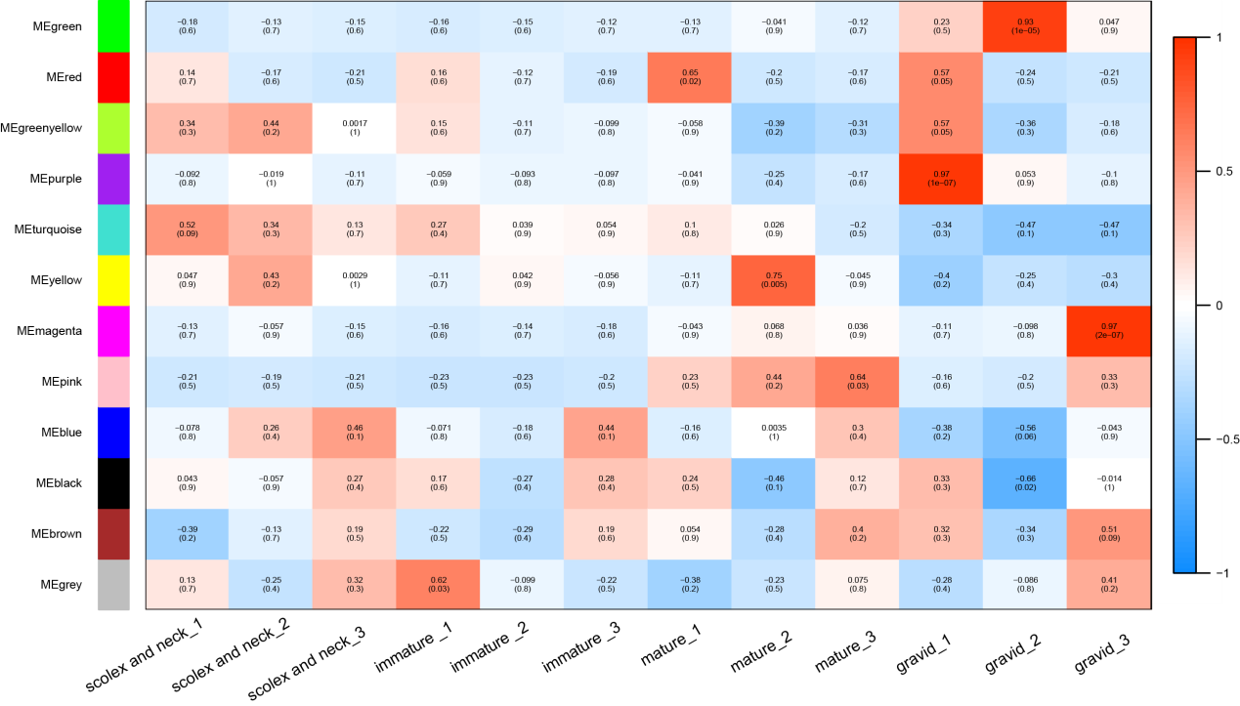
Additional file 1: Figure S1. Relationships between the modules and samples. Hierarchical clustering dendrogram of the module eigengenes and a heat map of the adjacencies using weighted coexpression network analysis. Blue represents a negative correlation, and red represents a positive correlation.
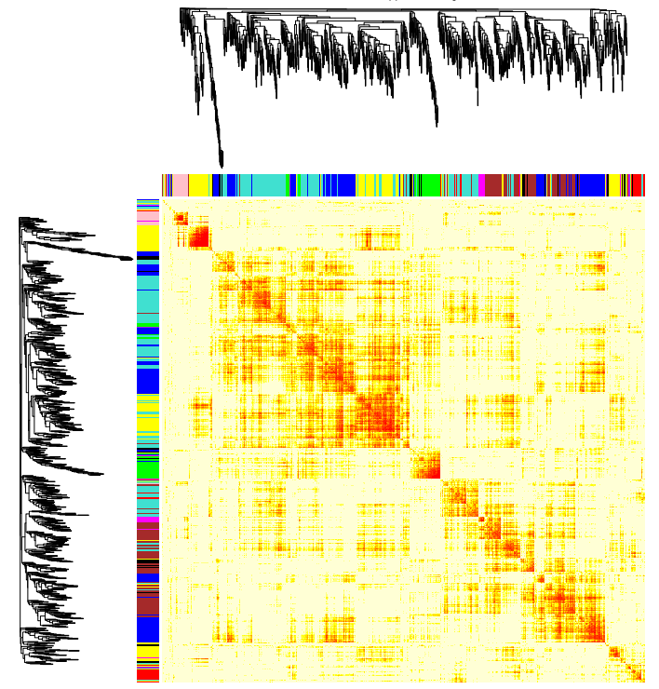
Additional file 1: Figure S2. Topological overlap heat map of the gene coexpression network. Each row and column represents a gene. A light color indicates low topological overlap, and progressively darker colors indicate increased topological overlap. Darker squares along the diagonal represent modules. The gene dendrogram and module assignment are displayed along the left and top of the figure.

