Additional file 1: Table S1. Snail survey sites (coordinates in decimal, WGS84)

site_code | district | locality | site_name | site_type | latitude | longitude
382865 | Kollo | Bangou Koirey | bangou koirey 1 bras du fleuve | rivulet | 13.60331 | 1.90767
382864 | Kollo | Bangou Koirey | bangou koirey 2 bras du fleuve | rivulet | 13.60475 | 1.90509
1658554 | Kollo | Bangou Koirey | bangou koirey 3 bras du fleuve | rivulet | 13.60993 | 1.90371
382866 | Tillaberi | Diambala | diambala 1 canal tertiaire | canal.3 | 14.31071 | 1.29644
382867 | Tillaberi | Diambala | diambala 2 canal tertiaire | canal.3 | 14.31055 | 1.28587
382868 | Tillaberi | Diambala | diambala 3 canal secondaire | canal.2 | 14.30949 | 1.28911
382869 | Tillaberi | Diambala | diambala 4 canal secondaire | canal.2 | 14.30968 | 1.29359
382870 | Tillaberi | Diambala | diambala 5 canal tertiaire | canal.3 | 14.30989 | 1.29365
382871 | Tillaberi | Diambala | diambala 6 canal secondaire | canal.2 | 14.31036 | 1.29175
382872 | Tillaberi | Diambala | diambala 7 canal tertiaire | canal.3 | 14.31047 | 1.29181
382874 | Say | Doguel Kaina | doguel kaina 1 bras du fleuve | rivulet | 13.28931 | 2.32526
382875 | Say | Doguel Kaina | doguel kaina 2 canal tertiaire | canal.3 | 13.28724 | 2.32726
382876 | Say | Doguel Kaina | doguel kaina 3 riziere | rice.p | 13.28718 | 2.32726
436558 | Say | Doguel Kaina | doguel kaina 4 fleuve | river | 13.29273 | 2.32335
601671 | Say | Doguel Kaina | doguel kaina 5 canal secondaire | canal.2 | 13.28259 | 2.33279
382877 | Say | Dokimana | dokimana 1 mare nordest | pond | 13.03523 | 2.3432
382878 | Say | Dokimana | dokimana 2 mare sudouest | pond | 13.03144 | 2.34215
382879 | Say | Gantchi Bassarou | gantchi bassarou 1 mare | pond | 13.17606 | 2.35497
382880 | Say | Gantchi Bassarou | gantchi bassarou 2 riziere | rice.p | 13.17232 | 2.34953
382881 | Kollo | Karma | karma 1 fleuve | river | 13.66431 | 1.82411
382882 | Kollo | Karma | karma 2 canal secondaire | canal.2 | 13.66373 | 1.824866
7920104 | Kollo | Karma | karma 3 canal tertiaire | canal.3 | 13.66367 | 1.82437
382884 | Kollo | Karma | karma 4 riziere | rice.p | 13.66344 | 1.82505
551014 | Kollo | Karma | karma 5 canal tertiaire | canal.3 | 13.66395 | 1.82468
487390 | Kollo | Karma | karma 6 bras du fleuve | rivulet | 13.66605 | 1.80992
382885 | Say | Kohan | kohan garantche 1 fleuve | river | 13.31996 | 2.29661
382887 | Say | Koutoukale | koutoukale zeno 1 canal secondaire | canal.2 | 13.68637 | 1.7452
382883 | Say | Koutoukale | koutoukale zeno 2 canal tertiaire | canal.3 | 13.6862 | 1.74518
382889 | Say | Koutoukale | koutoukale zeno 3 mare | pond | 13.6916 | 1.74321
487391 | Say | Koutoukale | koutoukale zeno 4 canal secondaire | canal.2 | 13.68351 | 1.75121
601670 | Say | Koutoukale | koutoukale zeno 5 canal tertiaire | canal.3 | 13.68381 | 1.75045
382891 | Kollo | Lata | lata kabia 1 canal secondaire | canal.2 | 13.74196 | 1.68257
436559 | Kollo | Lata | lata kabia 2 canal tertiaire | canal.3 | 13.74193 | 1.68262
382893 | Kollo | Lata | lata kabia 3 riziere | rice.p | 13.74199 | 1.68258
382892 | Kollo | Lata | lata kabia 4 mare | pond | 13.7425 | 1.68173
436560 | Kollo | Lata | lata kabia 5 canal tertiaire | canal.3 | 13.7561 | 1.67038
436561 | Kollo | Lata | lata kabia 6 deversoir | spillway | 13.75618 | 1.67031
487394 | Kollo | Lata | lata kabia 7 canal secondaire | canal.2 | 13.76104 | 1.67135
487395 | Kollo | Lata | lata kabia 8 canal secondaire | canal.2 | 13.76385 | 1.66861
382895 | Kollo | Libore | libore 1 canal secondaire | canal.2 | 13.40273 | 2.18918
382896 | Kollo | Libore | libore 2 canal secondaire | canal.2 | 13.40304 | 2.18897
382897 | Kollo | Libore | libore 3 canal tertiaire | canal.3 | 13.4034 | 2.18862
382898 | Kollo | Libore | libore 4 riziere | rice.p | 13.40342 | 2.18843
360829 | Kollo | Libore | libore 5 canal tertiaire | canal.3 | 13.39008 | 2.19711
436562 | Kollo | Libore | libore 6 canal secondaire | canal.2 | 13.39002 | 2.19714
360779 | Kollo | Libore | libore 6 riziere | rice.p | 13.39001 | 2.19713
382899 | Kollo | Libore | libore 7 canal secondaire | canal.2 | 13.39452 | 2.19297
382900 | Kollo | Libore | libore 8 canal secondaire | canal.2 | 13.40417 | 2.18802
382901 | Kollo | Libore | libore 9 canal secondaire | canal.2 | 13.38805 | 2.19913
382902 | Tillaberi | Namari Goungou | namari goungou 1 canal tertiaire | canal.3 | 14.34843 | 1.24819
382903 | Tillaberi | Namari Goungou | namari goungou 2 canal tertiaire | canal.3 | 14.34942 | 1.24808
382904 | Tillaberi | Namari Goungou | namari goungou 3 canal secondaire | canal.2 | 14.34818 | 1.25013
382905 | Tillaberi | Namari Goungou | namari goungou 4 canal tertiaire | canal.3 | 14.34492 | 1.25329
382906 | Tillaberi | Namari Goungou | namari goungou 5 canal tertiaire | canal.3 | 14.34615 | 1.24468
487296 | Tillaberi | Namari Goungou | namari goungou 6 canal secondaire | canal.2 | 14.34488 | 1.24571
382907 | Kollo | Namaro | namaro 1 canal secondaire | canal.2 | 13.71095 | 1.69746
382908 | Kollo | Namaro | namaro 2 canal tertiaire | canal.3 | 13.71124 | 1.69775
382909 | Kollo | Namaro | namaro 3 mare ouest | pond | 13.70943 | 1.69807
487396 | Kollo | Namaro | namaro 4 fleuve | river | 13.68974 | 1.71444
487397 | Kollo | Namaro | namaro 5 mare est | pond | 13.7102 | 1.69744
382911 | Say | Say | say 2 deversoir | spillway | 13.10468 | 2.35263
382912 | Say | Say | say 3 canal secondaire | canal.2 | 13.09918 | 2.35073
487398 | Say | Say | say 4 fleuve | river | 13.09848 | 2.37032
382913 | Kollo | Seberi | seberi 1 canal secondaire | canal.2 | 13.29359 | 2.34353
382914 | Kollo | Seberi | seberi 2 canal secondaire | canal.2 | 13.29434 | 2.34215
382915 | Kollo | Seberi | seberi 3 canal tertiaire | canal.3 | 13.29699 | 2.33337
382916 | Kollo | Seberi | seberi 4 canal tertiaire | canal.3 | 13.3038 | 2.33241
382917 | Kollo | Seberi | seberi 5 canal secondaire | canal.2 | 13.31099 | 2.32554
382918 | Kollo | Seberi | seberi 6 canal secondaire | canal.2 | 13.31313 | 2.32354
382920 | Kollo | Tagabati | tagabati 1 fleuve | river | 13.63102 | 1.87492
382921 | Kollo | Tagabati | tagabati 2 bras du fleuve | rivulet | 13.63109 | 1.87452
487399 | Kollo | Tagabati | tagabati 3 fleuve | river | 13.62944 | 1.87799
382923 | Kollo | Tiaguirire | tiaguirire 1 canal secondaire | canal.2 | 13.27167 | 2.33836
382922 | Kollo | Tiaguirire | tiaguirire 2 canal tertiaire | canal.3 | 13.27166 | 2.33829
487400 | Kollo | Tiaguirire | tiaguirire 3 riziere | rice.p | 13.27176 | 2.33823
382926 | Kollo | Tokeye | tokoye 1 mare | pond | 13.19668 | 2.35522
382927 | Kollo | Tokeye | tokoye 2 canal secondaire | canal.2 | 13.19224 | 2.36141
382928 | Kollo | Tokeye | tokoye 3 canal tertiaire | canal.3 | 13.19123 | 2.36171
487415 | Kollo | Tokeye | tokoye 4 canal secondaire | canal.2 | 13.1925 | 2.36142
382929 | Kollo | Yoreize Koira | yoreize koira 1 canal secondaire | canal.2 | 13.61844 | 1.87246
382930 | Kollo | Yoreize Koira | yoreize koira 2 canal tertiaire | canal.3 | 13.61853 | 1.87262
382931 | Kollo | Yoreize Koira | yoreize koira 3 riziere | rice.p | 13.61857 | 1.87245
487401 | Kollo | Yoreize Koira | yoreize koira 4 canal tertiaire | canal.3 | 13.61638 | 1.87466
382932 | Kollo | Youri | youri 1 bras du fleuve | rivulet | 13.33866 | 2.24118
382933 | Kollo | Youri | youri 2 riziere | rice.p | 13.33507 | 2.24781
382934 | Kollo | Youri | youri 3 fleuve | river | 13.33371 | 2.24556
382935 | Kollo | Zama Koira Tegui | zama koira tegui 1 canal secondaire | canal.2 | 13.70169 | 1.71942
382936 | Kollo | Zama Koira Tegui | zama koira tegui 2 canal tertiaire | canal.3 | 13.70186 | 1.71945
382937 | Kollo | Zama Koira Tegui | zama koira tegui 3 riziere | rice.p | 13.70183 | 1.71938
436563 | Kollo | Zama Koira Tegui | zama koira tegui 4 canal secondaire | canal.2 | 13.70432 | 1.72169
487402 | Kollo | Zama Koira Tegui | zama koira tegui 5 deversoir | spillway | 13.70023 | 1.71885
487403 | Kollo | Zama Koira Tegui | zama koira tegui 6 canal tertiaire | canal.3 | 13.709 | 1.71364

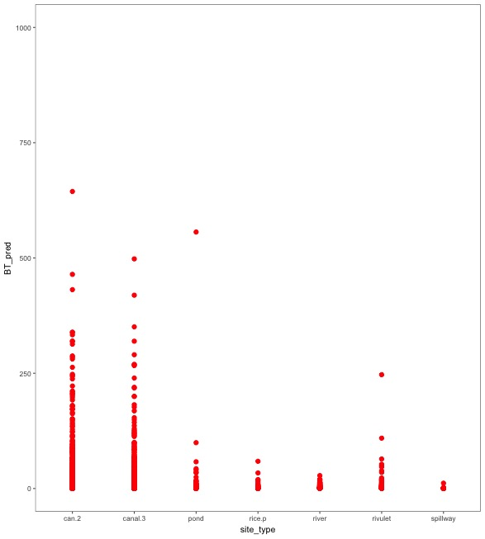
Additional file 1: Figure S1: Predicted counts by site type, B. truncatus

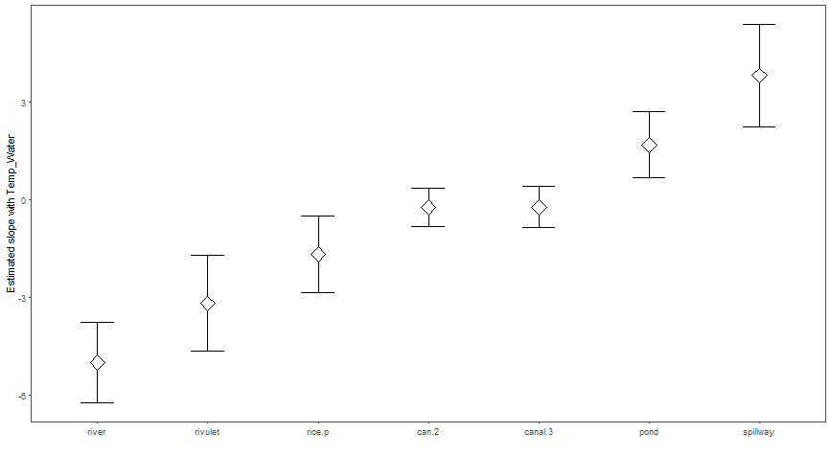
Additional file 1: Figure S2. Estimated slope of Bulinus spp with temperature by site type. 1 degree increase in temperature equals decrease in abundance in rivulet and river, rice paddies, ponds and irrigation canals no real change although in latter- v slight increase in abundance with temp, spillway and stream (I site)- increase in abundance with temperature
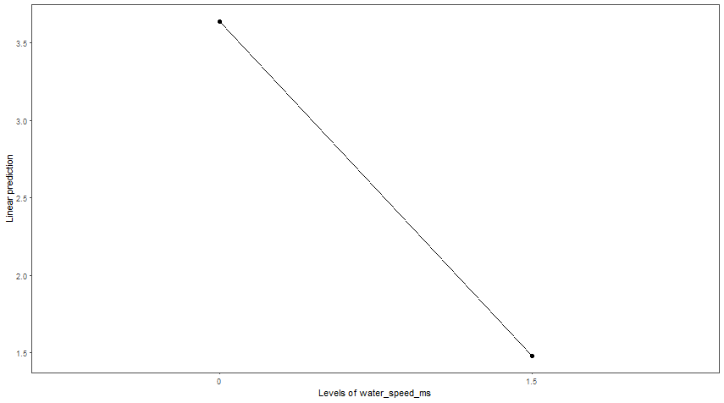
Additional file 1: Figure S3.Estimated slope of Bulinus spp with water speed.

Additional file 1: Table S2: B. truncatus glmmTMB negative binomial model summary output
BT_m1 | coefs | Estimate | Std..Error | z.value | Pr...z..
1 | (Intercept) | -0.252 | 1.169 | -0.215 | 0.830
2 | wmo_prec | -0.058 | 0.097 | -0.601 | 0.548
3 | site_typecanal.3 | -0.860 | 0.308 | -2.789 | 0.005
4 | site_typepond | -0.078 | 0.600 | -0.130 | 0.896
5 | site_typerice.p | -1.915 | 0.487 | -3.932 | 0.000
6 | site_typeriver | 0.125 | 0.610 | 0.205 | 0.837
7 | site_typerivulet | -0.611 | 0.840 | -0.728 | 0.467
8 | site_typespillway | -3.182 | 0.841 | -3.783 | 0.000
9 | month2 | 0.841 | 0.380 | 2.216 | 0.027
10 | month3 | 1.462 | 0.376 | 3.887 | 0.000
11 | month4 | 1.618 | 0.552 | 2.933 | 0.003
12 | month5 | 0.837 | 0.382 | 2.190 | 0.029
13 | month6 | 0.379 | 0.372 | 1.019 | 0.308
14 | month7 | -0.339 | 0.367 | -0.922 | 0.356
15 | month8 | -1.010 | 0.410 | -2.464 | 0.014
16 | month9 | -0.496 | 0.373 | -1.329 | 0.184
17 | month10 | -0.602 | 0.356 | -1.691 | 0.091
18 | month11 | -0.444 | 0.367 | -1.211 | 0.226
19 | month12 | -0.334 | 0.353 | -0.944 | 0.345
20 | BT_pos_tot | 0.414 | 0.071 | 5.811 | 0.000
21 | localityDiambala | 0.402 | 1.208 | 0.333 | 0.739
22 | localityDoguel Kaina | -1.834 | 1.097 | -1.672 | 0.094
23 | localityDokimana | -2.294 | 1.498 | -1.531 | 0.126
24 | localityKarma | -4.313 | 1.261 | -3.420 | 0.001
25 | localityKohan Garantche | -1.492 | 1.534 | -0.973 | 0.331
26 | localityKoutoukale Zeno | -0.646 | 1.234 | -0.523 | 0.601
27 | localityLata Kabia | -0.886 | 1.184 | -0.748 | 0.454
28 | localityLibore | -0.900 | 1.182 | -0.761 | 0.447
29 | localityNamari Goungou | 1.073 | 1.220 | 0.880 | 0.379
30 | localityNamaro | -1.851 | 1.221 | -1.515 | 0.130
31 | localitySay | -1.530 | 1.281 | -1.195 | 0.232
32 | localitySeberi | 0.411 | 1.215 | 0.338 | 0.735
33 | localityTagabati | -2.634 | 1.143 | -2.305 | 0.021
34 | localityTiaguirire | -1.420 | 1.306 | -1.087 | 0.277
35 | localityTokoye | -2.462 | 1.270 | -1.938 | 0.053
36 | localityYoreize Koira | -2.890 | 1.253 | -2.307 | 0.021
37 | localityYouri | -1.215 | 1.109 | -1.095 | 0.273
38 | localityZama Koira Tegui | -3.623 | 1.231 | -2.943 | 0.003
39

Additional file 1: Table S3: B. forskalii glmmTMB negative binomial model summary output
BF_m1 | coefs | Estimate | Std..Error | z.value | Pr...z..
1 | (Intercept) | -2.193 | 1.125 | -1.950 | 0.051
2 | wmo_prec | -0.075 | 0.095 | -0.793 | 0.427
3 | site_typecanal.3 | 0.800 | 0.283 | 2.828 | 0.005
4 | site_typepond | 0.445 | 0.520 | 0.856 | 0.392
5 | site_typerice.p | 0.352 | 0.420 | 0.839 | 0.402
6 | site_typeriver | -1.819 | 0.584 | -3.115 | 0.002
7 | site_typerivulet | -1.887 | 0.803 | -2.349 | 0.019
8 | site_typespillway | 0.963 | 0.663 | 1.453 | 0.146
9 | month2 | 0.786 | 0.407 | 1.934 | 0.053
10 | month3 | 1.171 | 0.403 | 2.902 | 0.004
11 | month4 | 1.582 | 0.582 | 2.718 | 0.007
12 | month5 | 0.750 | 0.404 | 1.856 | 0.063
13 | month6 | 0.560 | 0.397 | 1.410 | 0.159
14 | month7 | -0.068 | 0.393 | -0.172 | 0.864
15 | month8 | 0.560 | 0.427 | 1.313 | 0.189
16 | month9 | 1.362 | 0.400 | 3.405 | 0.001
17 | month10 | 0.206 | 0.381 | 0.541 | 0.589
18 | month11 | 0.227 | 0.391 | 0.580 | 0.562
19 | month12 | 0.237 | 0.377 | 0.629 | 0.529
20 | localityDiambala | -1.402 | 1.149 | -1.220 | 0.223
21 | localityDoguel Kaina | -0.254 | 1.046 | -0.243 | 0.808
22 | localityDokimana | -0.670 | 1.384 | -0.484 | 0.628
23 | localityGantchi Bassarou | -2.238 | 1.308 | -1.711 | 0.087
24 | localityKarma | -1.025 | 1.162 | -0.882 | 0.378
25 | localityKohan Garantche | 0.986 | 1.443 | 0.683 | 0.495
26 | localityKoutoukale Zeno | -0.207 | 1.172 | -0.177 | 0.860
27 | localityLata Kabia | 0.262 | 1.124 | 0.233 | 0.816
28 | localityLibore | -0.817 | 1.127 | -0.725 | 0.468
29 | localityNamari Goungou | -1.093 | 1.158 | -0.944 | 0.345
30 | localityNamaro | -0.770 | 1.158 | -0.664 | 0.506
31 | localitySay | -1.136 | 1.246 | -0.911 | 0.362
32 | localitySeberi | 0.053 | 1.152 | 0.046 | 0.963
33 | localityTagabati | -1.112 | 1.110 | -1.001 | 0.317
34 | localityTiaguirire | -1.465 | 1.236 | -1.186 | 0.236
35 | localityTokoye | -0.843 | 1.201 | -0.702 | 0.483
36 | localityYoreize Koira | -1.668 | 1.185 | -1.408 | 0.159
37 | localityYouri | -0.291 | 1.060 | -0.274 | 0.784
38 | localityZama Koira Tegui | -1.636 | 1.157 | -1.414 | 0.157
39 | BF_pos_tot | 0.537 | 0.345 | 1.558 | 0.119

Additional file 1: Table S4: Radix natalensis glmmTMB negative binomial model summary output
RN_m1 | coefs | Estimate | Std..Error | z.value | Pr...z..
1 | (Intercept) | -8.221 | 2.104 | -3.906 | 0.000
2 | wmo_prec | 0.056 | 0.206 | 0.270 | 0.787
3 | site_typecanal.3 | 0.396 | 0.702 | 0.564 | 0.573
4 | site_typepond | 4.215 | 1.257 | 3.354 | 0.001
5 | site_typerice.p | 2.022 | 0.883 | 2.290 | 0.022
6 | site_typeriver | 3.109 | 1.287 | 2.416 | 0.016
7 | site_typerivulet | 3.157 | 1.570 | 2.010 | 0.044
8 | site_typespillway | 0.434 | 1.877 | 0.231 | 0.817
9 | month2 | 1.586 | 0.617 | 2.570 | 0.010
10 | month3 | 2.734 | 0.610 | 4.485 | 0.000
11 | month4 | 2.794 | 0.873 | 3.201 | 0.001
12 | month5 | 0.748 | 0.646 | 1.159 | 0.246
13 | month6 | 0.463 | 0.674 | 0.686 | 0.493
14 | month7 | -1.780 | 0.735 | -2.421 | 0.015
15 | month8 | -1.902 | 0.795 | -2.392 | 0.017
16 | month9 | -2.043 | 0.761 | -2.683 | 0.007
17 | month10 | -2.019 | 0.735 | -2.748 | 0.006
18 | month11 | -1.161 | 0.713 | -1.628 | 0.104
19 | month12 | -0.656 | 0.619 | -1.059 | 0.290
20 | localityDiambala | -0.556 | 2.185 | -0.255 | 0.799
21 | localityDoguel Kaina | 2.109 | 1.898 | 1.111 | 0.266
22 | localityDokimana | 0.984 | 2.594 | 0.379 | 0.704
23 | localityGantchi Bassarou | 0.478 | 2.417 | 0.198 | 0.843
24 | localityKarma | -1.366 | 2.212 | -0.617 | 0.537
25 | localityKohan Garantche | -0.434 | 2.667 | -0.163 | 0.871
26 | localityKoutoukale Zeno | -17.933 | 1414.264 | -0.013 | 0.990
27 | localityLata Kabia | -2.187 | 2.229 | -0.981 | 0.326
28 | localityLibore | -0.756 | 2.129 | -0.355 | 0.722
29 | localityNamari Goungou | 2.697 | 2.158 | 1.250 | 0.211
30 | localityNamaro | -2.226 | 2.291 | -0.972 | 0.331
31 | localitySay | -2.602 | 2.594 | -1.003 | 0.316
32 | localitySeberi | -2.291 | 2.402 | -0.954 | 0.340
33 | localityTagabati | -0.647 | 1.944 | -0.333 | 0.739
34 | localityTiaguirire | 2.032 | 2.279 | 0.892 | 0.372
35 | localityTokoye | 3.591 | 2.207 | 1.627 | 0.104
36 | localityYoreize Koira | 2.250 | 2.173 | 1.036 | 0.300
37 | localityYouri | -2.059 | 1.941 | -1.061 | 0.289
38 | localityZama Koira Tegui | 0.295 | 2.189 | 0.135 | 0.893

Additional file 1: Table S5: Biomphalaria pfeifferi glmmTMB negative binomial model summary output
bp_m1 | coefs | Estimate | Std..Error | z.value | Pr...z..
1 | (Intercept) | -5.556 | 1.326 | -4.191 | 0.000
2 | wmo_prec | -0.266 | 0.420 | -0.632 | 0.527
3 | site_typecanal.3 | -1.863 | 1.060 | -1.758 | 0.079
4 | month2 | 2.228 | 1.332 | 1.673 | 0.094
5 | month3 | 2.682 | 1.329 | 2.018 | 0.044
6 | month4 | 5.088 | 2.064 | 2.466 | 0.014
7 | month5 | 2.202 | 1.336 | 1.648 | 0.099
8 | month6 | 2.502 | 1.246 | 2.007 | 0.045
9 | month7 | -1.005 | 1.451 | -0.692 | 0.489
10 | month8 | 0.246 | 1.650 | 0.149 | 0.881
11 | month9 | 0.884 | 1.301 | 0.680 | 0.497
12 | month10 | 0.526 | 1.373 | 0.383 | 0.702
13 | month11 | -0.393 | 1.330 | -0.295 | 0.768
14 | month12 | 1.272 | 1.362 | 0.934 | 0.350
15 | localityNamari Goungou | 1.802 | 1.048 | 1.719 | 0.086
16 | BP_pos_tot | 0.517 | 0.118 | 4.372 | 0.000

Additional file 1: Table S6: Bulinus spp glmmTMB negative binomial model summary output
Bulinus_m1 | coefs | Estimate | Std..Error | z.value | Pr...z..
1 | (Intercept) | 0.643 | 1.136 | 0.566 | 0.571
2 | Temp_Water | -0.211 | 0.654 | -0.323 | 0.747
3 | pH | 0.038 | 0.071 | 0.537 | 0.591
4 | water_speed_ms | -1.011 | 0.265 | -3.819 | 0.000
5 | water_depth | -0.631 | 0.244 | -2.583 | 0.010
6 | Cond | -0.005 | 0.165 | -0.030 | 0.976
7 | wmo_prec | -0.159 | 0.099 | -1.604 | 0.109
8 | site_typecanal.3 | 0.690 | 1.027 | 0.672 | 0.502
9 | site_typepond | -2.563 | 1.795 | -1.428 | 0.153
10 | site_typerice.p | 0.873 | 1.966 | 0.444 | 0.657
11 | site_typeriver | 2.358 | 1.682 | 1.402 | 0.161
12 | site_typerivulet | 5.000 | 2.389 | 2.093 | 0.036
13 | site_typespillway | -1.709 | 2.046 | -0.835 | 0.404
14 | Bulinus_pos_tot | 0.304 | 0.055 | 5.528 | 0.000
15 | month2 | 0.751 | 0.343 | 2.191 | 0.028
16 | month3 | 1.254 | 0.347 | 3.611 | 0.000
17 | month4 | 1.518 | 0.501 | 3.032 | 0.002
18 | month5 | 0.784 | 0.377 | 2.079 | 0.038
19 | month6 | 0.500 | 0.366 | 1.363 | 0.173
20 | month7 | 0.077 | 0.357 | 0.215 | 0.830
21 | month8 | 0.107 | 0.386 | 0.276 | 0.783
22 | month9 | 0.163 | 0.374 | 0.434 | 0.664
23 | month10 | -0.238 | 0.373 | -0.640 | 0.522
24 | month11 | 0.527 | 0.389 | 1.355 | 0.175
25 | month12 | -0.009 | 0.345 | -0.025 | 0.980
26 | localityDiambala | -0.619 | 0.843 | -0.734 | 0.463
27 | localityDoguel Kaina | -1.968 | 0.773 | -2.546 | 0.011
28 | localityDokimana | -3.046 | 1.041 | -2.926 | 0.003
29 | localityGantchi Bassarou | -3.457 | 0.984 | -3.512 | 0.000
30 | localityKarma | -2.125 | 0.859 | -2.473 | 0.013
31 | localityKohan Garantche | -2.083 | 1.064 | -1.958 | 0.050
32 | localityKoutoukale Zeno | -0.865 | 0.862 | -1.003 | 0.316
33 | localityLata Kabia | -0.836 | 0.822 | -1.018 | 0.309
34 | localityLibore | -1.637 | 0.832 | -1.968 | 0.049
35 | localityNamari Goungou | -0.059 | 0.851 | -0.070 | 0.945
36 | localityNamaro | -1.283 | 0.850 | -1.509 | 0.131
37 | localitySay | -1.807 | 0.893 | -2.023 | 0.043
38 | localitySeberi | -0.635 | 0.847 | -0.750 | 0.453
39 | localityTagabati | -1.980 | 0.818 | -2.420 | 0.016
40 | localityTiaguirire | -2.283 | 0.914 | -2.497 | 0.013
41 | localityTokoye | -2.418 | 0.887 | -2.726 | 0.006
42 | localityYoreize Koira | -2.418 | 0.868 | -2.786 | 0.005
43 | localityYouri | -1.757 | 0.778 | -2.259 | 0.024
44 | localityZama Koira Tegui | -2.849 | 0.851 | -3.349 | 0.001
45 | Temp_Water:site_typecanal.3 | 0.018 | 0.687 | 0.027 | 0.979
46 | Temp_Water:site_typepond | 1.716 | 1.093 | 1.570 | 0.117
47 | Temp_Water:site_typerice.p | -1.537 | 1.227 | -1.252 | 0.211
48 | Temp_Water:site_typeriver | -4.713 | 1.262 | -3.735 | 0.000
49 | Temp_Water:site_typerivulet | -2.924 | 1.511 | -1.935 | 0.053
50 | Temp_Water:site_typespillway | 3.990 | 1.646 | 2.424 | 0.015
51 | pH:site_typecanal.3 | -0.120 | 0.087 | -1.376 | 0.169
52 | pH:site_typepond | 0.001 | 0.155 | 0.009 | 0.992
53 | pH:site_typerice.p | -0.080 | 0.172 | -0.467 | 0.641
54 | pH:site_typeriver | 0.290 | 0.167 | 1.735 | 0.083
55 | pH:site_typerivulet | -0.291 | 0.174 | -1.666 | 0.096
56 | pH:site_typespillway | -0.418 | 0.212 | -1.971 | 0.049
57 | Cond:site_typecanal.3 | 0.009 | 0.233 | 0.040 | 0.968
58 | Cond:site_typepond | 0.640 | 0.246 | 2.600 | 0.009
59 | Cond:site_typerice.p | 0.579 | 0.352 | 1.645 | 0.100
60 | Cond:site_typeriver | -1.237 | 0.691 | -1.790 | 0.073
61 | Cond:site_typerivulet | -2.527 | 0.995 | -2.540 | 0.011
62 | Cond:site_typespillway | 0.320 | 0.320 | 0.998 | 0.318
63 | wmo_prec:site_typecanal.3 | -0.021 | 0.123 | -0.172 | 0.864
64 | wmo_prec:site_typepond | 0.404 | 0.180 | 2.248 | 0.025
65 | wmo_prec:site_typerice.p | 0.520 | 0.221 | 2.357 | 0.018
66 | wmo_prec:site_typeriver | -0.021 | 0.215 | -0.097 | 0.923
67 | wmo_prec:site_typerivulet | -0.419 | 0.231 | -1.816 | 0.069
68 | wmo_prec:site_typespillway | 0.226 | 0.169 | 1.338 | 0.181

Additional file 1: Table S7. Water chemistry and physical variable data, including WMO weather station data, A: averaged by month, and B: by site type (final year of ground collected data missing due to equipment failure)

A: month | av.pH | av.cond | air.temp | wat.temp | av.prec | av.wmo.avT | av.wmo.minT | av.wmo.maxT
1 | 7.6 | 91.6 | 29.0 | 22.0 | 0.0 | 25.2 | 17.7 | 32.8
2 | 7.8 | 105.9 | 29.2 | 23.4 | 0.0 | 28.3 | 20.4 | 36.2
3 | 7.9 | 105.7 | 32.0 | 26.3 | 0.0 | 32.6 | 25.8 | 39.3
4 | 8.3 | 107.7 | 35.6 | 30.8 | 0.1 | 35.2 | 29.1 | 41.3
5 | 7.4 | 125.8 | 33.5 | 29.8 | 1.0 | 34.6 | 28.8 | 40.5
6 | 7.1 | 147.9 | 31.0 | 28.7 | 1.3 | 32.5 | 27.4 | 37.6
7 | 7.5 | 138.5 | 29.9 | 28.0 | 6.1 | 30.4 | 25.9 | 35.0
8 | 8.0 | 119.1 | 29.9 | 28.7 | 12.5 | 28.4 | 24.8 | 32.0
9 | 7.3 | 104.0 | 31.8 | 29.7 | 1.6 | 29.9 | 25.0 | 34.8
10 | 7.9 | 87.8 | 32.5 | 29.2 | 0.0 | 31.7 | 25.4 | 38.1
11 | 8.0 | 83.8 | 31.3 | 26.3 | 0.0 | 29.4 | 21.2 | 37.5
12 | 8.4 | 93.4 | 29.0 | 23.3 | 0.0 | 25.0 | 17.2 | 32.8

2eeeeeeeeee | av.pH | av.TDS | av.cond | air.temp | water.temp
rivulet | 7.9 | 35.0 | 72.0 | 29.8 | 26.6
river | 7.7 | 35.7 | 74.7 | 31.9 | 27.7
can2 | 7.7 | 49.5 | 105.2 | 30.7 | 26.7
canal.3 | 7.7 | 50.1 | 106.8 | 30.3 | 26.4
rice.p | 7.6 | 59.7 | 122.5 | 31.3 | 27.5
pond | 7.9 | 80.9 | 164.8 | 32.3 | 28.4
spillway | 7.7 | 91.5 | 200.7 | 32.6 | 27.8

(Summary outputs for prevalence and abundance of infected snails, and pairwise emmeans tables available on request)

