Additional file 6: Mosquito feeding success on honey-baited FTA cards.
Additional file 6: Figure S2. Comparison of the three trap types and number of mosquitoes that fed on the FTA card within a 48-hour trapping period. The histograms show the frequency of recorded blue mosquitoes per 48-hour trapping session (n = 80 for each trap type). The diamonds and horizontal bars below represent the average number of blue mosquitoes per 48-hour trapping session with 95% confidence intervals as estimated with the GLMM. See outcome below and Additional file 3: Text S1 for R code.

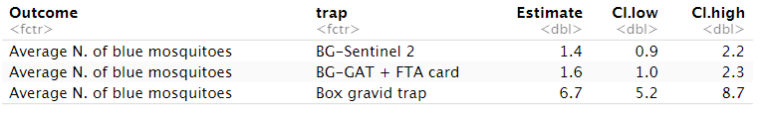

Additional file 6: Table S6. Mosquito feeding success on honey-baited FTA cards.
Number of blue mosquitoes / total
(% fed on FTA card)
 | Total | f | m
BG-Sentinel 2 | 65 / 99  (65.7%) | 51 / 72  (70.8%) | 14 / 27  (51.9%)
BG-GAT with FTA card | 74 / 89  (83.1%) | 60 / 74  (81.1%) | 14 / 15  (93.3%)
Box Gravid Trap | 821 / 1114  (73.7%) | 585 / 790  (74.1%) | 236 / 324  (72.8%)
Overall study collation | 960 / 1302  (73.7%) | 696 / 936  (74.4%) | 264 / 366  (72.1%)
Absolute numbers and percentages of female (f) and male (m) mosquitoes and their sum are recorded for each trap type and in the overall study. Chi-square test of independence revealed that there was no significant difference in sugar feeding rates between female and male mosquitoes (χ²=0.56, df=1, n=1302, P=0.45).

