Additional file 5: Figure S1. Subcellular location of phosphorylated proteins.

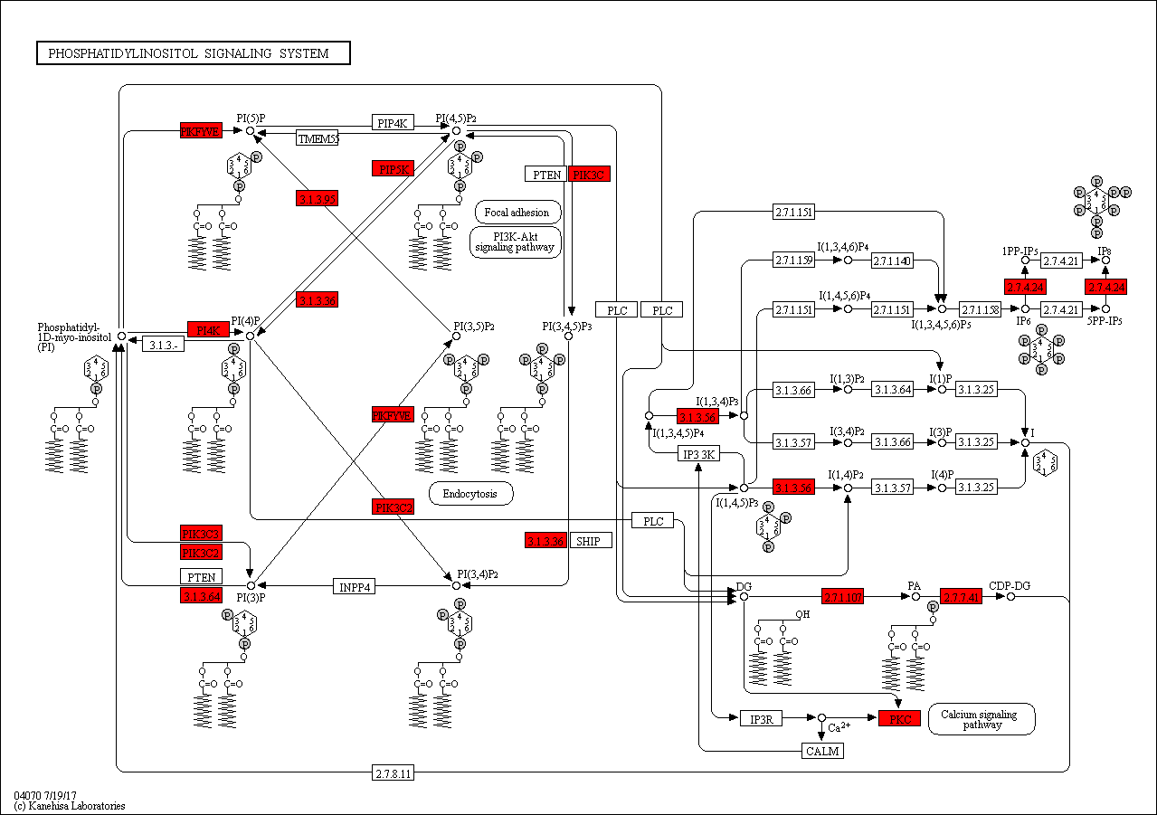

Additional file 5: Figure S2. Phosphatidylinositol signaling system (Environmental Information Processing; Signal transduction).

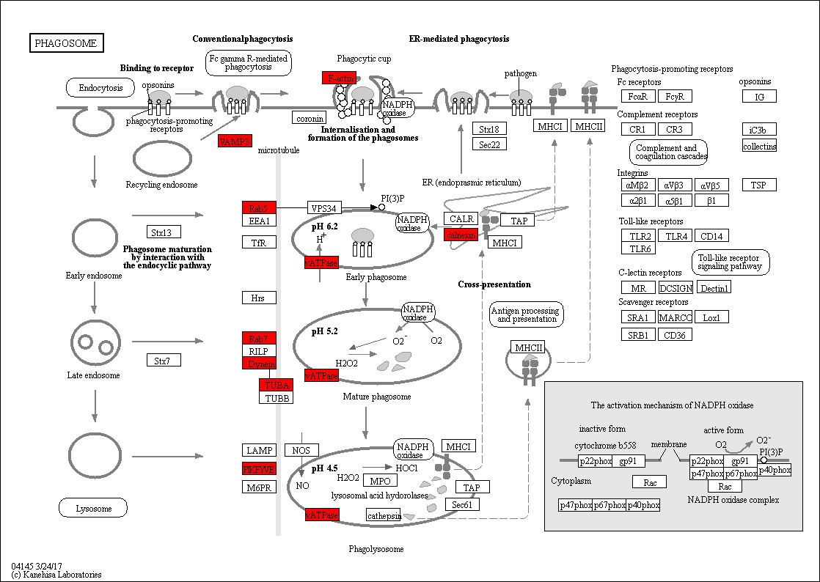

Additional file 5: Figure S3. Phagosome (Cellular Processes; Transport and catabolism).

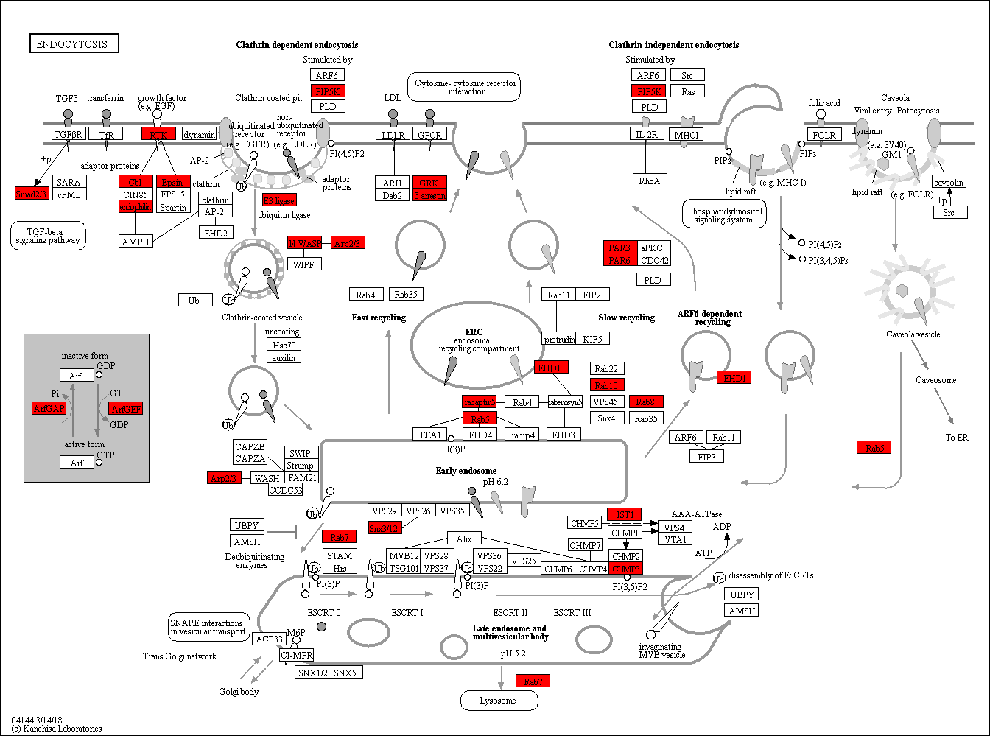

Additional file 5: Figure S4. Endocytosis (Cellular Processes; Transport and catabolism).

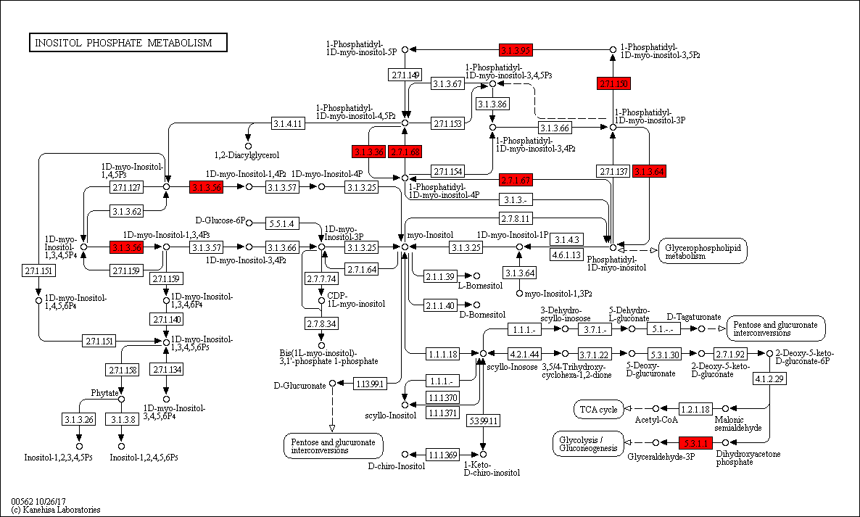

Additional file 5: Figure S5. Inositol phosphate metabolism (Carbohydrate metabolism).

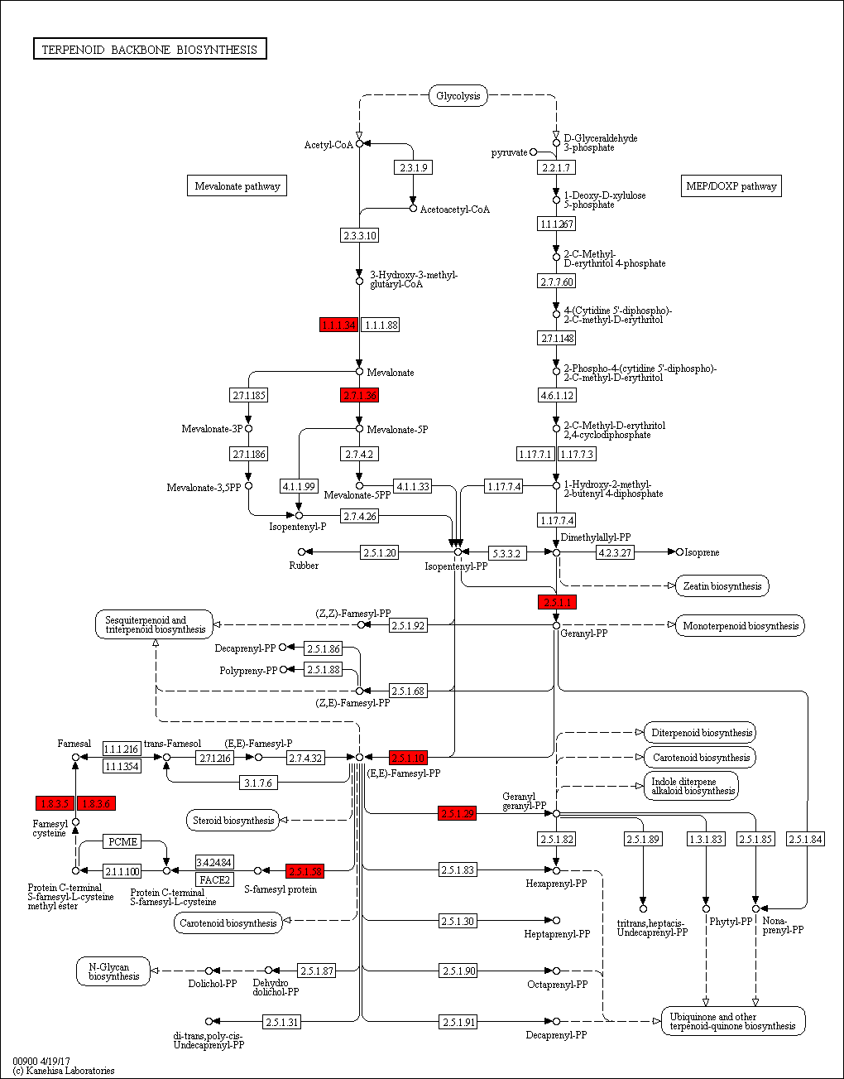

Additional file 5: Figure S6. Terpenoid backbone biosynthesis (Metabolism of terpenoids and polyketides).

