Additional file 2: Figure S1. Secondary structure prediction analysis of non-coding regions (NCR) in the mitochondrial genome of Hoplolaimus columbus by FORNA

NCR1
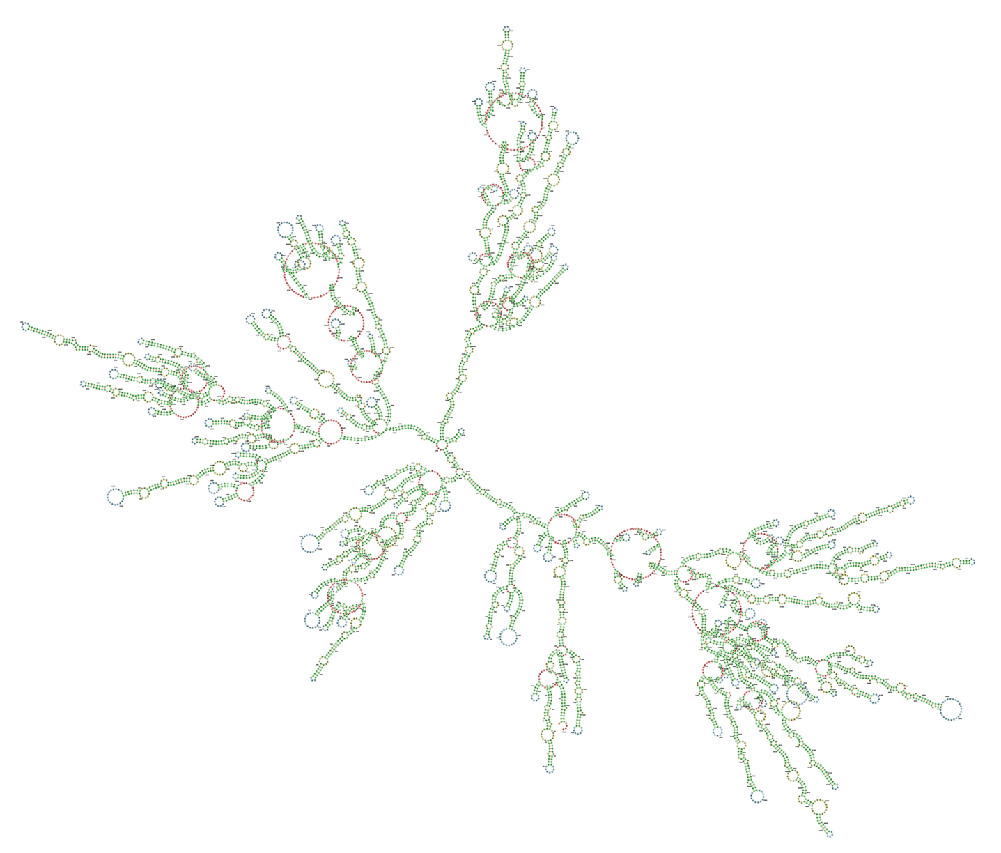

NCR2
