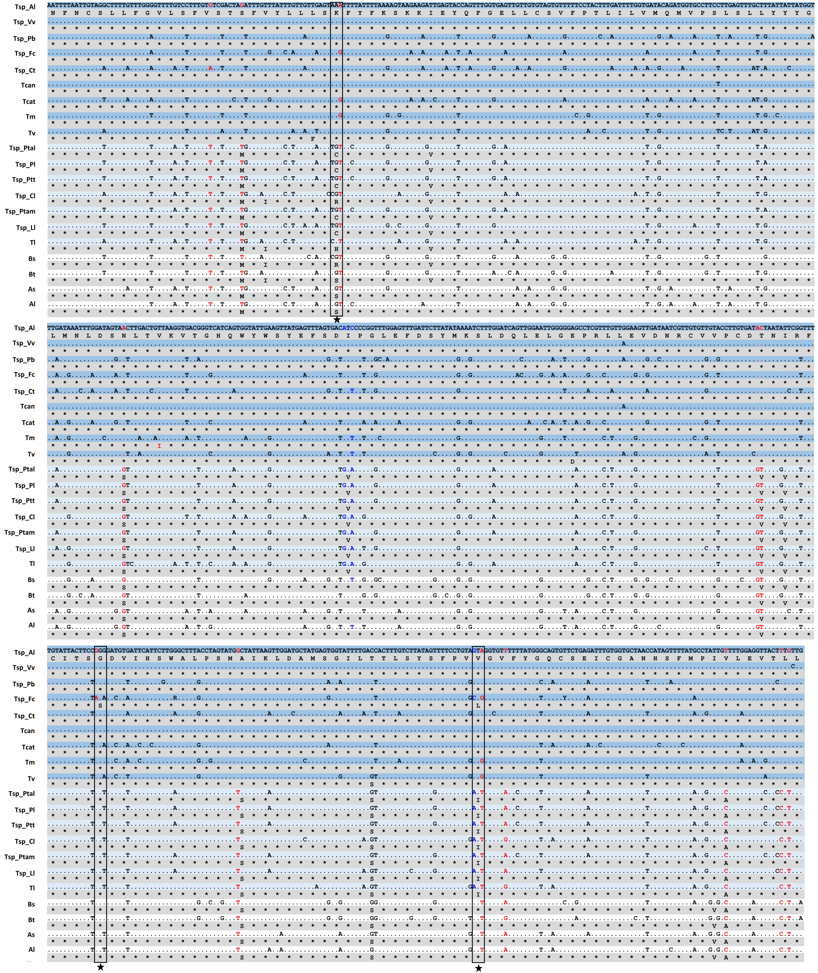
Additional file 2: Figure S1. A simultaneous alignment of nucleotide and amino acid sequences of partial mitochondrial cox1 genes of 11 representative isolates of Toxocara/Toxascaris identified in this study and other related ascaridoid species. Building on the alignment of nucleotide sequences, the corresponding amino acid sequences inferred according to the Invertebrate Mitochondrial Code were added and aligned. Regions of identity in either nucleotide (.) or amino-acid (*) are indicated. The variable base loci unique for Toxocara spp. are highlighted in red and for Toxascaris spp. highlighted in blue. Further, these variable base loci unique for Toxocara/Toxascaris are subjected to detection of the non-synonymous substitutions, and a total of 3 amino-acid changes: K/R/S (Va/Arg/Ser)→C(Ilu), G(Gly)→S(Ser) and V/I(Val/Ilu)→L(Leu) are observed and targeted with a black star. Species abbreviations and GenBank accession numbers (in parentheses) are indicated as follows: Tsp_Al, Toxocara/Toxascaris sp. from A. lagopus (MK318032); Tsp_Vv, Toxocara/Toxascaris sp. from V. vulpes (MK318034); Tsp_Pb, Toxocara/Toxascaris sp. from P. bengalensis (JF792244); Tsp_Fc, Toxocara/Toxascaris sp. from F. chaus (MK318031); Tsp_Ct, Toxocara/Toxascaris sp. from C. temmincki (MK318007); Tsp_Ptal, Toxocara/Toxascaris sp. from P. tigris altaica (MK317996); Tsp_Pl, Toxocara/Toxascaris sp. from P. leo (MK318011); Tsp_Ptt, Toxocara/Toxascaris sp. from P. tigris tigris (MK318001); Tsp_Cl, Toxocara/Toxascaris sp. from Canis lupus (JF792247); Tsp_Ptam, Toxocara/Toxascaris sp. from P. tigris amoyensis (MK318025); Tsp_Ll, Toxocara/Toxascaris sp. from L. lynx (MK318009); T. canis (JN593098); T. cati (NC_010773); T. malaysiensis (AM412316); T. vitulorum (FJ664617); T. leonina (NC_023504); Baylisascaris schroederi (HQ671081); B. transfuga (NC_015924); Ascaris suum (NC_001327); and A. lumbricoides (JN801161).

