Additional file 1

Table S1. Information on the global panel of Ae. aegypti populations included in this study
Region | Country/Area | Population | ID ª | Samples | Latitude | Longitude | Year
Africa | Guinea-Bissau (GW) | Bijagos | 1 | 30 / 0 ^{b} | 11.250 | -16.083 | 2009
Africa | Senegal (SN) | Ngari | 2 | 16 / 0 | 14.744 | -17.512 | 2012
Africa | Senegal (SN) | Dakar | 3 | 30 / 0 | 14.694 | -17.444 | 2005
Africa | Senegal (SN) | N'goye | 4 | 30 / 0 | 14.642 | -16.435 | 2007
Africa | Senegal (SN) | Sedhiou | 5 | 30 / 9 | 12.707 | -15.555 | 2012
Africa | Senegal (SN) | Koungheul | 6 | 30 / 0 | 13.980 | -14.802 | 2006
Africa | Senegal (SN) | Goudiry | 7 | 30 / 9 | 14.184 | -12.717 | 2012
Africa | Senegal (SN) | Kedougou | 8 | 30 / 0 | 12.561 | -12.175 | 2006
Africa | Cameroon (CM) | Yaounde Mokolo | 9 | 0 / 5 | 3.873 | 11.501 | 2015
Africa |  | Yaounde MvogAda | 10 | 0 / 7 | 3.863 | 11.526 | 2015
Africa |  | Yaounde Center | 11 | 30 / 8 | 3.867 | 11.517 | 2014
Africa |  | Yaounde Forest | 12 | 0 / 7 | 3.876 | 11.376 | 2015
Africa |  | Yaounde Village | 13 | 0 / 8 | 3.861 | 11.394 | 2015
Africa |  | Buffalo camp | 14 | 0 / 8 | 8.371 | 13.866 | 2014
Africa | Gabon (GA) | La Lopé forest | 15 | 0 / 11 | -0.379 | 11.527 | 2014
Africa |  | La Lopé village | 16 | 0 / 9 | -0.379 | 11.527 | 2014
Africa |  | La Lopé forest  2016 | 17 | 30 / 11 | -0.176 | 11.607 | 2016
Africa |  | La Lopé village 2016 | 18 | 30 / 8 | -0.106 | 11.607 | 2016
Africa |  | Franceville | 19 | 30 / 12 | -1.633 | 13.583 | 2014
Africa | Angola (AO) | Luanda | 20 | 28 / 8 | -9.767 | 14.267 | 2016
Africa | South Africa (ZA) | Johannesburg | 21 | 18 / 7 | -25.990 | 27.901 | 2015
Africa | Uganda (UG) | Kichwamba | 22 | 30 / 0 | -0.221 | 30.098 | 2009
Africa |  | Bundibugyo | 23 | 30 / 0 | 0.708 | 30.064 | 2009
Africa |  | Zika village | 24 | 0 / 10 | 0.127 | 32.531 | 2016
Africa |  | Lunyo | 25 | 30 / 7 | 0.072 | 32.463 | 2013
Africa | Kenya (KE) | Kakamega | 26 | 8 / 0 | 0.283 | 34.752 | 2012
Africa |  | Kisumu | 27 | 30 / 5 | -0.092 | 34.768 | 2012
Africa |  | Nairobi | 28 | 30 / 7 | -1.290 | 36.818 | 2012
Africa |  | Garissa | 29 | 19 / 0 | -0.453 | 39.646 | 2012
Africa |  | Mombasa | 30 | 30 / 0 | -4.044 | 39.668 | 2012
Africa |  | Kaya Forest | 31 | 0 / 10 | -3.932 | 39.596 | 2012
Africa |  | Rabai-out | 32 | 30 / 0 | -3.932 | 39.596 | 2009
Africa |  | Rabai-in | 33 | 30 / 9 | -4.049 | 39.671 | 2012
Africa |  | Rabai forest  2017 | 34 | 30 / 11 | -3.930 | 39.596 | 2017
Africa |  | Rabai peridomestic 2017 | 35 | 22 / 12 | -3.929 | 39.571 | 2017
Africa |  | Rabai domestic 2017 | 36 | 30 / 18 | -3.929 | 39.571 | 2017
America | United States (USA) | Miami | 37 | 20 / 0 | 25.762 | -80.192 | 2011
America | Dominica (DM) | Dominica | 38 | 20 / 9 | 15.592 | -61.411 | 2009
America | Costa Rica (CR) | Siquirres | 39 | 20 / 5 | 9.938 | -84.095 | 2014
America | Colombia (CO) | Cali | 40 | 30 / 7 | 3.439 | -76.516 | 2013
America | Brazil (BR) | Maraba | 41 | 30 / 0 | -5.374 | -49.130 | 2010
America |  | Macapà | 42 | 0 / 12 | 0.035 | -51.071 | \ ^{c}
America | Mexico (ME) | Chetumal lab | 43 | 0 / 8 | \ ^{c} | \ ^{c} | 2005
Asia-Europe-Pacific | Georgia (GE) | Georgia | 44 | 0 / 5 | 41.961 | 43.362 | 2015
Asia-Europe-Pacific | Portugal (PO) | Madeira | 45 | 20 / 0 | 32.761 | -16.960 | 2012
Asia-Europe-Pacific | Vietnam (VT) | Ho Chi Minh City | 46 | 20 / 12 | 10.803 | 106.695 | 2013
Asia-Europe-Pacific | Philippines (PH) | Philippines | 47 | 20 / 7 | 10.283 | 123.947 | 2013
Asia-Europe-Pacific | Australia (AU) | Cairns | 48 | 0 / 7 | -16.817 | 145.686 | 2013
Asia-Europe-Pacific |  | Townsville | 49 | 20 / 0 | -19.259 | 146.817 | 2009
Asia-Europe-Pacific | French Polynesia (FP) | Tahiti | 50 | 20 / 11 | -17.531 | -149.558 | 2010
ª Population indexes
^{b} Number of samples in the microsatellite data / number of samples in the SNP data
^{c} Information is not available.

Table S2. Allelic richness, private allelic richness, expected heterozygosity (He) and observed heterozygosity (Ho) of La Lopé and Rabai samples grouped by habitats or sampling sites.
Group | Allelic richness ª | Private alleles ª | He (microsatellite) | Ho (microsatellite) | He (SNP) | Ho (SNP)
La Lopé forest | 6.73 | 1.57 | 0.693 | 0.622 | 0.273 | 0.245
La Lopé village | 5.87 | 0.71 | 0.651 | 0.644 | 0.264 | 0.246
Rabai forest | 7.76 | 0.99 | 0.732 | 0.656 | 0.229 | 0.203
Rabai peridomestic | 8 | 0.95 | 0.697 | 0.644 | 0.239 | 0.208
Rabai domestic | 7.79 | 1.29 | 0.704 | 0.608 | 0.244 | 0.216
Kaya Bomu forest |  |  |  |  | 0.229 | 0.203
Chang’ombe |  |  |  |  | 0.236 | 0.212
Mbarekani |  |  |  |  | 0.240 | 0.214
Bengo |  |  |  |  | 0.242 | 0.209
Kwa Bendegwa |  |  |  |  | 0.242 | 0.217
ª Average values of the 12 microsatellite loci, estimated in HPRARE with rarefaction to the minimum sample size (44 genes)

Table S3. Pairwise F_{st} of La Lopé and Rabai samples grouped by habitats or sampling sites.
Group 1 | Group 2 | F_{st} (microsatellite) | F_{st} (SNP)
La Lopé forest | La Lopé village | 0.0336* | 0.0086
Rabai forest | Rabai peridomestic | 0.0068 | 0.0042
Rabai forest | Rabai domestic | 0.0066* | 0.0079
Rabai peridomestic | Rabai domestic | 0.0100* | -0.0004
Kaya Bomu Forest | Chang’ombe |  | 0.0031
Kaya Bomu Forest | Mbarekani |  | 0.0058
Kaya Bomu Forest | Bengo |  | 0.0114
Kaya Bomu Forest | Kwa Bendegwa |  | 0.0198
Chang’ombe | Mbarekani |  | 0.0002
Chang’ombe | Bengo |  | 0.0038
Chang’ombe | Kwa Bendegwa |  | 0.0119
Mbarekani | Bengo |  | -0.0031
Mbarekani | Kwa Bendegwa |  | 0.0095
Bengo | Kwa Bendegwa |  | 0.0076
* F_{st} values that are statistically significant determined by genepop.

Table S4. Annotated genes in the region of the Fst peak in La Lopé populations
Gene ID | Gene name | Gene description | Gene start (bp) | Gene  end (bp)
AAEL003867 |  |  | 84985916 | 84998389
AAEL003891 |  | Ctl transporter | 85012958 | 85036685
AAEL003901 |  |  | 85043660 | 85088513
AAEL003887 |  | Vacuolar membrane protein pep11 | 85091046 | 85100508
AAEL003874 |  |  | 85116735 | 85135667
AAEL003872 | Tctp | Translationally controlled tumor protein homolog (TCTP) | 85147401 | 85160385
AAEL003873 |  | Glycerol-3-phosphate dehydrogenase | 85191823 | 85266305
AAEL003875 |  | transcription factor SP4, putative | 85282197 | 85302730
AAEL025841 |  |  | 85323409 | 85324281
AAEL003899 |  | Sugar transporter | 85352740 | 85370365
AAEL003894 | GNBPB5 | Gram-Negative Binding Protein (GNBP) or Beta-1 3-Glucan Binding Protein (BGBP). | 85381249 | 85389978
AAEL003889 | GNBPB1 | Gram-Negative Binding Protein (GNBP) or Beta-1 3-Glucan Binding Protein (BGBP). | 85412482 | 85421308
AAEL003890 |  | Cytochrome P450 | 85683648 | 85685698
AAEL019766 |  |  | 86037281 | 86791700
AAEL014372 |  | Juvenile hormone-inducible protein, putative | 86733087 | 86734639
AAEL021562 |  |  | 86931875 | 87006061
Source: vectorbase.org
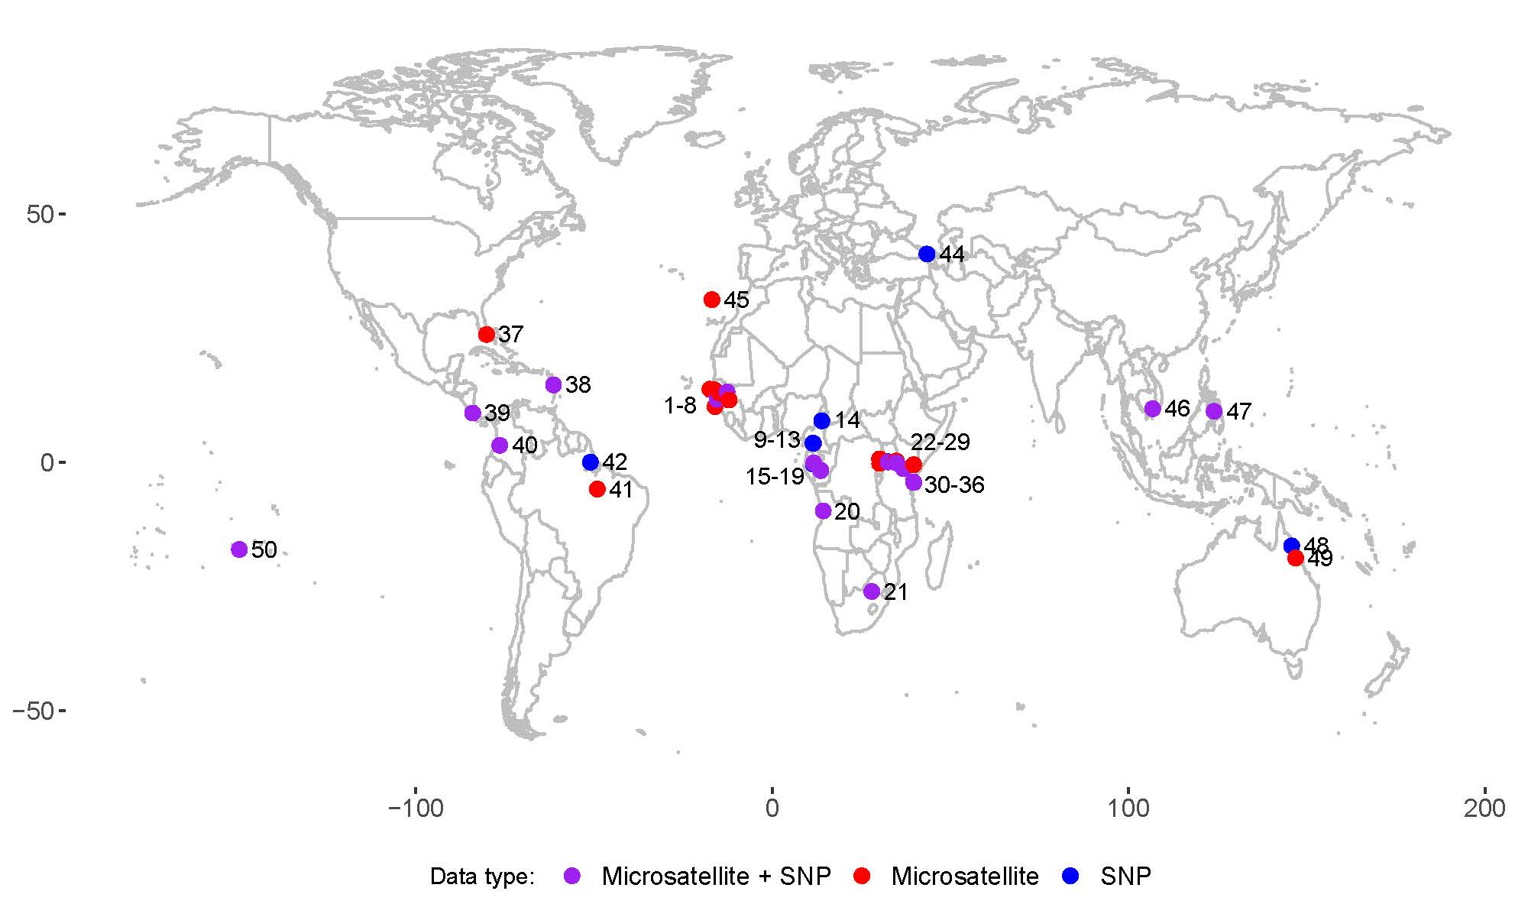
Figure S1. Geographic locations of the global panel of Ae. aegypti populations included in this study. The number that labels each population corresponds to the population index in Table S1 (column “ID”). The color of each point represents the availability of microsatellite and SNP data for that population.

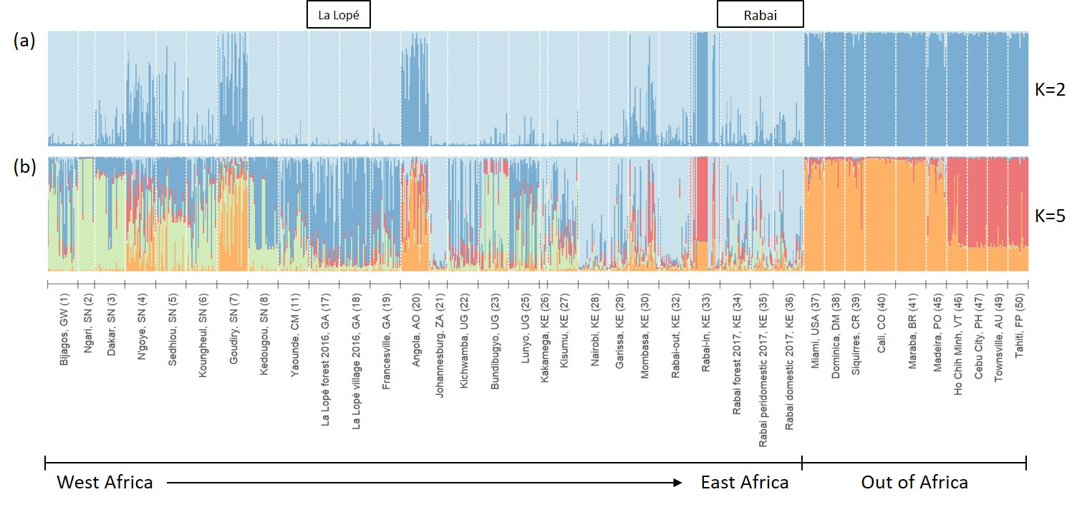
Figure S2. Genetic ancestry of the La Lopé and Rabai populations with a reference panel of global populations of Ae. aegypti, estimated using the 12 microsatellite loci in STRUCTURE with K=2 (a) and K=5 (b). Each bar represents one individual. Different colors represent different genetic clusters, and the proportion of a color indicates the probability of an individual assigned to that genetic cluster. The reference panel was selected from Gloria-Soria et al. 2016. Population names with country abbreviations and regions are listed on the x-axis. The numbers in the parentheses correspond to the population index in Table S1 (column “ID”) as well as the numbers in Figure S1. La Lopé and Rabai samples collected in 2016 and 2017 are indicated by the box on top of the figure.

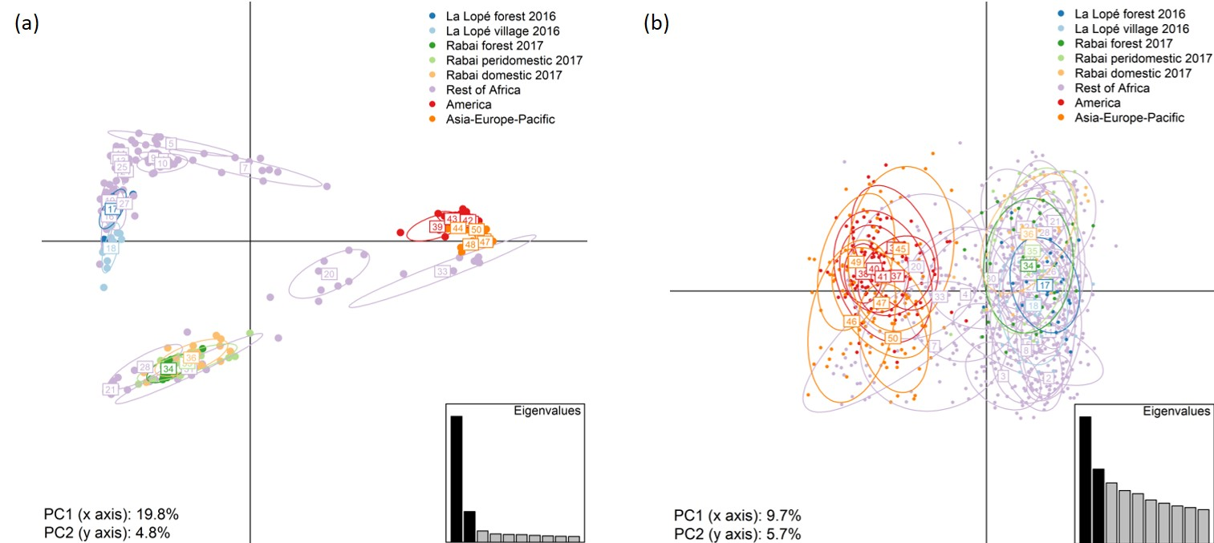
Figure S3. PCA of the La Lopé and Rabai populations with the global panel of populations using (a) 23,767 SNPs and (b) 12 microsatellite loci. The first two principal components (PCs) were shown with the percentage of total genetic variation explained by them labeled at the bottom left of each panel. The color of the points represents the regions of samples (Table S1) with the La Lopé 2016 and Rabai 2017 collections labeled by different colors. Eclipses were drawn for each population with a 67% probability. Populations were labeled by their indexes (Table S1, column ID), which also match the numbers in Figure S1. The inset at the bottom right of each panel shows the eigenvalues of the top 10 PCs with the first two PCs marked in black. The PCA was performed in the R package adegenet.

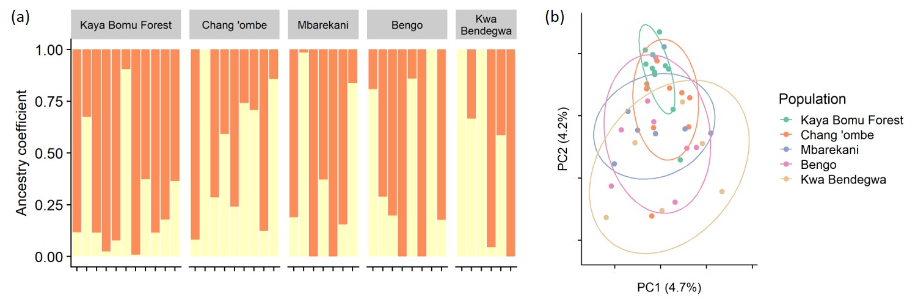
Figure S4. Genetic structure of the Rabai mosquito samples grouped by sampling sites generated using 23,068 SNP loci. (a) Results of the LEA analysis with K=2. The sampling sites are labeled on top of each bar plot. (b) PCA biplots by LEA showing the first two principal components (PCs). The numbers in the parentheses on the axes indicate the percentage of total variation explained by the PCs. Eclipses were drawn with an 80% confidence level.

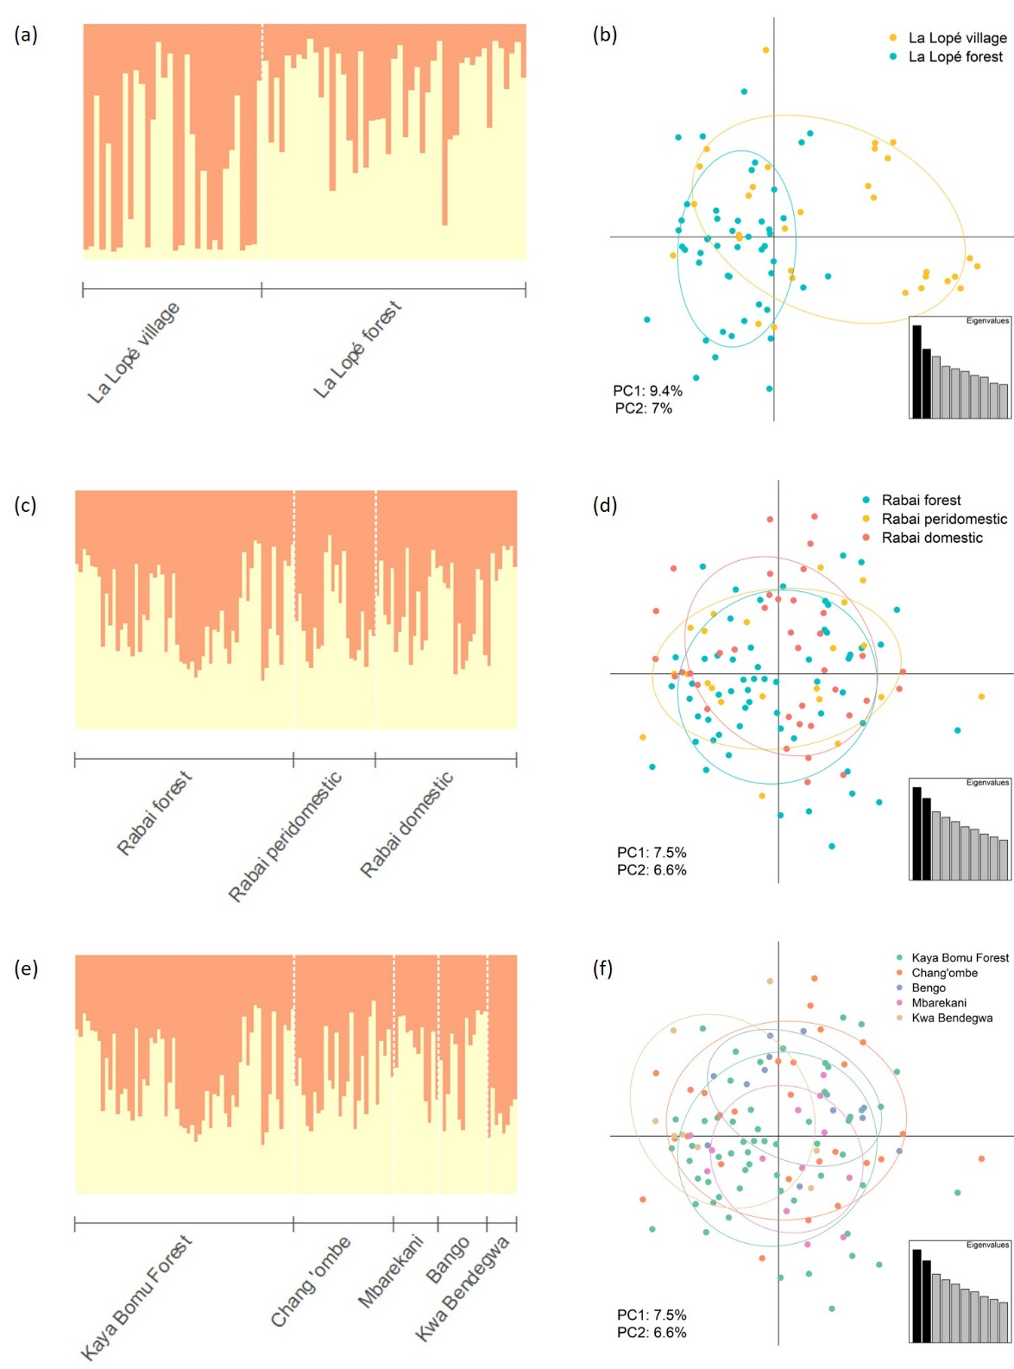
Figure S5. Genetic structure of the La Lopé (a, b) and Rabai (c-f) mosquitoes grouped by sampling sites or habitats, generated using the 12 microsatellite loci. (a, c, e) Results of STRUCTURE analysis with K=2. The groups are labeled on the bottom of each bar plot. (b, d, f) PCA biplots by adegenet showing the first two principal components (PCs). Eclipses were drawn with a 67% probability of inclusion. The inset in each biplot shows the eigenvalues of the top 10 PCs with the first two PCs marked in black. The percentage of total variance explained by each of the two PCs is labeled at the bottom left.

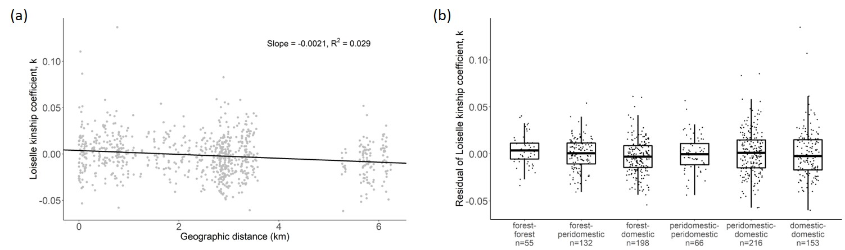
Figure S6. Individual pairwise kinship coefficients of mosquito samples from Rabai. Each point represents one mosquito pair. (a) Correlation between geographic distance and kinship coefficients. The linear regression is used to remove this distance effect is represented by the line, with the slope and R² values labeled. (b) Residuals of the kinship coefficients in Rabai after removing distance effects categorized by habitats, with the number of pairs labeled on the x-axis. The boxplots show the median (the horizontal bar), interquartile range (IQR, the box), and 1.5 x IQR above and below the IQR (the vertical bar). ANOVA did not find significant difference between categories (F = 1.337, bootstrap p = 0.211).
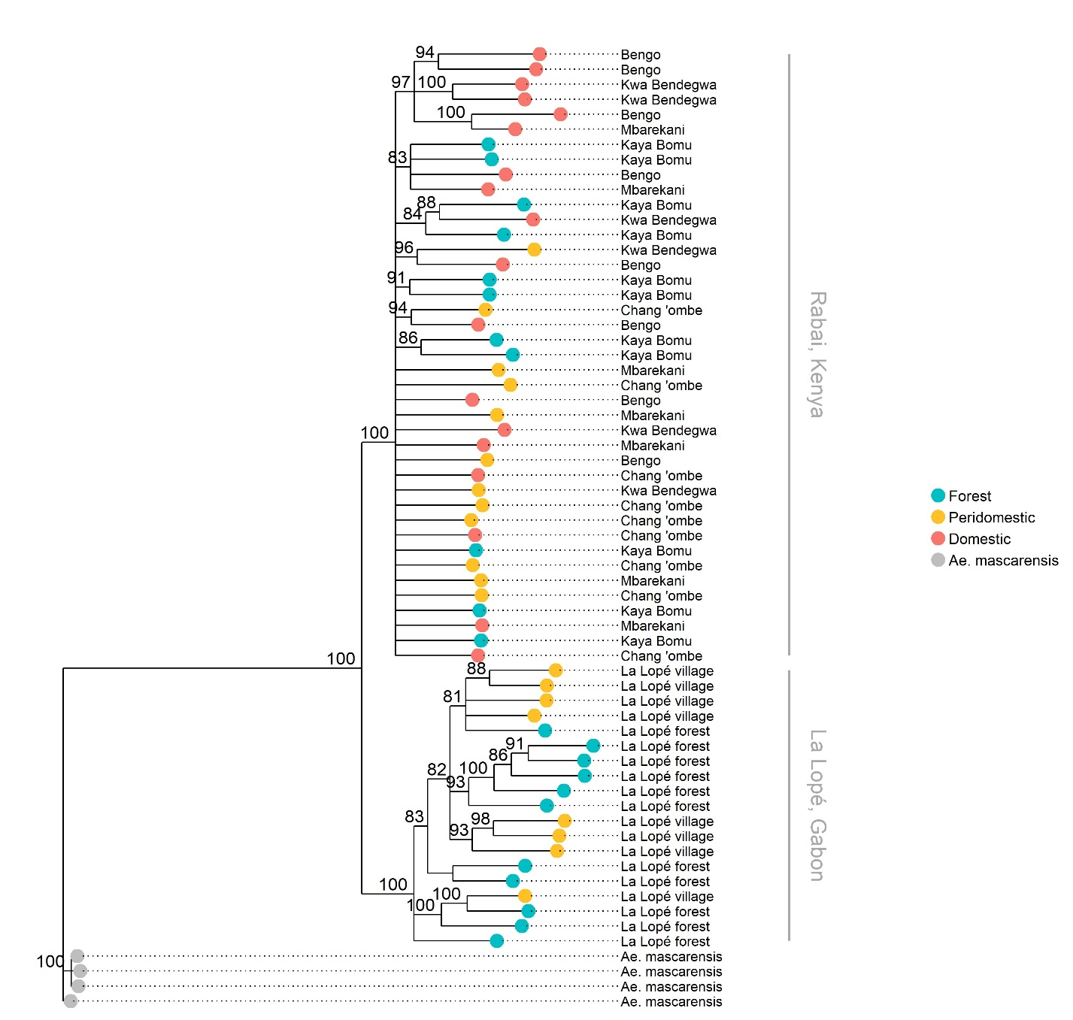
Figure S7. Phylogeny of the La Lopé and Rabai mosquitoes generated in IQTree with 22,287 SNP loci. Four Ae. mascarensis samples were used as the outgroup. The number on each node indicates the support level estimated by 1000 ultrafast bootstraps and nodes with support values smaller than 80 are collapsed. The colors of the tips represent the habitats, and the labels indicate the sampling sites.

