Additional file 1
Figure S1 ¹H NMR spectrum (400 MHz) of (A) MeOH in methanol-d₄ and KH₄PO₄ solution in D₂O; pH 6; (B) EtOAc in CDCl₃ and (C) CH₂Cl₂ in CDCl₃. The signals at δ 1.60 and δ 2.30 ppm are characteristics of β-CH₂ and α-CH₂ of saturated fatty acids. Signals of unsaturated fats acids at δ 2.07 and δ 5.35 ppm. The aromatic compounds appeared between δ 7.0 and 8.0 ppm.
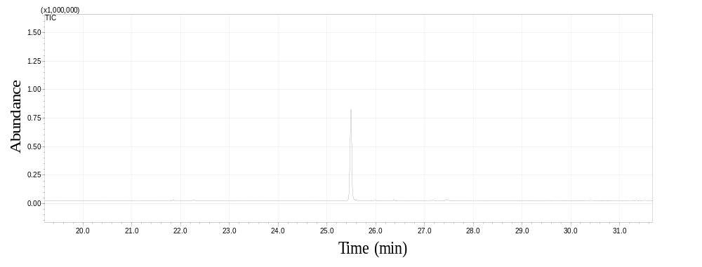
Figure S2 Chromatogram of the F5 which was obtained by gas chromatography coupled to mass spectrometry. The main substance, identified as ketamine, was ionized by electron impact at 70 eV.
Coding name sub-fraction | Substances
F1 | Nonanoic acid, 9-oxo-methyl ester; Palmitic acid methyl ester; Oleic acid methyl ester; Stearic acid methyl ester
F2 | Nonanoic acid, 9-oxo-methyl ester; Palmitic acid methyl ester; Oleic acid methyl ester; Stearic acid methyl ester; cis-Vaccenic acid
F7 | Benzeneacetic acid; 2,5-Dihydroxyphenylacetic acid; 1,9-Decadiyne; Benzeneacetic acid, 10-undecenyl ester; Palmitic acid
F8 | Linolelaidic acid, methyl ester; Palmitic acid
F9 | Palmitic acid; Oleic acid methyl ester; cis-vaccenic acid
Table S1 Substances present in the ethyl acetate sub-fractions identified by GC/MS.

Table S2 ¹H and ¹³C NMR spectral data and ¹H-¹H COSY; ¹H-¹³C HSQC and ¹H-¹³C HMBC of F5 and its correlations to structure ketamine.
Position | δ ¹Hª | δ ¹³C^{b} | COSY | HMBC
1 | - | 208.9 | - | -
2 | - | 70.6 | - | -
3 | 1.83, 2.93 | 38.4 | H-4 | C-2, C-4,C-5, C-1’
4 | 1.74 | 21.8 | H-3, H-5 | C-5
5 | 1.86, 2.04 | 28.7 | H-6 | C-4
6 | 2.52 | 39.8 | H-5 | C-1
1’ | - | 135.6 | - | -
2’ | - | 134.0 | - | -
3’ | 7.38 | 131.4 | H-4’ | C-5’
4’ | 7.29 | 129.4 | H-3’, H-5’ | C-2’, C-6’
5’ | 7.35 | 127.0 | H-6’ | C-1’, C-3’
6’ | 7.60 | 129.8 | H-5’ | C-4’, C-2’
NCH₃ | 2.14 | 28.8 | - | C-2
a ¹H determined from HSQC experiment.
b ¹³C determined from HSQC and HMBC experiments.

Figure S3 Key HMBC and ¹H–¹H COSY correlations of ketamine.

Figure S4 The ¹H–¹H COSY spectrum of F5 in CDCl₃ at 400 MHz.
Figure S54 The ¹H-¹³C HSQC spectrum of F5 in CDCl₃ at 400 and 100 MHz.

Figure S6 The ¹H-¹³C HMBC spectrum of F5 in CDCl₃ at 400 and 100 MHz.

Figure S7 Chromatogram of EtOAcF5, obtained by UHPLC / MS monitored by ultraviolet light (A) and monitored by positive mode electrospray ionization (B). Spotlight figure spectral profiles fragments obtained in MS/MS mode positive ionization for ions m/z = 238 Da (A- EtOAc fraction and B- Ketamine reference) and m/z = 240 (C- EtOAc fraction and D- Ketamine reference). m/z = 238 Da [M + H]⁺, m/z = 240.10 Da [M + ³⁷Cl]⁺

Figure S8 Proposal of ions after fragmentation the ion m/z 238.17 Da, monitored by positive mode electrospray ionization at retention time 2.24 min.

