Spatio-temporal analysis of the main dengue vector populations in Singapore

Haoyang Sun^{1, §}, Borame Dickens¹, Daniel Richards², Janet Ong³, Jayanthi Rajarethinam³, Muhammad E. E. Hassim⁴, Jue Tao Lim¹, L Roman Carrasco⁵, Joel Aik³, Grace Yap³, Alex R Cook^{1, §}, Lee Ching Ng^{3, 6}

¹ Saw Swee Hock School of Public Health, National University of Singapore and National University Health System, Singapore
² Natural Capital Singapore, Singapore-ETH Centre, ETH Zurich, Singapore
³ Environmental Health Institute, National Environment Agency, Singapore, Singapore
⁴ Centre for Climate Research Singapore, Meteorological Service Singapore, National Environment Agency, Singapore, Singapore
⁵ Department of Biological Sciences, National University of Singapore, Singapore
⁶ School of Biological Sciences, Nanyang Technological University, Singapore, Singapore

§ Correspondence to:

Haoyang Sun. Saw Swee Hock School of Public Health, National University of Singapore, 12 Science Drive 2, Singapore 117549, Republic of Singapore. Email: ephsunh@nus.edu.sg.

Alex R Cook. Saw Swee Hock School of Public Health, National University of Singapore, 12 Science Drive 2, Singapore 117549, Republic of Singapore. Email: ephcar@nus.edu.sg.

Supporting Information

Figure S1: Weekly mean catch per trap for Aedes aegypti (red) and Ae. albopictus (blue) at Bukit Batok Street 52, Jurong West Avenue 1, Tampines Street 21, and Yishun Avenue 9. Week 1 refers to the first epidemiological week of 2017, and week 104 the last epidemiological week of 2018. Due to the large number of sites (n=552) in our study, we picked these four sites to visualize Aedes abundance over time for demonstration purposes.

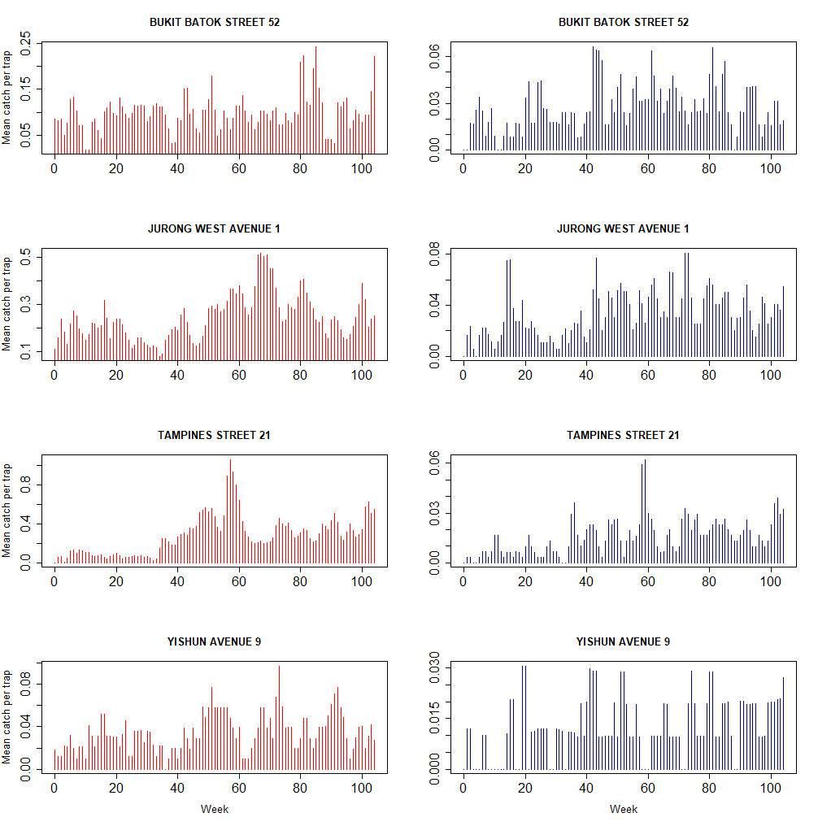

Figure S2: Visualizations of spatial variables: (a) distance to the nearest waterway (m), (b) Drain line density (km⁻¹), and (c) distance to the nearest water area (m) for each site, as well as (d) the land classification map produced by Richards & Tunçer.

Figure S3: Visualizations of weather variables. Each sub-plot shows a weather variable whose weekly value was averaged across all the sites in the study.

