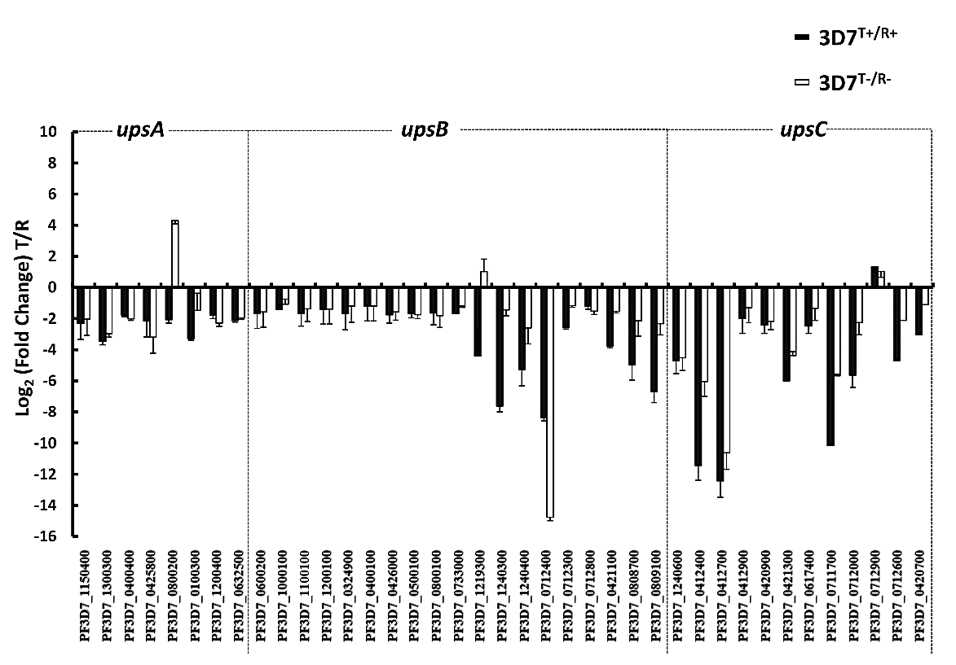

Additional file 11: Figure S7. Detection of Var gene expression pattern during a single 48-hour life-cycle in P. falciparum clone 3D7. qPCR analysis of the transcription level of individual var genes in 3D7 clone during a single 48-hour life-cycle of P. falciparum. The data are presented as log₂ fold change of trophozoite to ring within the third life-cycle, using the seryl-tRNA synthetase gene (GenBank: PF3D7_0717700) as an endogenous control. The error bars represent the mean ± SD of three independent experiments determined by qPCR. Abbreviations: R, ring; T, trophozoite; Key: +, shield1 induced; -, shield1 not induced.

