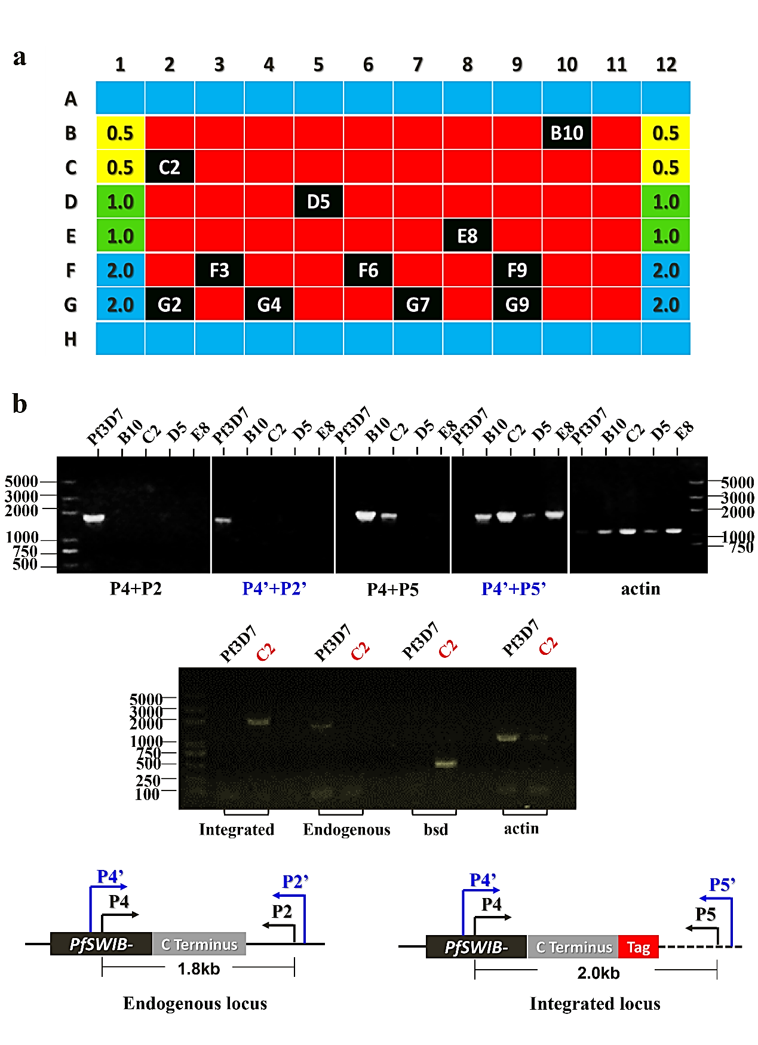

Additional file 3: Figure S1. Identification of integration events and clone screening of integrated clones. a Clone screening of integrated clones. Clone screening was performed by a serial dilution of parasites in 96-well plates. B10, C2, D5, E8, F3, F6, F9, G2, G4, G7 and G9 represent different clones at a level of 0.5, 1 and 2 parasite per well, detected by microscopy. b Identification of integration events by PCR. The integration events were detected on screened clones at a level of 0.5 and 1 parasite per well after extended the culture to 24-well plates. The description of primers P2, P4 and P5 can be found in Additional file 1: Table S1. P4 + P2 are used for detecting the endogenous PfSWIB locus, while P4 + P5 are used for detecting the integrated PfSWIB locus. P2’, P4’ and P5’ are alternative primers in respect to P2, P4 and P5, respectively.

