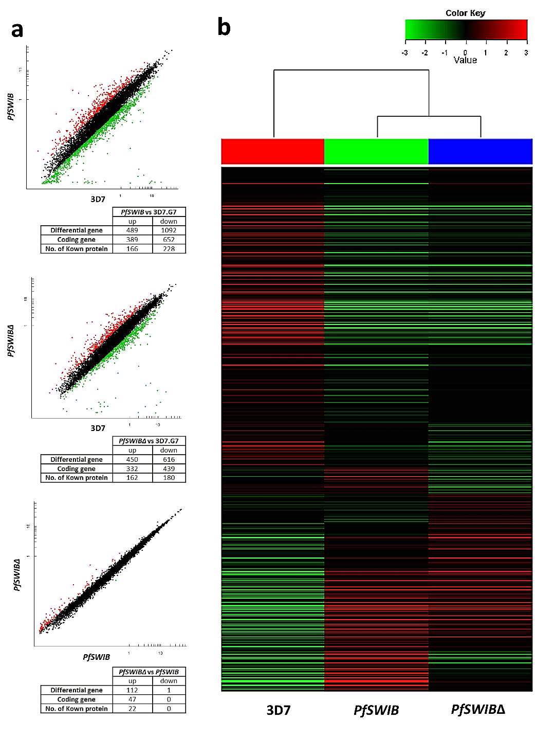

Additional file 6: Figure S3. RNA-seq analysis of expression profile in different parasite lines. a Comparison of transcriptomes of PfSWIB vs 3D7, PfSWIB∆ vs 3D7, and PfSWIB∆ vs PfSWIB after re-invasion in 3rd life-cycle of P. falciparum. X-axis and Y-axis are logarithmic and correspond to relative signal of hybridization to each gene shown as a dot. Red dots denote the upregulated genes (fold change ≥1.5, FDR <0.05, P <0.05), while green dots denote the downregulated genes (fold change ≤ -1.5, FDR <0.05, P <0.05). b Hierarchical clustering heatmap of log₂-transformed fragments per kilobase of transcript per million (FPKM) gene expression values for all the differentially expressed genes after re-invasion in 3rd life-cycle. The color scale ranges from green to red, showing a range from minimum (≤-0.4) to maximum (≥-0.4) log₂ FPKM gene expression values for each variant.

