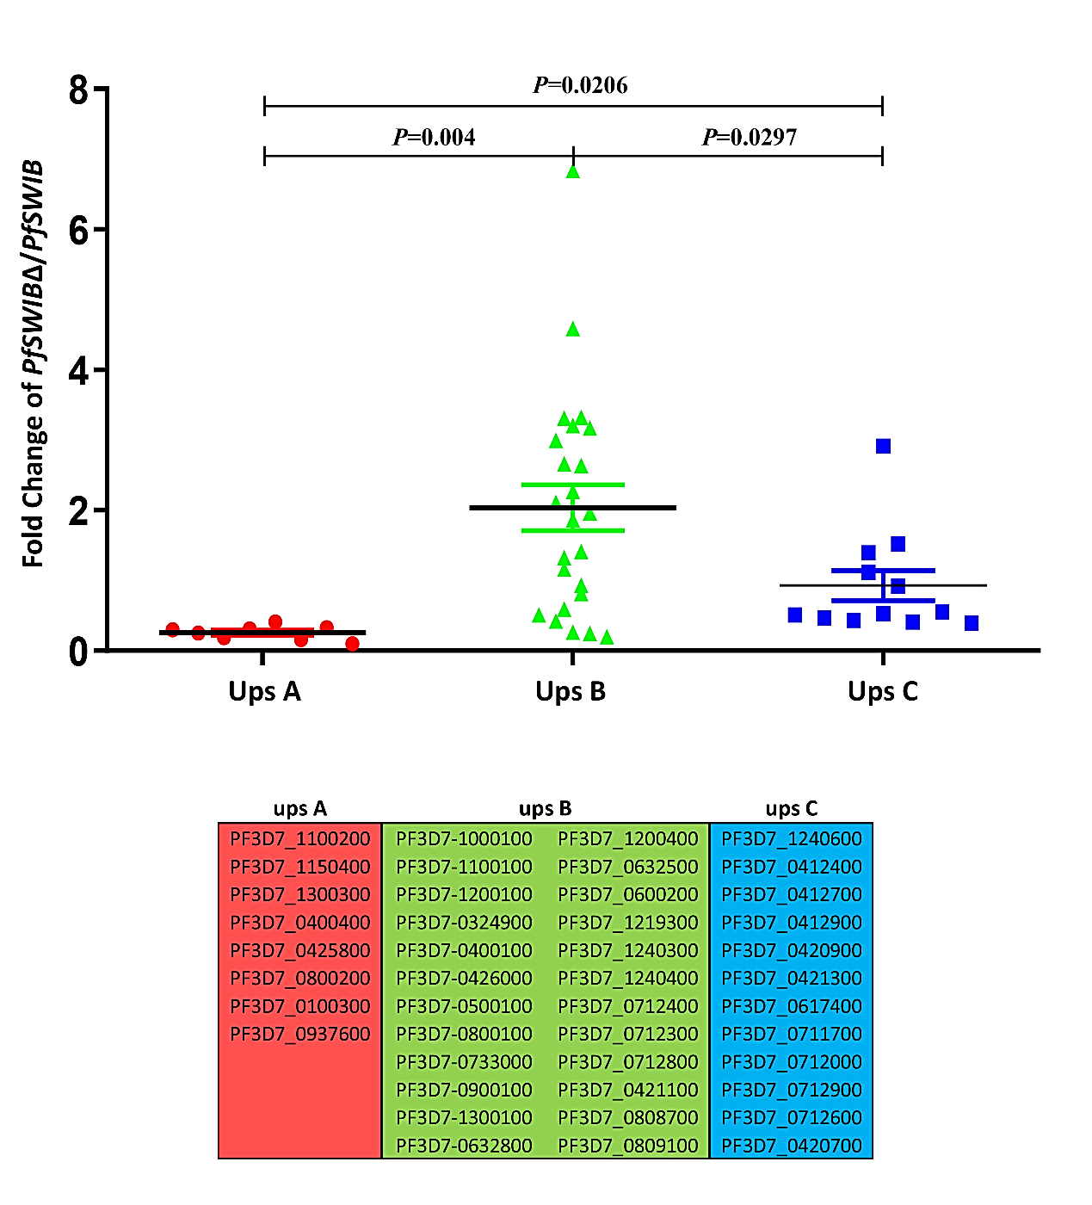

Additional file 7: Figure S4. Conditional knockdown of PfSWIB leads to a change in mutually exclusive var gene transcription. Significance and different expression levels of individual var genes are demonstrated in scatter plots (GraphPad Prism, version 5.0) in the same clone pre- and post-shield1 induction. Data are presented as fold change of var transcription level in the PfSWIB∆ line with respect to the PfSWIB line. The error bars represent the mean ± SD of three independent experiments determined by qPCR. The red, green and blue dots indicate the upsA-, upsB- and upsC-subtype vars, respectively.

