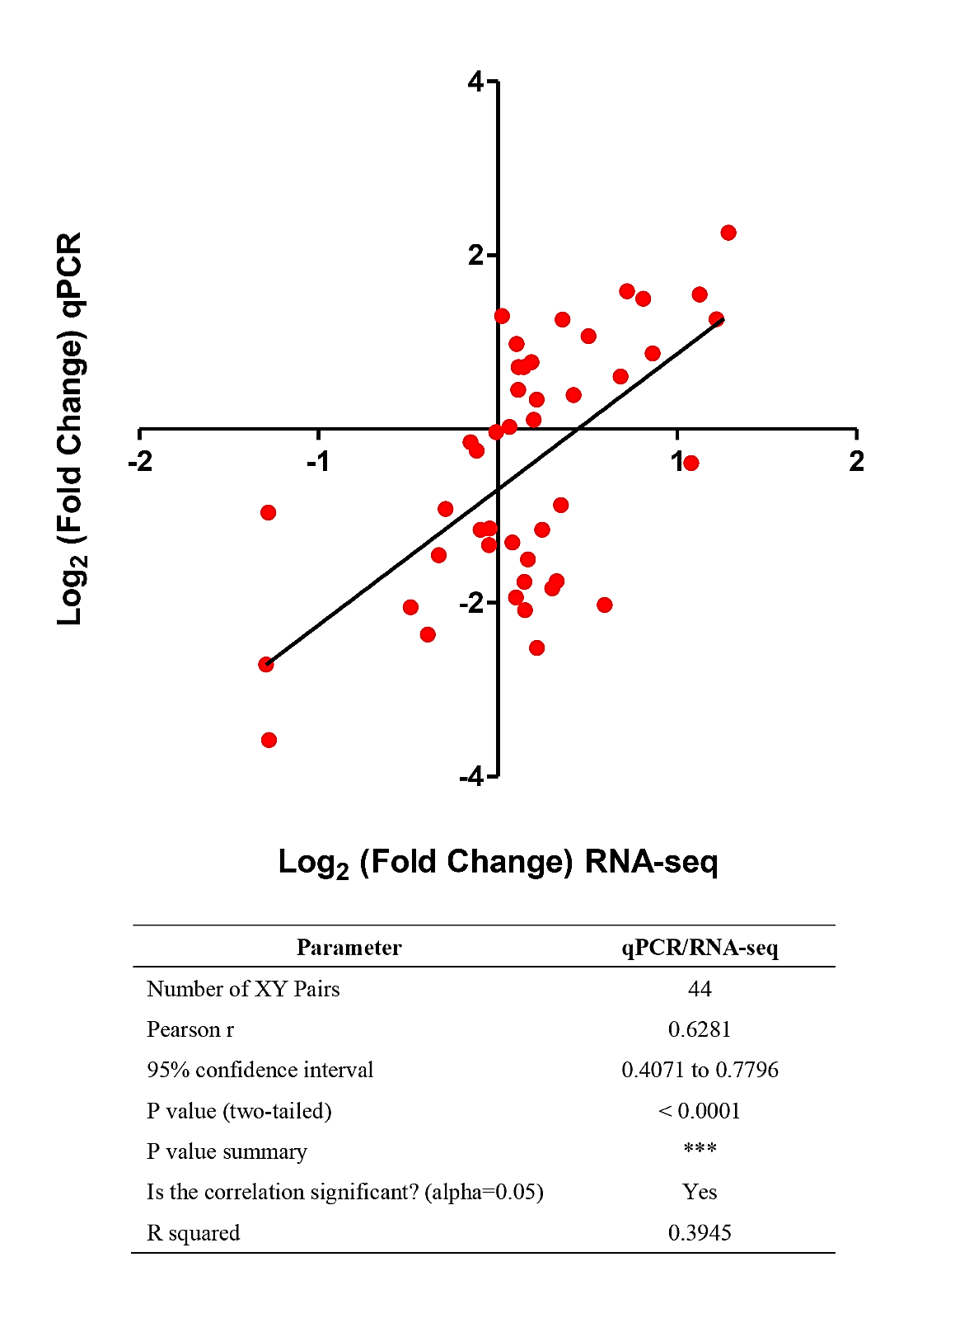

Additional file 9: Figure S6. Linear regression analysis between qPCR and RNA-seq data. Linear regression analysis of the correlation between qPCR and RNA-seq data was performed to investigate the transcriptome data accuracy on 44 var genes. Red dots denote the log₂ (fold change) of 44 vars in the PfSWIB vs PfSWIB∆ comparison. The linear regression and correlation were analyzed using GraphPad Prism® (version 5.0) and SPSS (version 16.0).

