Fig. S4 PRISMA flowchart of paper selection
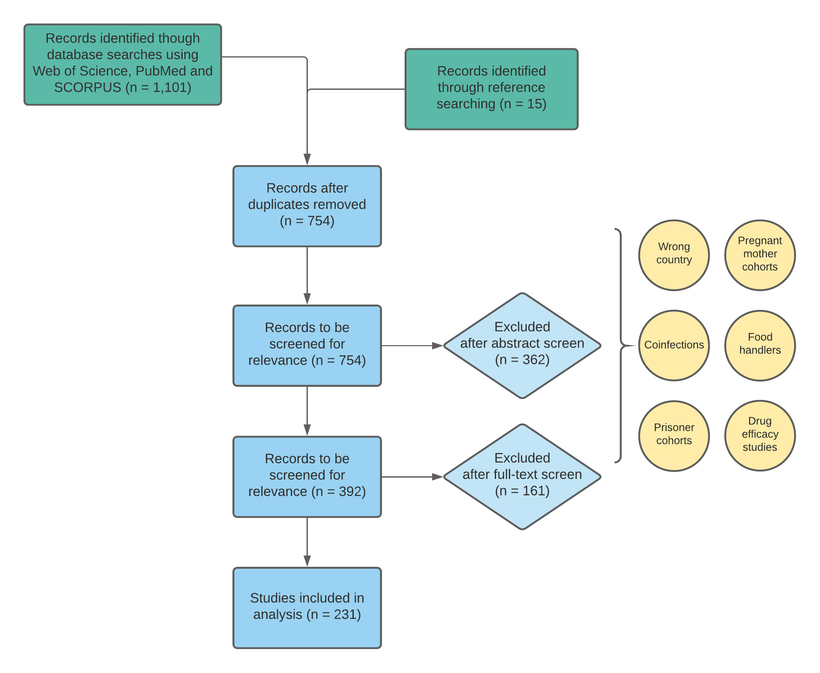
The selection flowchart undertaken for this review, following the PRISMA guidelines. Main themes of the excluded papers are shown in yellow circles. From an initial 754 records, a final 231 records were selected for analysis.

