Additional file 1
Age-group differences by clinical exam type were observed. Pups 2 to 6-months of age comprised 18.5% (n= 228,453) of the wellness exam population, and only 8.9% (n = 59,114) of the other clinical population
Table S1. Proportion of dogs tested using flotation by centrifugation and coproantigen during a wellness or other clinical veterinary visits by age category.
Visit Type | 2-6 mo | 7-12 mo | 1-2 yr | 3-5 yr | 6-8 yr | 9-13 yr | 14+ yr | Total
Wellness | 228,453 (18.5%) | 29,232 (2.4%) | 102,225 (8.3%) | 266,287 (21.5%) | 240,313 (19.4%) | 310,585 (25.1%) | 59,353 (4.8%) | 1,236,448 (64.9%)
Other Clinical  Visit | 59,114 (8.9%) | 41,320 (6.2%) | 63,810 (9.6%) | 131,433 (19.7%) | 115,794 (17.3%) | 200,067 (30%) | 55,866 (8.4%) | 667,404 (35.1%)
Total | 287,567 (15.1%) | 70,552 (3.7%) | 166,035 (8.7%) | 397,720 (20.9%) | 356,107 (18.7%) | 510,652 (26.8%) | 115,219 (6.1%) | 1,903,852

Giardia was the most common parasite identified by centrifugation with a positivity of 3.8%, followed by Hookworm (2.2%), Ascarid (1.7%), Cystoisospora (1.5%), whipworm (0.7%), and tapeworm (0.3%). Giardia and hookworm had the highest percent positive on coproantigen with 11.5% and 3.5% positive results respectively. For each intestinal parasite tested by both diagnostic methods, the proportion of positive tests was significantly higher by coproantigen than by centrifugation (Additional file 2: Table S2, Additional file 4: Table S3). The highest co-infection was ascarid and Giardia which occurred in 0.32% of all fecal tests. Additional co-infection information can be found in Additional file 5: Table S4.

Table S2. Proportion of dogs with a positive test result for an intestinal parasite by centrifugation or coproantigen and binary age group (puppy < 2 years old, adults ≥ 2 years old).

Visit Type | Age Group | Method | Cystoisospora | Eimeria | Giardia | Hookworm | Ascarid | Tapeworm | Whipworm
All | < 2 years | Centrifugation | 4.9  (4.8 - 4.9) | 2.6  (2.5 - 2.6) | 8.8  (8.8 - 8.9) | 4.2  (4.2 - 4.3) | 5.3  (5.2 - 5.3) | 0.4  (0.4 - 0.4) | 1.1  (1.1 - 1.1)
All | < 2 years | Coproantigen | --- | --- | 16.3  (16.2 - 16.4) | 6.0  (5.9 - 6.1) | 5.8  (5.7 - 5.9) | --- | 1.7  (1.7 - 1.7)
All | ≥ 2 years | Centrifugation | 0.3  (0.3 - 0.3) | 1.3  (1.3 - 1.3) | 0.7  (0.7 - 0.7) | 1.5  (1.5 - 1.5) | 0.3  (0.3 - 0.3) | 0.2  (0.2 - 0.2) | 0.6  (0.6 - 0.6)
All | ≥ 2 years | Coproantigen | --- | --- | 1.7  (1.7 - 1.8) | 2.6  (2.6 - 2.6) | 0.4  (0.3 - 0.4) | --- | 0.6  (0.6 - 0.6)
Wellness | < 2 years | Centrifugation | 5.0  (5.0 - 5.1) | 2.7  (2.6 - 2.7) | 8.6  (8.5 - 8.7) | 4.3  (4.2 - 4.4) | 5.9  (5.8 - 5.9) | 0.4  (0.4 - 0.4) | 1.0  (0.9 - 1.0)
Wellness | < 2 years | Coproantigen | --- | --- | 15.5  (15.3 - 15.6) | 6.1 (6.0 - 6.2) | 6.5  (6.4 - 6.5) | --- | 1.6  (1.5 - 1.6)
Wellness | ≥ 2 years | Centrifugation | 0.2  (0.2 - 0.2) | 1.4  (1.4 - 1.4) | 0.5  (0.5 - 0.5) | 1.3  (1.3 - 1.4) | 0.3  (0.3 - 0.3) | 0.2  (0.2 - 0.2) | 0.5  (0.5 - 0.5)
Wellness | ≥ 2 years | Coproantigen | --- | --- | 1.3  (1.2 - 1.3) | 2.5  (2.4 - 2.5) | 0.3  (0.3 - 0.3) | --- | 0.5  (0.5 - 0.6)
Other Clinical Visit | < 2 years | Centrifugation | 4.5  (4.4 - 4.6) | 2.4  (2.3 - 2.4) | 9.4  (9.2 - 9.5) | 4.0  (3.9 - 4.1) | 4.0  (3.9 - 4.1) | 0.5  (0.5 - 0.5) | 1.5  (1.4 - 1.5)
Other Clinical Visit | < 2 years | Coproantigen | --- | --- | 18.1  (17.9 - 18.3) | 5.8  (5.6 - 5.9) | 4.3  (4.2 - 4.4) | --- | 2.0  (1.9 - 2.0)
Other Clinical Visit | ≥ 2 years | Centrifugation | 0.4  (0.4 - 0.4) | 1.2  (1.1 - 1.2) | 0.9  (0.9 - 1.0) | 1.7  (1.7 - 1.8) | 0.4  (0.3 - 0.4) | 0.3  (0.2 - 0.3) | 0.7  (0.7 - 0.7)
Other Clinical Visit | ≥ 2 years | Coproantigen | --- | --- | 2.6  (2.5 - 2.6) | 2.9  (2.9 - 2.9) | 0.4  (0.4 - 0.4) | --- | 0.8  (0.8 - 0.8)

Table S3. Proportion of dogs with a positive test result for an intestinal parasite by centrifugation or coproantigen.
Parasite |  | Centrifugation  % (95% CI) |  | Coproantigen  % (95% CI)
Giardia |  | 3.8 (3.8 - 3.9) |  | 11.5 (11.4 -11.5)
Hookworm |  | 2.2 (2.2 - 2.3) |  | 3.5 (3.5 - 3.6)
Ascarid |  | 1.7 (1.7 - 1.7) |  | 1.9 (1.8 - 1.9)
Eimeria |  | 1.7 (1.6 – 1.7) |  | ---
Cystoisospora |  | 1.5 (1.5 - 1.6) |  | ---
Whipworm |  | 0.7 (0.7 - 0.7) |  | 0.9 (0.9 - 0.9)
Tapeworm |  | 0.3 (0.3 - 0.3) |  | ---

Table S4. Combined co-infection rate by either centrifugation or coproantigen.
Species | Percentage
4 Coinfections
Hookworm/Ascarid/Whipworm/Giardia | 0.01%
3 Coinfections
Hookworm/Ascarid/Giardia | 0.06%
Hookworm/Ascarid/Whipworm | 0.02%
Hookworm/Whipworm/Giardia | 0.03%
Ascarid/Whipworm/Giardia | 0.02%
2 Coinfections
Hookworm/Giardia | 0.26%
Hookworm/Ascarid | 0.13%
Hookworm/Whipworm | 0.11%
Ascarid/Giardia | 0.32%
Ascarid/Whipworm | 0.03%
Whipworm/Giardia | 0.07%

Of the fecal samples that tested positive for ascarids by either method, 16.3% were positive by centrifugation alone, 24.6% were positive by coproantigen alone, and the remaining 59.1% were positive by both methods. For Giardia, the positivity by centrifugation alone was 15.6%, 57.2% by coproantigen alone, and 27.2% by both. For hookworm, the contribution by centrifugation alone was 14.0%, 45.8% by coproantigen alone, and 40.2% by both. For whipworm, the contribution by centrifugation alone was 21.9%, 38.0% by coproantigen alone, and 40.0% by both. Numbers of positive tests by each method are detailed in Additional File 6 Table S5.

Table S5. Number of positive test results by parasite and method.
Parasite | Positives  Either  Method |  | Positives  Both  Methods |  | Positives Centri-  fugation |  | Positives Copro-  antigen |  | Centri-  fugation Only |  | Antigen  Only
Giardia | 110504 |  | 35,256 |  | 36521 |  | 109239 |  | 1,265 |  | 73,983
Hookworm | 78,528 |  | 31,585 |  | 42,555 |  | 67,558 |  | 10,970 |  | 35,973
Ascarid | 42,200 |  | 24,935 |  | 31,822 |  | 35,313 |  | 6,887 |  | 10,378
Whipworm | 22,464 |  | 8,991 |  | 13,919 |  | 17,536 |  | 4,928 |  | 8,545

When pooled together, pups aged two to six-months were observed to have the highest proportion positive by either centrifugation or coproantigen (Additional file 3: Figure S1). Samples from two to six-month-old pups were found to have the highest proportion of positive test results for both centrifugation and coproantigen compared to samples from other age categories in Giardia, Cystoisospora, and ascarids (Additional file 6: Table S5, Additional file 7: Figure S2). Both centrifugation and coproantigen in hookworm and whipworms, had the highest proportion positive in seven to twelve-month old pups (Additional file 7: Figure S2, Additional file 9: Table S6).

Figure S1. Proportion of dogs with a positive test result for any intestinal parasite by either centrifugation or coproantigen by age category. Parasites included: Giardia, hookworm, ascarid, whipworm, Eimeria, Cystoisospora, and tapeworm.

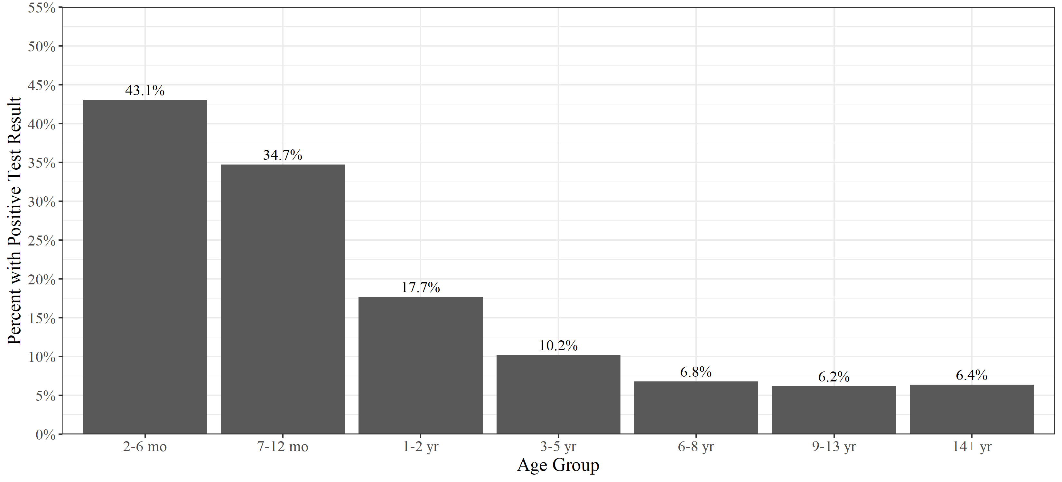

Figure S2. Proportion of dogs with positive test results for intestinal parasite by centrifugation and coproantigen by age category.

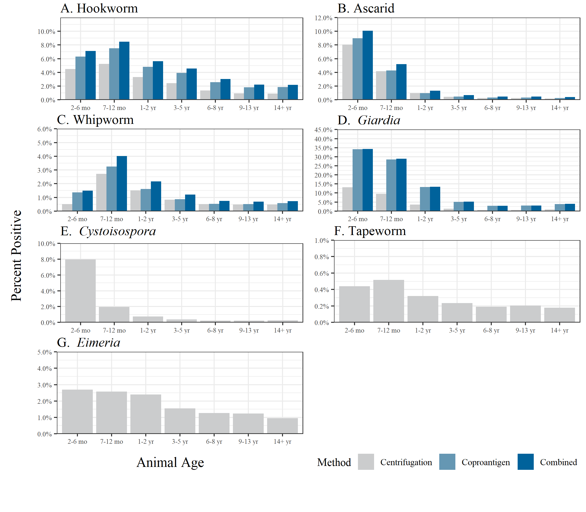

Table S6. Proportion of dogs with positive test results for intestinal parasite by centrifugation and coproantigen by age category.
Parasite | Method | 2-6 mo  (95% CI) | 7-12 mo  (95% CI) | 1-2 yr  (95% CI) | 3-5 yr  (95% CI) | 6-8 yr  (95% CI) | 9-13 yr  (95% CI) | 14+ yr  (95% CI)
Giardia | Centrifugation | 12.3  (12.2 - 12.5) | 8.5  (8.3 - 8.7) | 2.9  (2.8 - 2.9) | 1.0  (0.9 - 1.0) | 0.5  (0.5 - 0.5) | 0.5  (0.5 - 0.6) | 0.8  (0.7 - 0.8)
Giardia | Coproantigen | 21.4  (21.2 - 21.5) | 17.9  (17.6 - 18.2) | 6.8  (6.7 - 6.9) | 2.5  (2.4 - 2.5) | 1.3  (1.3 - 1.4) | 1.4  (1.4 - 1.4) | 1.9  (1.8 - 1.9)
Hookworm | Centrifugation | 4.5  (4.4 - 4.5) | 5.2  (5.1 - 5.4) | 3.3  (3.2 - 3.4) | 2.4  (2.4 - 2.5) | 1.4  (1.3 - 1.4) | 0.9  (0.9 - 1.0) | 0.9  (0.9 - 1.0)
Hookworm | Coproantigen | 6.3  (6.2 - 6.4) | 7.5  (7.3 - 7.7) | 4.8  (4.7 - 4.9) | 3.9  (3.9 - 4.0) | 2.6  (2.5 - 2.6) | 1.8  (1.8 - 1.9) | 1.9  (1.8 - 1.9)
Ascarid | Centrifugation | 8.0  (7.9 - 8.1) | 4.2  (4.0 - 4.3) | 1.0  (0.9 - 1.0) | 0.4  (0.4 - 0.5) | 0.3  (0.2 - 0.3) | 0.3  (0.2 - 0.3) | 0.2  (0.2 - 0.2)
Ascarid | Coproantigen | 9.0  (8.9 - 9.1) | 4.3  (4.1 - 4.4) | 1.0  (0.9 - 1.0) | 0.5  (0.5 - 0.5) | 0.3  (0.3 - 0.3) | 0.3  (0.3 - 0.3) | 0.3  (0.2 - 0.3)
Eimeria | Centrifugation | 2.7  (2.6 - 2.8) | 2.6  (2.5 - 2.7) | 2.4  (2.3 - 2.5) | 1.6  (1.5 - 1.6) | 1.3  (1.2 - 1.3) | 1.2  (1.2 - 1.3) | 1.0  (0.9 - 1)
Cystoisospora | Centrifugation | 7.9  (7.9 - 8.0) | 2.0  (1.9 - 2.1) | 0.8  (0.7 - 0.8) | 0.4  (0.4 - 0.4) | 0.2  (0.2 - 0.2) | 0.2  (0.2 - 0.2) | 0.2  (0.2 - 0.3)
Whipworm | Centrifugation | 0.5  (0.5 - 0.5) | 2.7  (2.6 - 2.8) | 1.5  (1.4 - 1.6) | 0.8  (0.8 - 0.9) | 0.5  (0.5 - 0.5) | 0.5  (0.5 - 0.5) | 0.5  (0.4 - 0.5)
Whipworm | Coproantigen | 1.4  (1.3 - 1.4) | 3.3  (3.1 - 3.4) | 1.6  (1.5 - 1.7) | 0.9  (0.8 - 0.9) | 0.5  (0.5 - 0.6) | 0.5  (0.5 - 0.5) | 0.6  (0.5 - 0.6)
Tapeworm | Centrifugation | 0.4  (0.4 - 0.5) | 0.5  (0.5 - 0.6) | 0.3  (0.3 - 0.3) | 0.2  (0.2 - 0.3) | 0.2  (0.2 - 0.2) | 0.2  (0.2 - 0.2) | 0.2  (0.2 - 0.2)

