Additional file 2: Figure S1.
N-terminal signal peptide prediction. The amino acid sequences of Fg-CaBP4 (GenBank: JN604670.1) was used to predict N-terminal signal peptides by SignalP 4.1 Server.
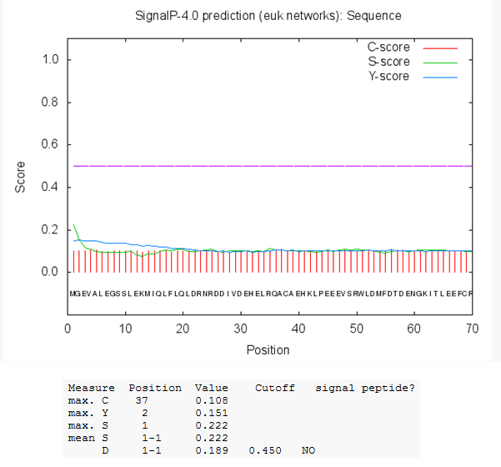

Additional file 2: Figure S2.
Fg-CaBP4 (GenBank: JN604670.1) was used to identify N-Glycosylation sites. The consecutive amino acids in the sequence for Asn-Xaa-Ser/Thr are highlighted in blue. Asparagines predicted to be N-glycosylated are highlighted in red. Proteins without signal peptides are unlikely to be exposed to the N-glycosylation machinery and thus may not be glycosylated, even though they contain potential motifs.

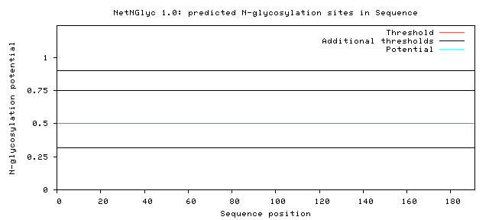
Additional file 2: Figure S3.
Transmembrane domains prediction using TMHMM Server v.2.0. The amino acid sequences of Fg-CaBP4 (GenBank: JN604670.1) was analysed to predict transmembrane domain in structure. There were no transmembrane domains predicted in this protein structure.
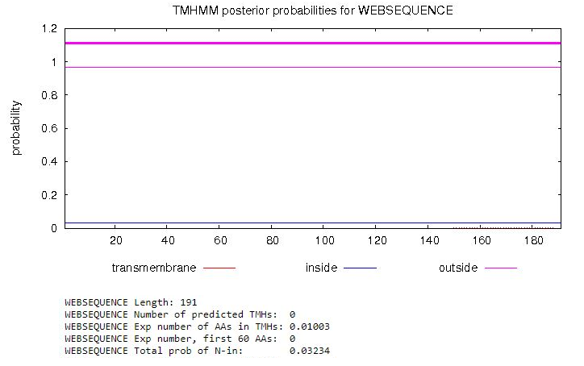

Additional file 2: Figure S4.
Prediction of B-cell epitopes for Fg-CaBP4. Protein sequence (GenBank: JN604670.1) was utilized for B-cell epitopes prediction using Bepipred Linear Epitope Prediction 2.0, that revealed 7 peptides of B cell epitopes.
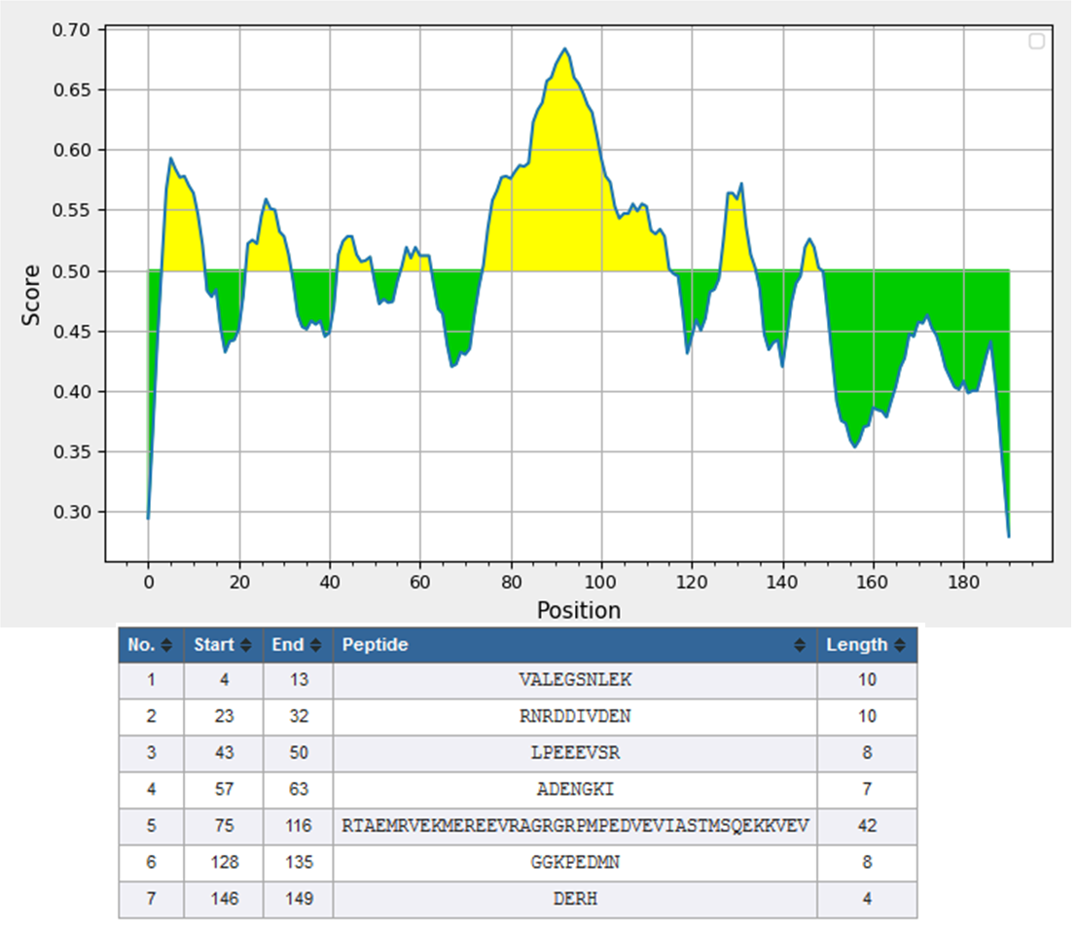

Additional file 2: Figure S5.
Protein sequence of Fg-CaBP4 (GenBank: JN604670.1) was utilized for prediction of T-cell motifs. The results showed that 12 potential T-Cell epitopes were found in the target sequence as shown below.

