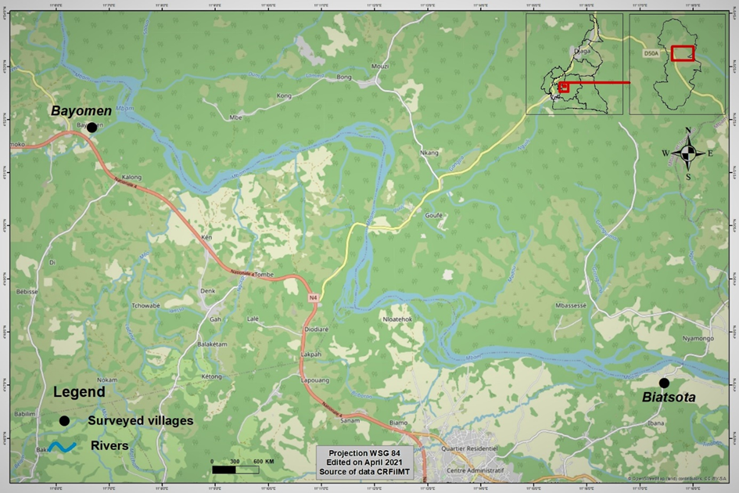
Figure 1: Map of the Bafia Health District showing surveyed communities

