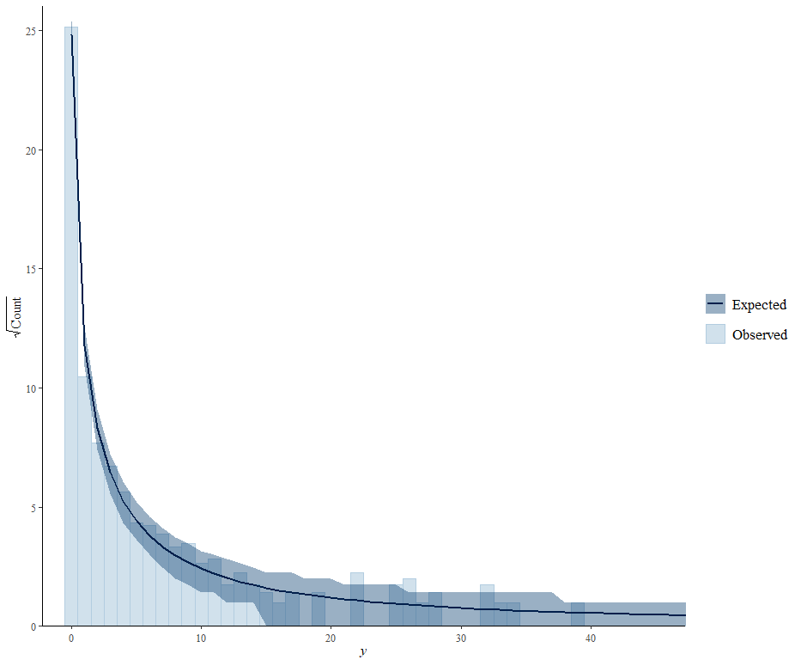Figure S1. Rootogram showing performance of the model in the presence of zeroes in the dataset. The line and shaded area represent model predictions and 95% credible intervals. The histogram bars represent the actual data.

