Supplementary Tables and Figures

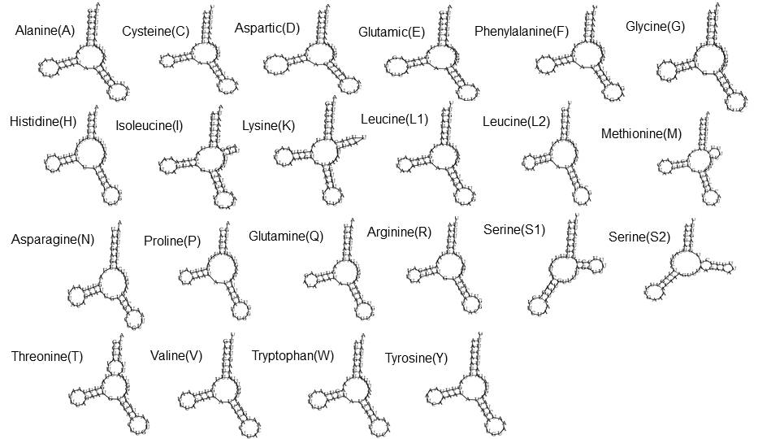
Supplementary Figure S1. Predicted secondary structure of tRNA genes in the Ancylostoma sp. mt genome.

Supplementary Table S1. Retrieved 18S rRNAs in species of Strongylida and Ascaridida from GenBank.
Family | Species | Size (bp) | Accession number
Ancylostomatidae | Necator americanus | 1,737 | AJ920348.1
Ancylostomatidae | Ancylostoma caninum | 1,737 | AJ920347.2
Ancylostomatidae | Ancylostoma duodenale | 1,622 | EU344798.1
Ancylostomatidae | Ancylostoma sp. | 1,681 | MZ681936.1
Trichostrongylidae | Ostertagia ostertagi | 1,738 | AJ920352.1
Trichostrongylidae | Ostertagia leptospicularis | 1,738 | AJ920351.1
Metastrongylidae | Metastronylus elongatus | 1,738 | AJ920363.2
Metastrongylidae | Metastrongylus salmi | 1,687 | AY295809.1
Angiostrongylidae | Angiostrongylus cantonensis | 1,691 | AY295804.1
Angiostrongylidae | Angiostrongylus costaricensis  Angiostrongylus vasorum | 1,759  1,738 | DQ116748.1  AJ920365.1
Dictyocaulidae | Dictyocaulus filaria | 1,783 | AJ920362.1
Dictyocaulidae | Dictyocaulus viviparus | 1,763 | AJ920361.1
Toxocaridae | Toxocara cati | 1,798 | EF180059.1
Toxocaridae | Toxocara canis | 1,754 | U94382.1

Supplementary Table S2. The mt genome from order of Strongylida
Family | Species | Size (bp) | Accession number
Ancylostomatidae | Ancylostoma duodenale | 13,721 | AJ417718.1
Ancylostomatidae | Ancylostoma duodenale | 13,710 | AP017676.1
Ancylostomatidae | Ancylostoma tubaeforme | 13,730 | KY070315.1
Ancylostomatidae | Ancylostoma caninum | 13,702 | AP017673.1
Ancylostomatidae | Ancylostoma caninum | 13,717 | FJ483518.1
Ancylostomatidae | Ancylostoma ceylanicum | 13,655 | AP017674.1
Ancylostomatidae | Ancylostoma ceylanicum | 13,660 | KY640299.1
Ancylostomatidae | Necator americanus | 13,606 | AJ556134.1
Ancylostomatidae | Bunostomum phlebotomum | 13,790 | FJ483517.1
Ancylostomatidae | Bunostomum phlebotomum | 13,803 | KF011546.1
Ancylostomatidae | Bunostomum trigonocephalum | 13,764 | JQ234674.1
Ancylostomatidae | Bunostomum trigonocephalum | 13,771 | KF255998.1
Ancylostomatidae | Ancylostoma sp. | 13,757 | MZ665481.1
Chabertiidae | Chabertia erschowi | 13,705 | KF660603.1
Chabertiidae | Chabertia ovina | 13,682 | GQ888721.1
Chabertiidae | Oesophagostomum dentatum | 13,751 | AP017691.1
Chabertiidae | Oesophagostomum quadrispinulatum | 13,681 | FM161883.1

Supplementary Table S3. Nucleotide composition (%) of protein coding genes (PCGs), entire mt genome, and skew value of Ancylostoma sp.
Gene | A | G | C | T | A+T (%) | G+C (%) | AT skew | GC skew
cox1 | 22 | 22 | 10 | 46 | 68 | 32 | -0.32 | 0.36
cox2 | 26 | 20 | 8 | 46 | 72 | 28 | -0.24 | 0.42
nad3 | 24 | 18 | 2 | 56 | 80 | 20 | -0.38 | 0.78
nad5 | 26 | 18 | 6 | 50 | 76 | 24 | -0.29 | 0.48
nad6 | 25 | 18 | 4 | 53 | 78 | 22 | -0.36 | 0.61
nad4L | 25 | 16 | 3 | 56 | 81 | 19 | -0.35 | 0.65
nad1 | 24 | 18 | 8 | 50 | 74 | 26 | -0.32 | 0.36
atp6 | 27 | 17 | 6 | 50 | 77 | 23 | -0.29 | 0.44
nad2 | 25 | 15 | 5 | 55 | 80 | 20 | -0.34 | 0.48
cob | 25 | 17 | 8 | 50 | 75 | 25 | -0.31 | 0.33
cox3 | 23 | 20 | 9 | 48 | 71 | 29 | -0.33 | 0.38
nad4 | 25 | 15 | 7 | 53 | 78 | 22 | -0.35 | 0.35
LNCR | 38 | 11 | 7 | 44 | 82 | 18 | -0.06 | 0.20
SNCR | 36 | 19 | 3 | 42 | 78 | 22 | -0.04 | 0.67
AT-Rich | 46 | 6 | 4 | 44 | 90 | 10 | 0.00 | 0.21
Cmtg | 27 | 17 | 7 | 49 | 76 | 24 | -0.26 | 0.41
EPCG | 25 | 18 | 7 | 50 | 75 | 25 | -0.32 | 0.42
EtRNA | 36 | 14 | 6 | 44 | 80 | 20 | -0.08 | 0.36
ErRNA | 35 | 15 | 6 | 44 | 79 | 21 | -0.11 | 0.40
ENCR | 41 | 10 | 4 | 45 | 86 | 14 | -0.02 | 0.40
Cmtg: Complete mitochondrial genome, E: entire (PCG, tRNA, rRNA, NCR)

