Quantity | Unit | Description | Unit price ($) | Total USD
1 | Item | Substructure foundation and platform
175m | m | Excavation and concrete base layer | 5.19 | 908.25
175m/2 | m/2 | Building foundation walls with 6" concrete block | 12.98 | 2,272.00
4 | Rolls | Steel reinforcement (roll = 22m x 4m) | 160.00 | 640.00
151 | Tonne | compacted soil and hardcore stones | 20.00 | 3,020.00
22.5 | m/3 | Concrete slab 225m/2 x 100 mm | 121.00 | 2,725.00
225 | m/2 | concrete floor scread 5 cm thick | 5.17 | 1,168.00
150 | meter | water proof concrete ant channel | 9.69 | 1,454.00
40 | piece | Iron brackets for mounting roof pillars | 13.00 | 520.00
1 | Item | Roof construction
120 | piece | Treated timber for pillars 6"x2" x 6m | 13.85 | 1,662.00
90 | piece | Treated timbers for roof trusses 4" x 2" x 6m | 10.39 | 935.00
92 | piece | Treated timbers for roof trusses 3" x 2" x 6m | 7.78 | 716.00
250 | meter | Heat reflecting foil | 9.52 | 2,379.00
270 | m/2 | Corrugated Iron sheets | 9.73 | 2,628.00
1 | Item | Iron frames for iterior
92 | piece | Square tube 25mm x 25mm x 2mm (6m) | 18.17 | 1,672.00
12 | piece | square tube 30mm x 30mm x 2mm (6m) | 29.67 | 356.00
1 | piece | Steel plate 120cm x 240cm x 3mm | 121.00 | 121.00
 |  | Netting doors and chambers
420 | meter | Phizer fiberglass uv resistant netting 1.2m wide sewn | 7.14 | 3,000.00
10 | piece | Cloth and net chamber 3.5m x 2.3m x 2m | 216.00 | 2,160.00
70 | meter | White PVC material for doors and dividers | 10.00 | 700.00
 |  | Labour and transport |  | 9,300.00
 |  |  |  | 38,336.25
 |  | VAT |  | 6,900.00
 |  | Total |  | 45,236.25
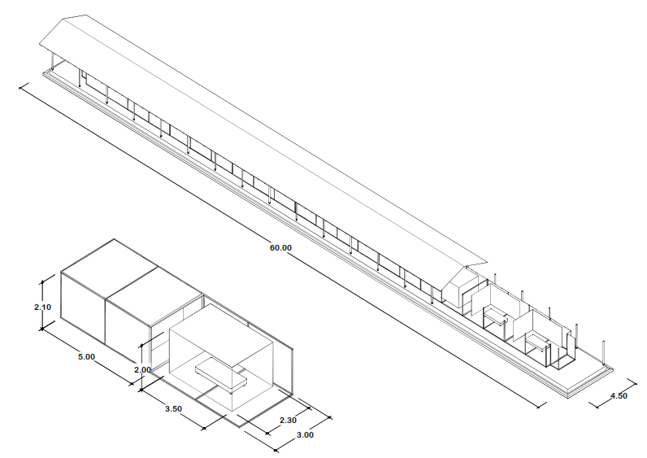
For additional information and building plans, please contact jmoore@ihi.or.tz

