Supplementary Figures and Tables:
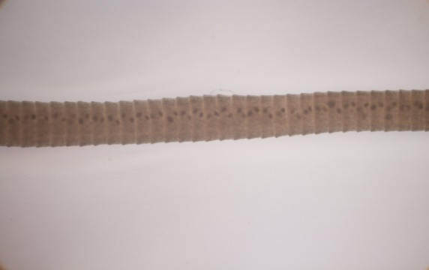
Additional file1: Fig. S1. Morphological observation of worm originated from wild pangolin

Additional file1: Fig. S2. Alignment and phylogenetic analysis of ITS2 region from worms of sample A and sample B.

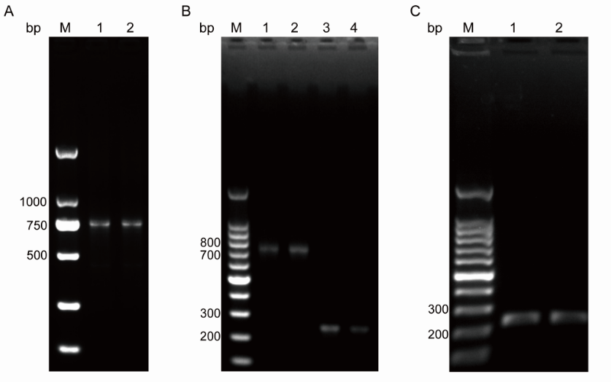
Additional file1: Fig. S3. PCR fragments amplified from uncertain regions of the two mitochondrial sequences. A) lanes 1-2, mt1 repeat sequences; B) lanes 1-2, mt2 repeat sequences; lanes 3-4, mt1 N sequences; C) lanes 1-2, mt2 N-sequences; lanes M: DNA marker.

Additional file1: Fig. S4. Reads mapping result of the mt DNA of Raillietina sp. was visualized by IGV. The result shows that each base account for half of the mutation site.

Additional file1: Fig. S5. Sequences alignment of mt1 and mt2 of Raillietina sp. amplified by PCR using two different primers (JB11-JB12 and mt2-PCR).

Additional file1: Fig. S6. Predicted secondary structure of 22 tRNAs in mt1 and mt2 of Raillietina sp. compared with Raillietina tetragona.

Additional file1: Fig. S7. Putative secondary structure of non-coding regions (NCR1, NCR2) in mt1, mt2, and related species of R. tetragona predicted by mfolds. A) non-repetitive region of NCR1 in mt1; B) non-repetitive region of NCR1 in mt2; C) repeat region of NCR2 in both mts; D) NCR1 of R. tetragona; E) repeat region of NCR2 in R. tetragona. NCR1 was found between trnY and trnS2; NCR2 was found between nad5 and trnG.

Additional file1: Table S1. Primers used for amplification of repeat and N-sequence / unidentified regions of mt1 and mt2 of Raillietina sp.
mtDNA | Uncertain regions | Forward Primer (5′ to 3′) | Reverse Primer (5′ to 3′)
mt1 | N sequence | CTTTGCTTTTTTATGAGTATTTGAT | ACACCAACATAACAAAAGTAAAATAA
mt1 | Repeat sequence | ACTAAAATTATTAATTTATTCGATGTAT | ATAAAGGTATTACAGACATTCCAAC
mt2 | N sequence | TCTGTTTTCTTTGCTTTTTTG | AAGTAAAATAATAGGCGGGTC
mt2 | Repeat sequence | TTTATTCGATATTTTTCTTCCTT | GTATTACAGACATCCCAAACCAC
Note: N- unidentified sequence region

Additional file1: Table S2. The retrieved 18S rRNA sequences of observed Raillietina sp. and species in the Cyclophyllidea, Diphyllobothriidae, and Schistosomatidae (Trematode as outgroup) for phylogenetic analysis.
Order | Family | Species | Size (bp) | Accession number
Cyclophyllidea | Taeniidae | Taenia saginata | 2608 | JQ609338.1
Cyclophyllidea | Taeniidae | Taenia asiatica | 2583 | GQ260088.1
Cyclophyllidea | Taeniidae | Taenia multiceps | 2574 | GQ260089.1
Cyclophyllidea | Taeniidae | Taenia solium | 2599 | GQ260091.1
Cyclophyllidea | Taeniidae | Taenia crassiceps | 2665 | AB731618.1
Cyclophyllidea | Taeniidae | Hydatigera krepkogorski | 2752 | AB731632.1
Cyclophyllidea | Taeniidae | Hydatigera kamiyai | 2765 | AB731630.1
Cyclophyllidea | Taeniidae | Hydatigera taneaformis | 2891 | JQ609340.1
Cyclophyllidea | Taeniidae | Echinococcus granulosus | 2394 | U27015.1
Cyclophyllidea | Taeniidae | Echinococcus equinus | 2266 | AB731640.1
Cyclophyllidea | Mesocestoididae | Mesocestiodes litteratus | 2154 | DQ643002.1
Cyclophyllidea | Mesocestoididae | Mesocestiodes corti | 2294 | AF286984.1
Cyclophyllidea | Dipylidiidae | Diplidium caninum | 2406 | AB731643.1
Cyclophyllidea | Hymenolepididae | Hymenolepis diminuta | 2174 | AF124475.1
Cyclophyllidea | Hymenolepididae | Hymenolepis microstoma | 2140 | AJ287525.1
Cyclophyllidea | Hymenolepididae | Hymenolepis nana | 2244 | AY193875.1
Cyclophyllidea | Davaineidae | Raillietina sp. | 2183 | EU665467.1
Cyclophyllidea | Davaineidae | Raillietina sonini | 2183 | EU665468.1
Cyclophyllidea | Davaineidae | Fuhrmannetta malakartis | 2185 | EU665463.1
Cyclophyllidea | Davaineidae | Raillietina sp. | 2214 | OL547740.1
Cyclophyllidea | Davaineidae | Raillietina sp. | 2183 | EU665466.1
Cyclophyllidea | Davaineidae | Raillietina dromaius | 2220 | AY382314.1
Cyclophyllidea | Davaineidae | Raillietina chiltoni | 2242 | AY382313.1
Cyclophyllidea | Davaineidae | Raillietina australis | 2235 | AY382311.1
Cyclophyllidea | Davaineidae | Raillietina mitchelli | 2238 | AY382315.1
Cyclophyllidea | Davaineidae | Raillietina beveridgei | 2219 | AY382312.1
Cyclophyllidea | Davaineidae | Raillietina australis | 2238 | AF286980.1
Diphyllobothriidea | Diphyllobothriidae | Spirometra erinacei | 2182 | D64072.1
Diphyllobothriidea | Diphyllobothriidae | Spirometra sp. | 2242 | HQ228992.1
Diphyllobothriidea | Diphyllobothriidae | Diplogonaporus balaenopterae | 2022 | KY552792.1
Diphyllobothriidea | Diphyllobothriidae | Diplogonaporus grandis | 2156 | AB353272.1
Diphyllobothriidea | Diphyllobothriidae | Dibothriocephalus nihonkaiensis | 2171 | AB374225.1
Diphyllobothriidea | Diphyllobothriidae | Diphyllobothrium latum | 3356 | KF218246.1
Strigeidida | Schistosomatidae | Schistosoma japonicum | 1883 | AY157226.1

Additional file1: Table S3. The ITS2 sequences of cestode parasites retrieved from GenBank and sequences from two samples of current Raillietina sp.
Order | Family | Species | Size (bp) | Accession No
Cyclophyllidea | Mesocestoididae | Mesocestoides sp. | 559 | AF119707.1
 |  | Mesocestoides litteratus | 1340 | MH936660.1
 | Taeniidae | Taenia multiceps | 1359 | FJ886762.1
 |  | Taenia hydatigena | 1259 | FJ886760.1
 |  | Taenia pisiformis | 1300 | JX317661.1
 | Hymenolepididae | Hymenolepis folkertsi | 833 | MN723751.1
 |  | Hymenolepis nana | 1379 | JF766715.1
 | Davaineidae | Raillietina cesticillus | 2236 | KP893422.1
 |  | Raillietina saudiae | 726 | MK201802.1
 |  | Raillietina tetragona | 926 | MH421967.1
 |  | Raillietina sp. sample A | 850
 |  | Raillietina sp. sample B | 858
 |  | Raillietina beveridgei | 1081 | AY382318.1
 |  | Raillietina dromaius | 973 | AY382320.1
 |  | Raillietina australis | 984 | AY382317.1
 |  | Raillietina beveridgei | 1081 | AY382318.1
Diphyllobothriidea | Diphyllobothriidae | Spirometra sp. | 1307 | HQ228993.1
 |  | Spirometra erinaceieuropaei | 1307 | KC561781.1
 |  | Diphyllobothrium stemmacephalum | 1251 | DQ768181.1
 |  | Diphyllobothrium sp. | 1238 | AB437411.3
 |  | Diphyllobothrium dendriticum | 1323 | FM204787.1
Strigeidida | Schistosomatidae | Schistosoma japonicum | 1541 | FJ852488.1

Additional file1: Table S4. The mt1 and mt2 of Raillietina sp. and the downloaded mt genome of 12 PCGs from the order of Cyclophyllidea, Pseudophyllidea, Diphyllobothriidae, and Schistosomatidae (out-group).
Order | Family | Species | Size (bp) | Accession number
Cyclophyllidea | Mesocestoididae | Mesocestoides vogae | 13892 | LC102498.1
Cyclophyllidea | Mesocestoididae | Mesocestoides corti | 13670 | AP017667.1
Cyclophyllidea | Mesocestoididae | Dipylidium caninum | 14226 | MN099047.1
Cyclophyllidea | Taeniidae | Echinococcus granulosus | 13579 | KU601616.1
Cyclophyllidea | Taeniidae | Echinococcus equinus | 13605 | AB786665.1
Cyclophyllidea | Taeniidae | Hydatigera sp. | 13840 | LC008533.1
Cyclophyllidea | Taeniidae | Hydatigera taeniaeformis | 13822 | AP017671.1
Cyclophyllidea | Taeniidae | Taenia crassiceps  Taenia twitchelli | 13503  13519 | AF216699.1  AB731759.1
Cyclophyllidea | Taeniidae | Taenia laticollis | 13483 | AB731727.1
Cyclophyllidea | Taeniidae | Taenia hydatigena | 13492 | GQ228819.1
Cyclophyllidea | Hymenolepididae | Drepanidotaenia lanceolata | 13573 | NC_028164.1
Cyclophyllidea | Hymenolepididae | Hymenolepis diminuta | 13708 | AP017664.1
Cyclophyllidea | Hymenolepididae | Hymenolepis nana | 13764 | KT951722.1
Cyclophyllidea | Davaineidae | Raillietina tetragona | 14444 | KP057580.1
Cyclophyllidea | Davaineidae | mt1 of Raillietina sp. | 14331 | OL597539.1
Cyclophyllidea | Davaineidae | mt2 of Raillietina sp. | 14341 | OL597540.1
Cyclophyllidea | Paruterinidae | Cladotaenia vulturi | 13411 | NC_032067.1
Cyclophyllidea | Anoplocephalidae | Anoplocephala perfoliata | 14459 | NC_028425.1
Cyclophyllidea | Anoplocephalidae | Anoplocephala magna | 13759 | NC_031801.1
Pseudophyllidea | Cephalochlamydidae | Cephalochlamys namaquensis | 13696 | MW602524.1
Diphyllobothriidea | Diphyllobothriidae | Spirometra erinaceieuropaei | 13641 | JQ267473.1
Diphyllobothriidea | Diphyllobothriidae | Spirometra decipiens | 13641 | NC_026852.1
Diphyllobothriidea | Diphyllobothriidae | Diplogonoporus balaenopterae | 13724 | NC_017613.1
Diphyllobothriidea | Diphyllobothriidae | Diplogonoporus grandis | 13725 | NC_017615.1
Diphyllobothriidea | Diphyllobothriidae | Diphyllobothrium latum | 13608 | NC_008945.1
Diphyllobothriidea | Diphyllobothriidae | Diphyllobothrium nihonkaiense | 13747 | NC_009463.1
Strigeidida | Schistosomatidae | Schistosoma japonicum | 14085 | NC_002544.1

Additional file1: Table S5. The number of nucleotide deletions and insertions observed between mt1 and mt2 of Raillietina sp.
mt1 positions | mt2
mt1 positions | Nucleotide deletion | Nucleotide insertion
2,028-2,029 |  | G
2,429-2,430 | TA
5,204-5,205 |  | T
7,493-7,493 |  | T
12,478-12,479 |  | TTGGGGG
12,568-12,569 |  | T
14,256-14,257 |  | T

Additional file1: Table S6. Nucleotide compositions (%) of PCGs, entire mt genome, transfer RNA, ribosomal RNA, and skew value of mt1 and mt2 of Raillietina sp.
Gene | A % | G % | C % | T % | A+T % | G+C % | AT skew | GC skew
cox1 | 23.7/23.9 | 21.6/21.1 | 9.9/9.9 | 44.8/45.1 | 68.6/69.0 | 31.4/31.0 | -0.3/-0.3 | 0.4/0.4
cox2 | 27.0/26.8 | 22.5/22.8 | 9.1/9.2 | 41.4/41.2 | 68.4/68.1 | 31.6/31.9 | -0.2/-0.2 | 0.4/0.4
nad6 | 23.3/23.3 | 20.7/21.1 | 7.6/7.4 | 48.4/48.2 | 71.7/71.5 | 28.3/28.5 | -0.4/-0.4 | 0.5/0.5
nad5 | 25.0/25.2 | 19.5/19.2 | 9.6/9.9 | 45.9/45.7 | 70.9/70.9 | 29.1/29.1 | -0.3/-0.3 | 0.3/0.3
cox3 | 22.5/21.9 | 22.9/23.2 | 6.7/7.9 | 47.9/47.0 | 70.4/68.8 | 29.6/31.2 | -0.4/-0.4 | 0.6/0.5
cytb | 23.1/23.6 | 22.0/21.3 | 9.2/9.4 | 45.7/45.7 | 68.8/69.3 | 31.2/30.7 | -0.3/-0.3 | 0.4/0.4
nad4L | 22.6/23.8 | 21.1/20.3 | 7.6/6.9 | 48.7/49.0 | 71.3/72.8 | 28.7/27.2 | -0.4/-0.4 | 0.5/0.5
nad4 | 23.5/23.4 | 21.9/21.9 | 6.9/7.8 | 47.7/46.9 | 71.2/70.3 | 28.8/29.7 | -0.3/-0.3 | 0.5/0.5
atp6 | 25.4/25.0 | 19.5/19.9 | 10.3/9.3 | 44.8/45.8 | 70.2/70.8 | 29.8/29.2 | -0.3/-0.3 | 0.3/0.4
nad2 | 17.9/17.3 | 23.1/23.5 | 5.5/5.5 | 53.5/53.7 | 71.3/71.0 | 28.7/29.0 | -0.5/-0.5 | 0.6/0.6
nad1 | 22.6/22.5 | 22.6/23.2 | 7.0/6.6 | 47.8/47.7 | 70.4/70.1 | 29.6/29.9 | -0.4/-0.4 | 0.5/0.6
nad3 | 26.2/25.9 | 20.1/20.4 | 3.4/3.7 | 50.3/50.0 | 76.4/75.9 | 23.6/24.1 | -0.3/-0.3 | 0.7/0.7
Cmt | 25.3/25.3 | 21.5/21.5 | 8.1/8.2 | 45.1/45.0 | 70.4/70.3 | 29.6/29.7 | -0.3/-0.3 | 0.5/0.5
EPCG | 23.4/23.4 | 21.5/21.5 | 8.2/8.3 | 46.9/46.8 | 70.3/70.2 | 29.7/29.8 | -0.3/-0.3 | 0.5/0.4
EtRNA | 29.1/29.8 | 20.9/20.3 | 9.8/9.4 | 40.2/40.5 | 69.3/70.2 | 30.7/29.8 | -0.2/-0.2 | 0.4/0.4
ErRNA | 28.5/28.6 | 20.7/20.8 | 9.5/9.9 | 41.3/40.7 | 69.8/69.3 | 30.2/30.7 | -0.2/-0.2 | 0.4/0.4
ENCR | 33.4/33.4 | 25.5/25.5 | 1.6/1.8 | 39.5/39.3 | 73.0/72.7 | 27.0/27.3 | -0.1/-0.1 | 0.9/0.9
Complete mitochondrial (Cmt), Entire (PCG, tRNA, rRNA, NCR).

