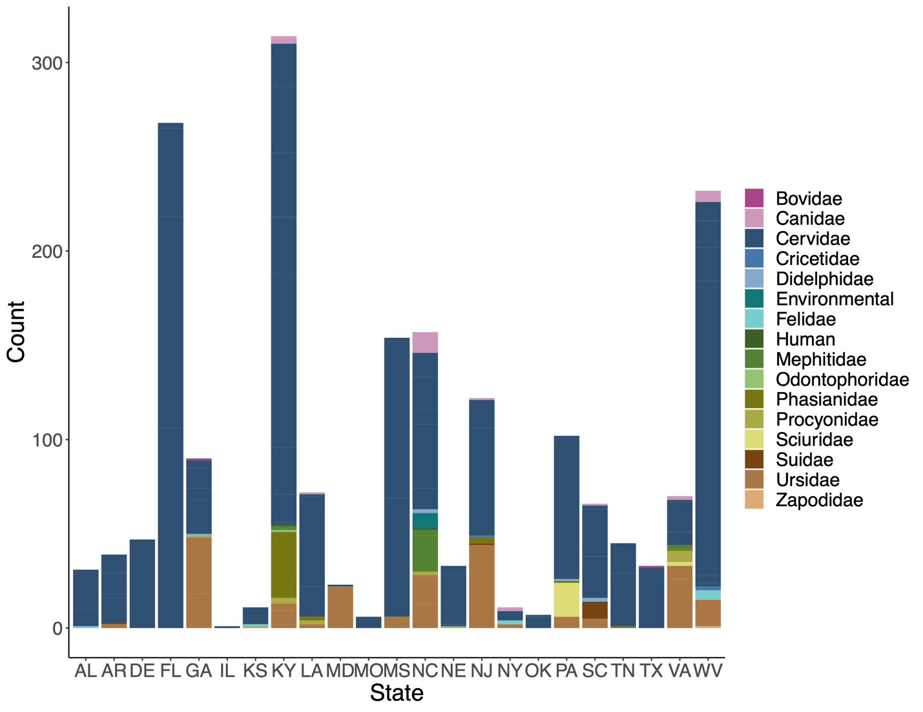

Additional File 2. Host submissions by state, 2010 – 2021. Stacked bar chart represents total number of submissions by state, bars are colored in by number of host group submitted.

