Additional File 7: Figure S5-12. The predicted environmental suitability for Ixodes ricinus in Europe using 96 different modelling approaches, using three modelling algorithms [random forests (RF), maximum entropy (MaxEnt) and generalised additive models (GAM)], four explanatory variable sets (bioclimatic variables, WorldClim, TerraClimate and MODIS satellite-derived variables) and eight training extents (100 km – 700 km buffering extents around occurrence data increasing in increments of 100 km, and the European extent).
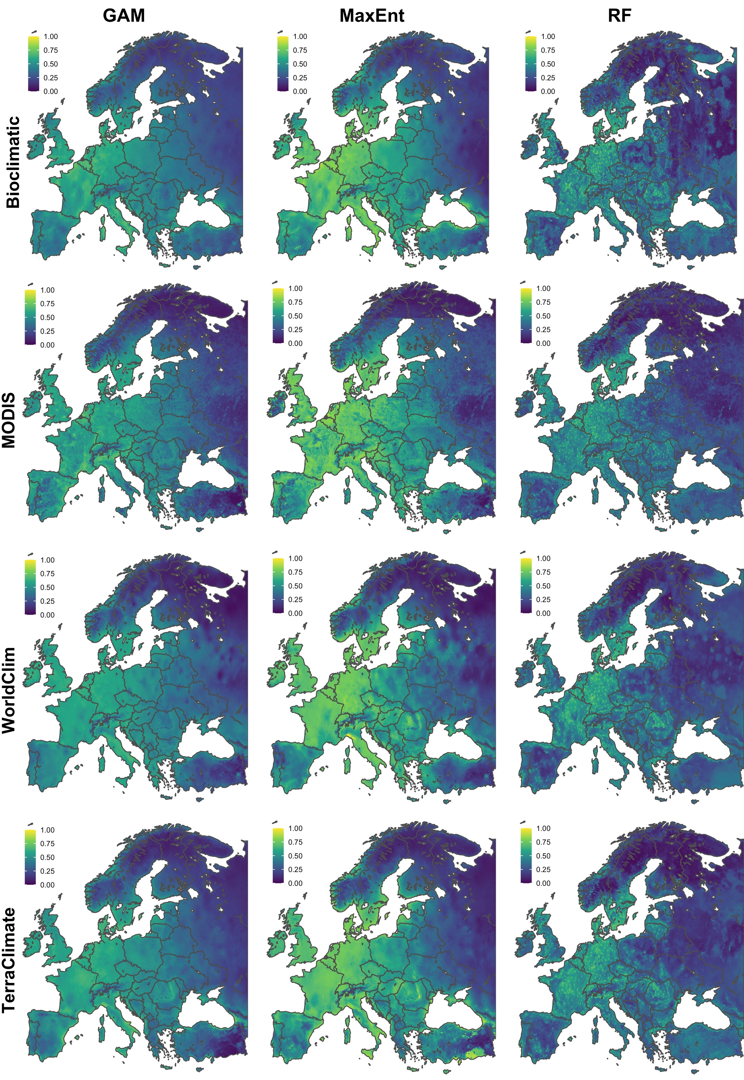
Figure S5. The predicted environmental suitability for Ixodes ricinus in Europe using different modelling approaches, including three modelling algorithms [random forests (RF), maximum entropy (MaxEnt) and generalised additive models (GAM)] and four explanatory variable sets (bioclimatic variables, WorldClim, TerraClimate and MODIS satellite-derived variables) using a 100km buffer training extent.

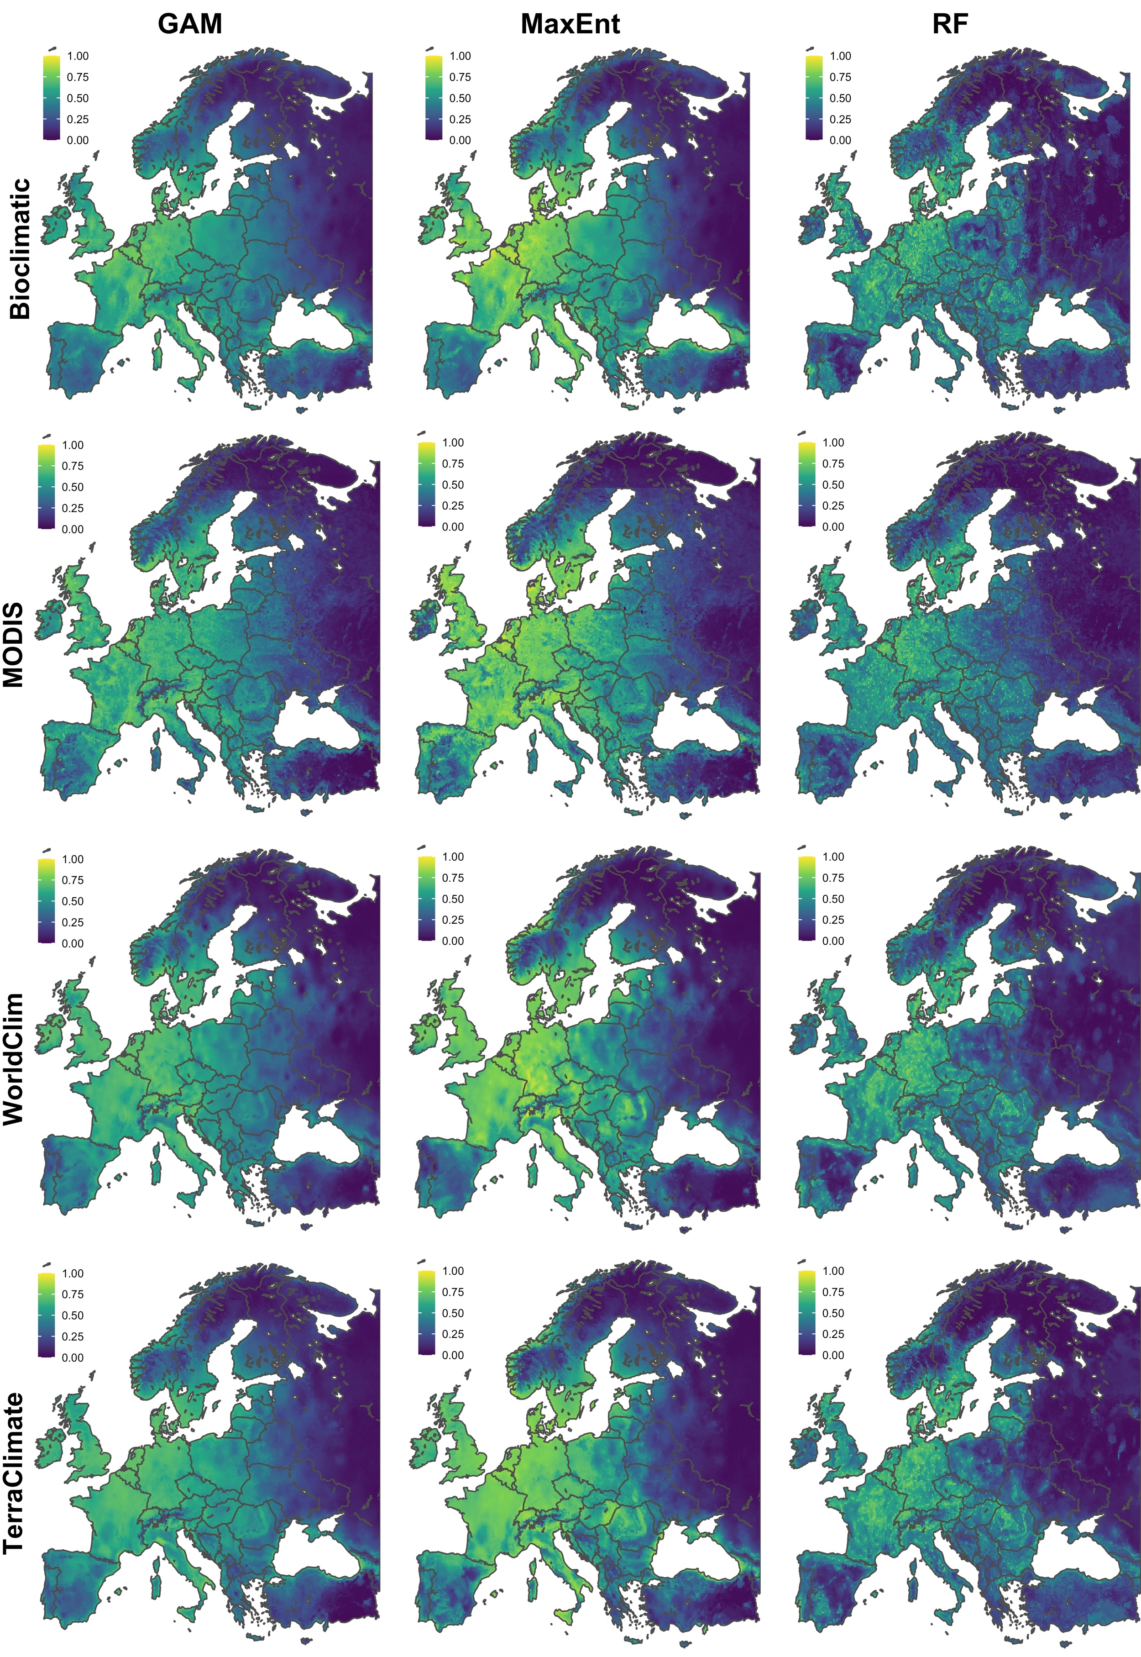
Figure S6. The predicted environmental suitability for Ixodes ricinus in Europe using different modelling approaches, including three modelling algorithms [random forests (RF), maximum entropy (MaxEnt) and generalised additive models (GAM)] and four explanatory variable sets (bioclimatic variables, WorldClim, TerraClimate and MODIS satellite-derived variables) using a 200km buffer training extent.

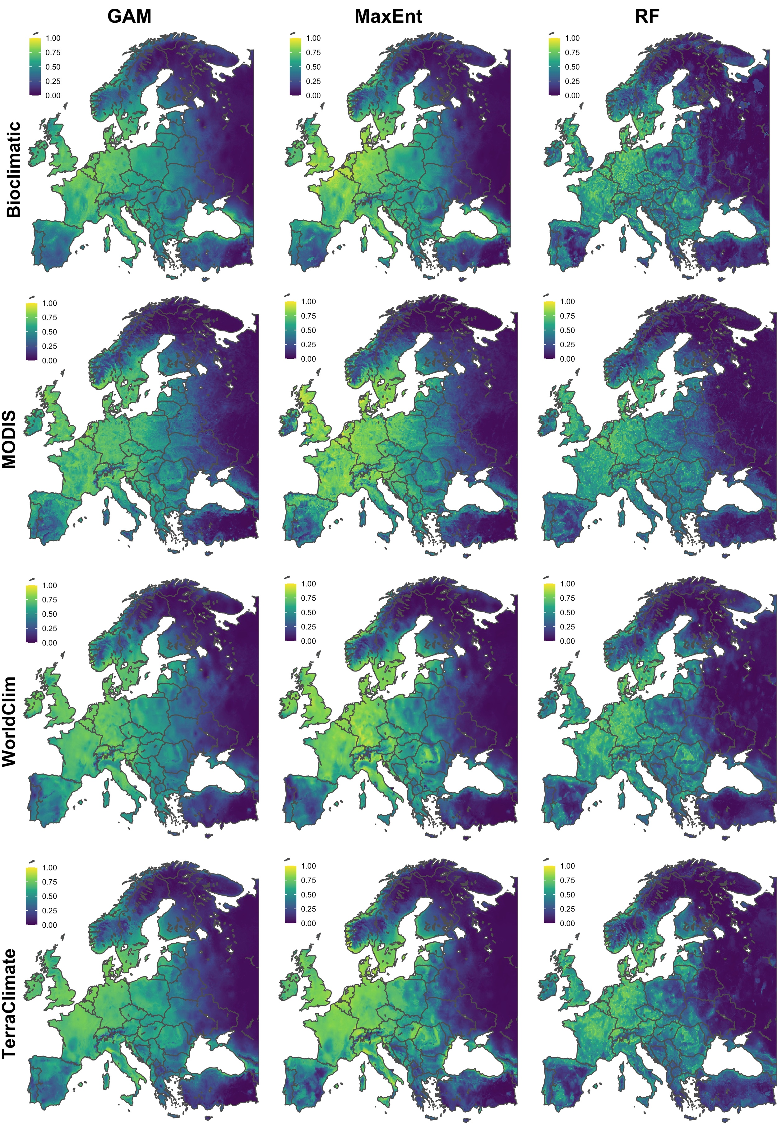
Figure S7. The predicted environmental suitability for Ixodes ricinus in Europe using different modelling approaches, including three modelling algorithms [random forests (RF), maximum entropy (MaxEnt) and generalised additive models (GAM)] and four explanatory variable sets (bioclimatic variables, WorldClim, TerraClimate and MODIS satellite-derived variables) using a 300km buffer training extent.

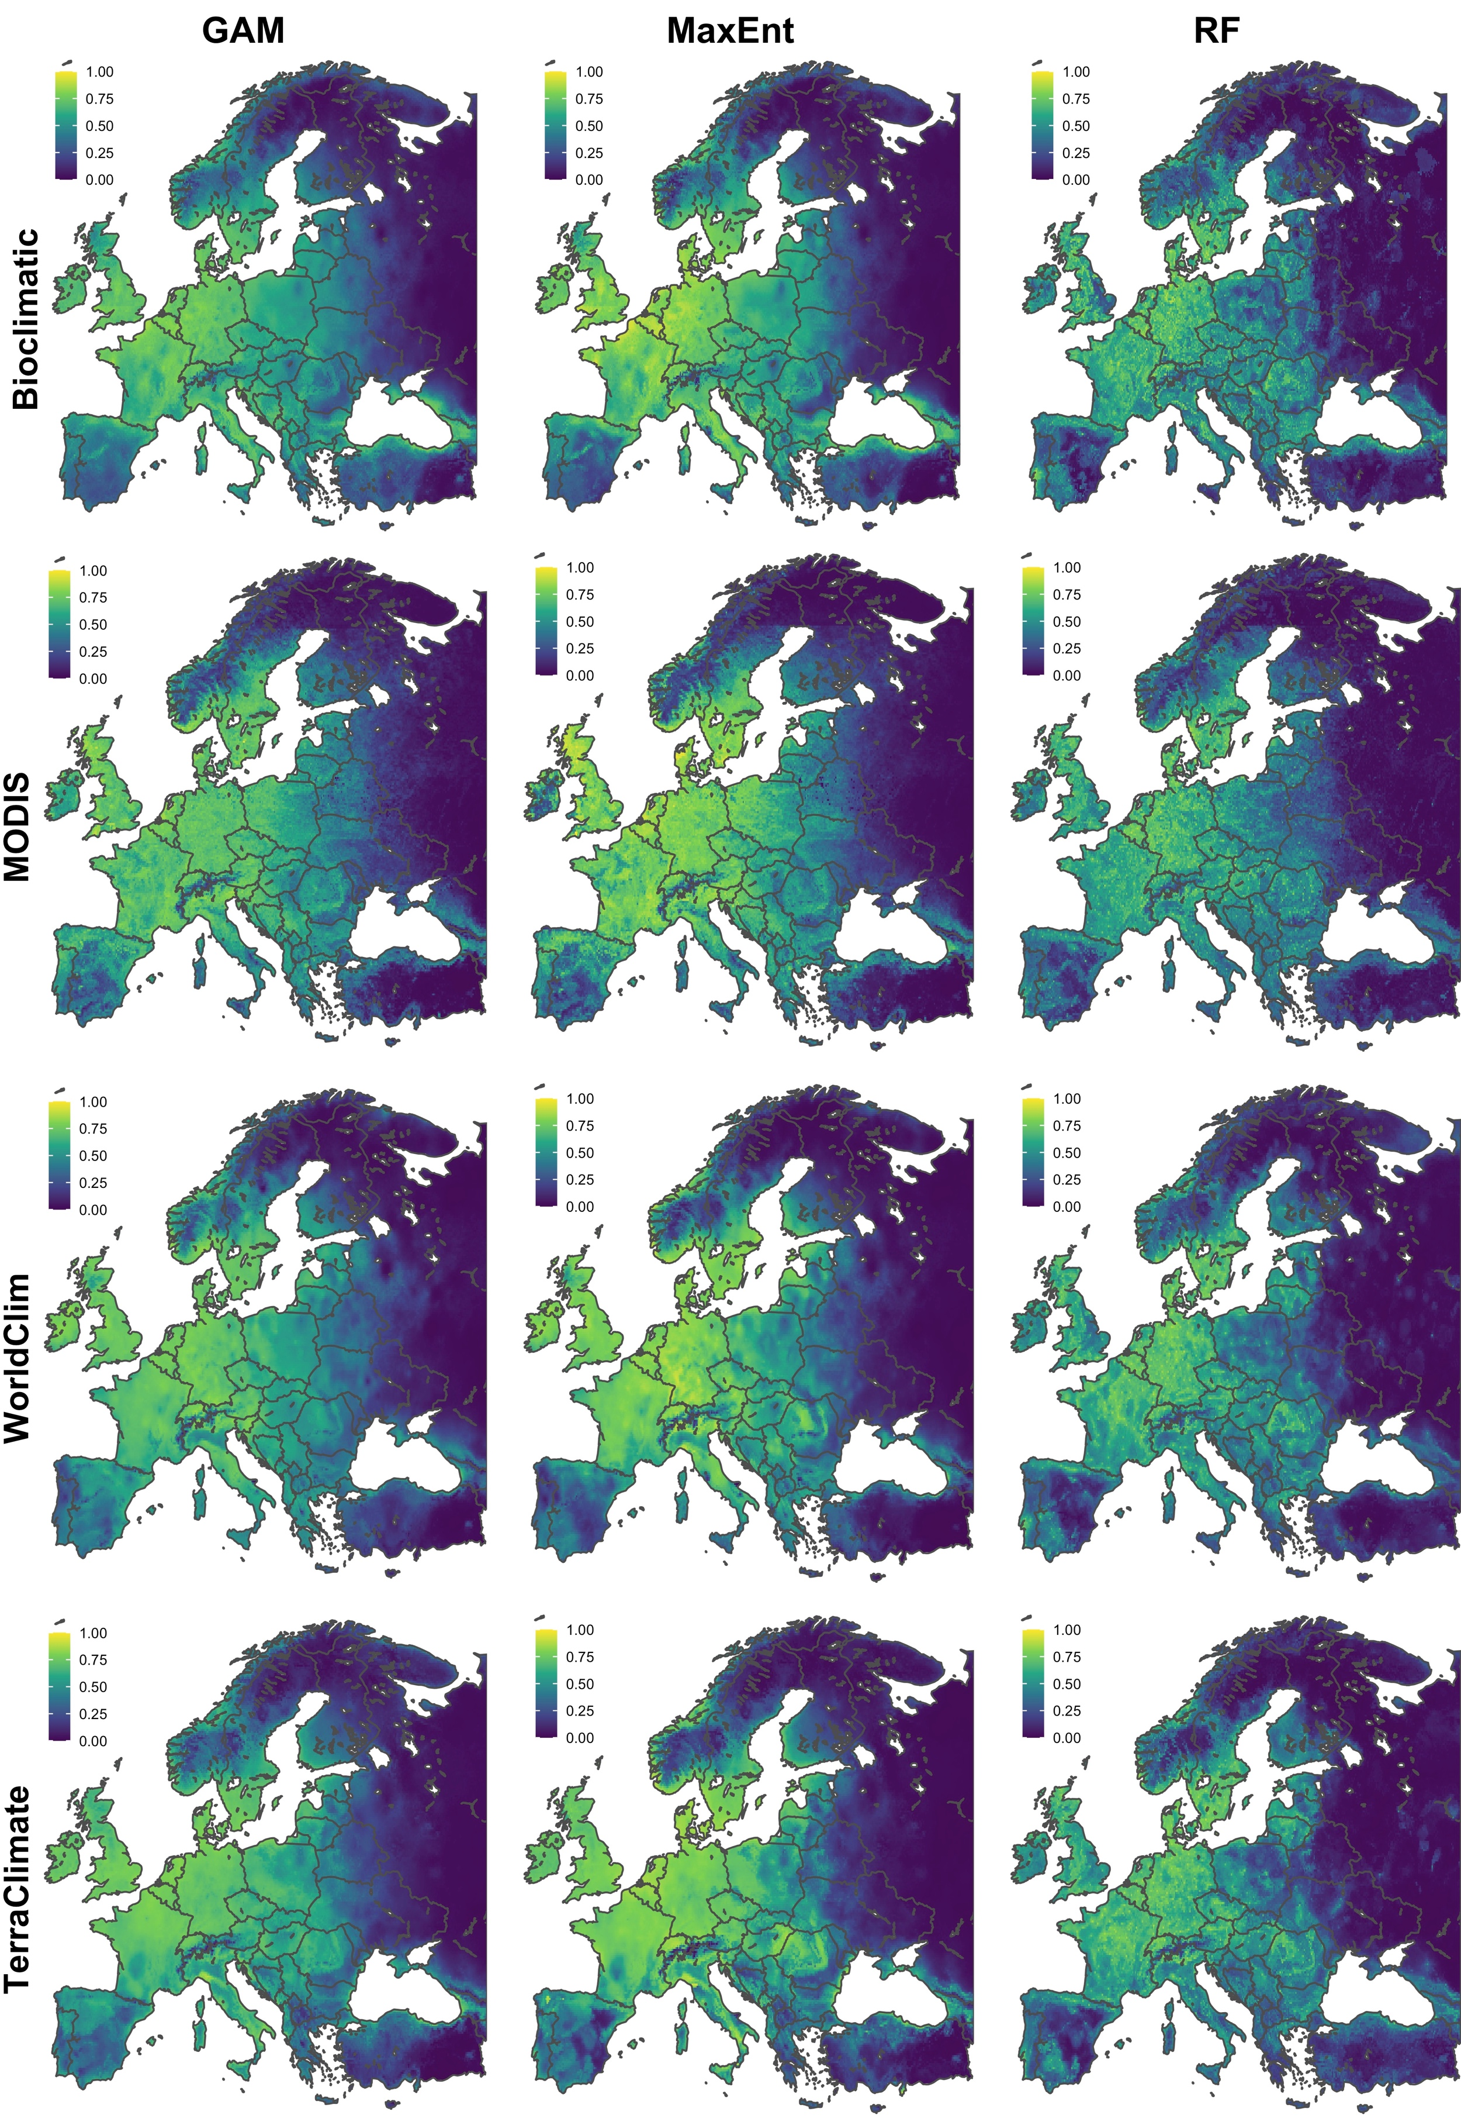
Figure S8. The predicted environmental suitability for Ixodes ricinus in Europe using different modelling approaches, including three modelling algorithms [random forests (RF), maximum entropy (MaxEnt) and generalised additive models (GAM)] and four explanatory variable sets (bioclimatic variables, WorldClim, TerraClimate and MODIS satellite-derived variables) using a 400km buffer training extent.
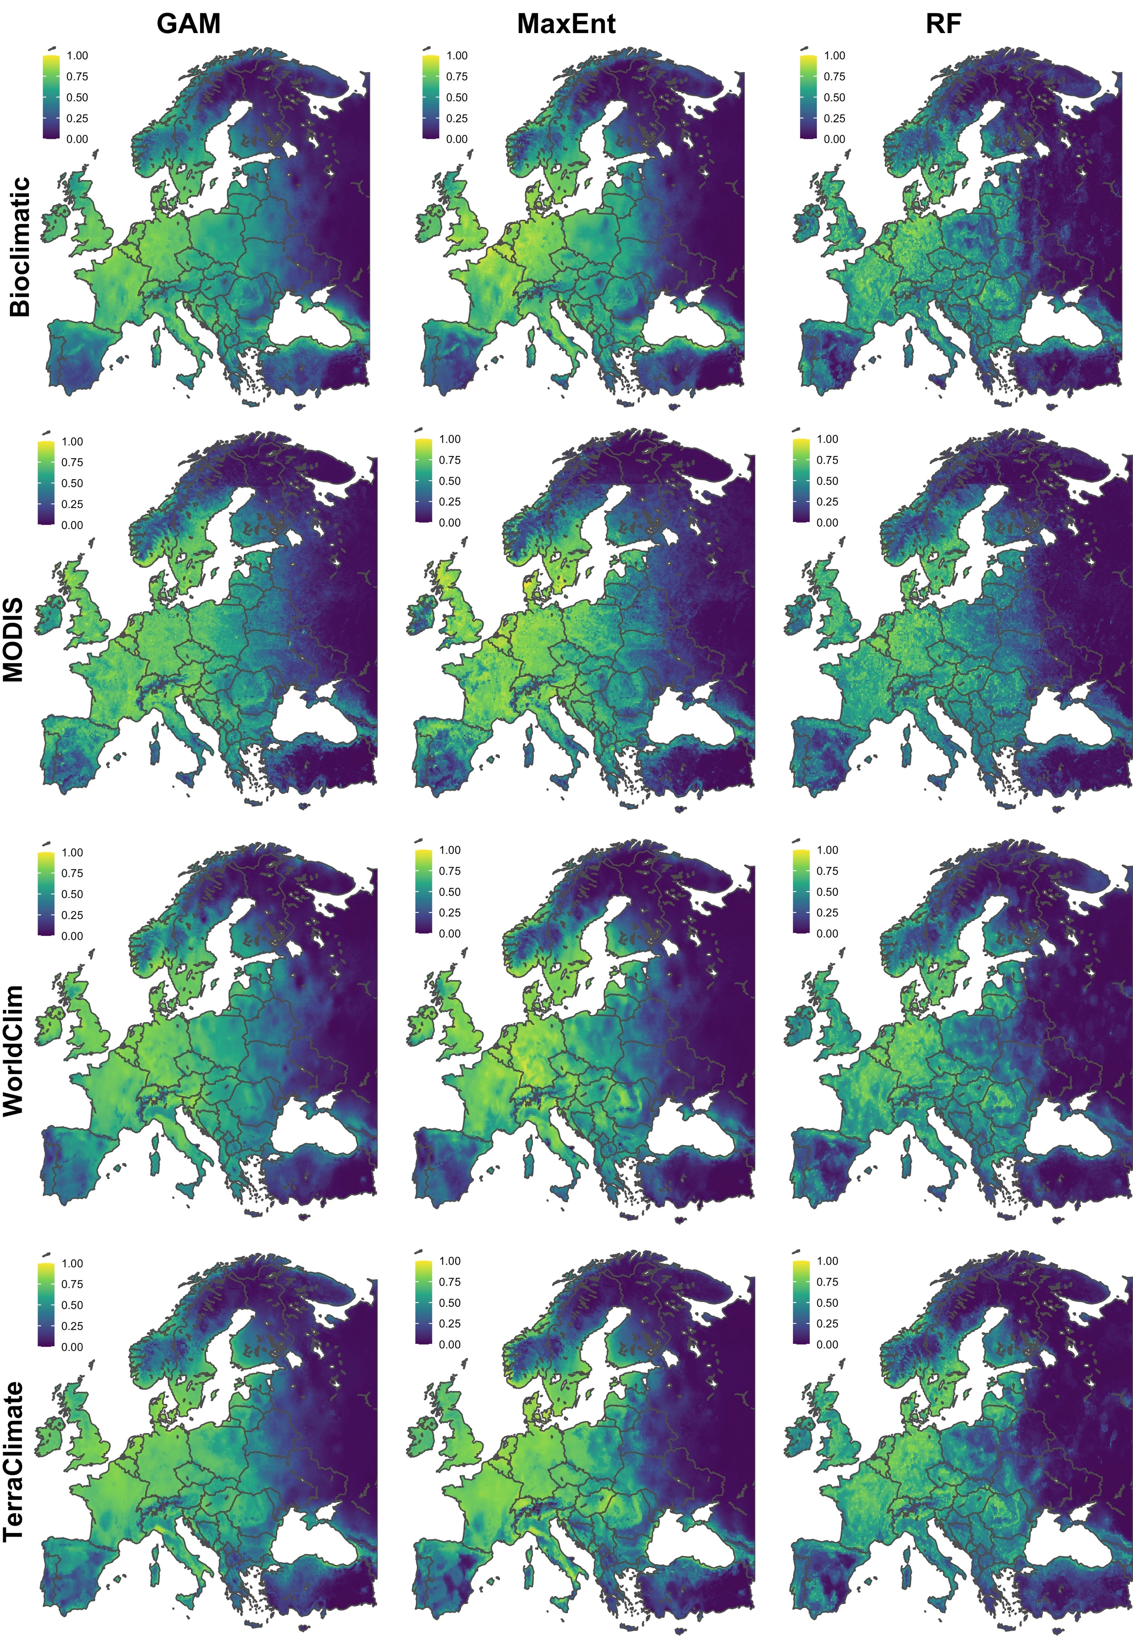
Figure S9. The predicted environmental suitability for Ixodes ricinus in Europe using different modelling approaches, including three modelling algorithms [random forests (RF), maximum entropy (MaxEnt) and generalised additive models (GAM)] and four explanatory variable sets (bioclimatic variables, WorldClim, TerraClimate and MODIS satellite-derived variables) using a 500km buffer training extent.
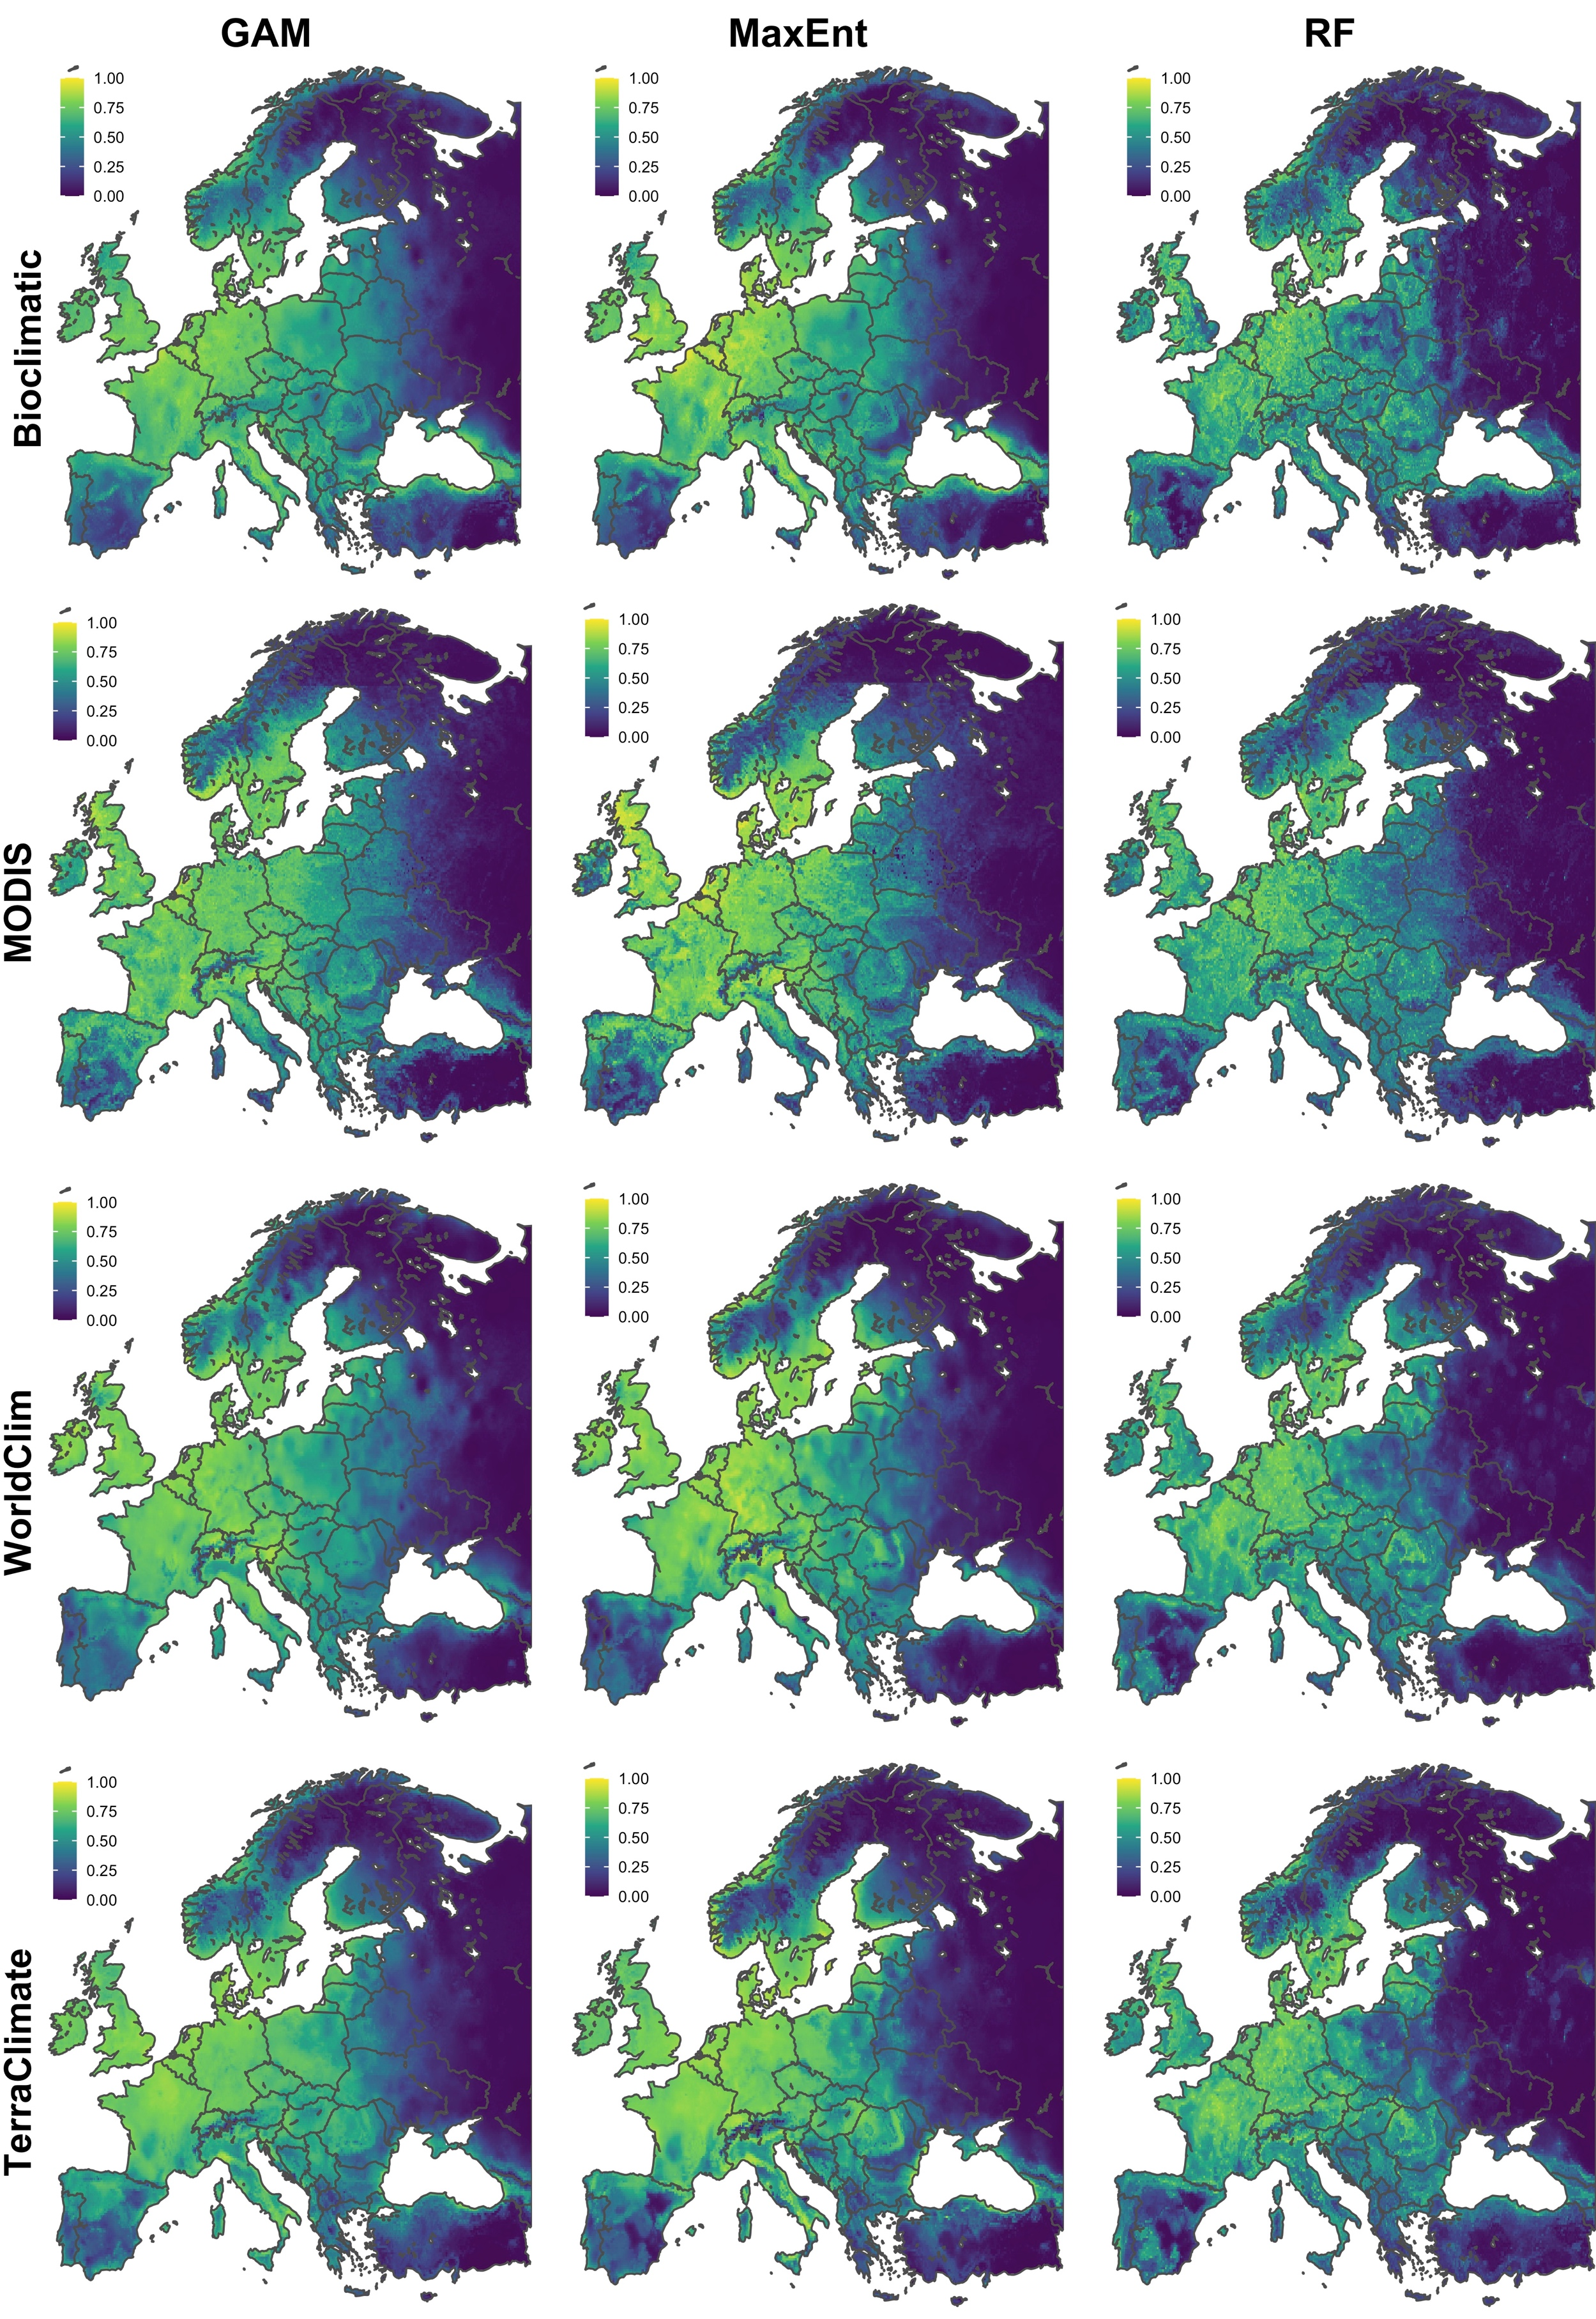
Figure S10. The predicted environmental suitability for Ixodes ricinus in Europe using different modelling approaches, including three modelling algorithms [random forests (RF), maximum entropy (MaxEnt) and generalised additive models (GAM)] and four explanatory variable sets (bioclimatic variables, WorldClim, TerraClimate and MODIS satellite-derived variables) using a 600km buffer training extent.
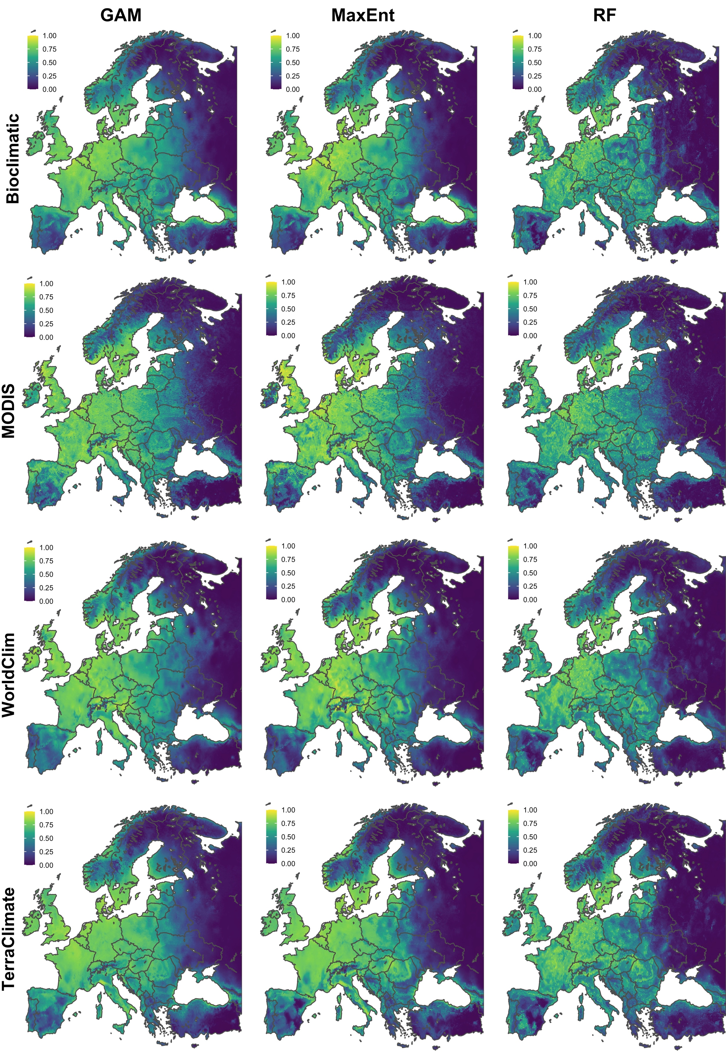
Figure S11. The predicted environmental suitability for Ixodes ricinus in Europe using different modelling approaches, including three modelling algorithms [random forests (RF), maximum entropy (MaxEnt) and generalised additive models (GAM)] and four explanatory variable sets (bioclimatic variables, WorldClim, TerraClimate and MODIS satellite-derived variables) using a 700km buffer training extent.
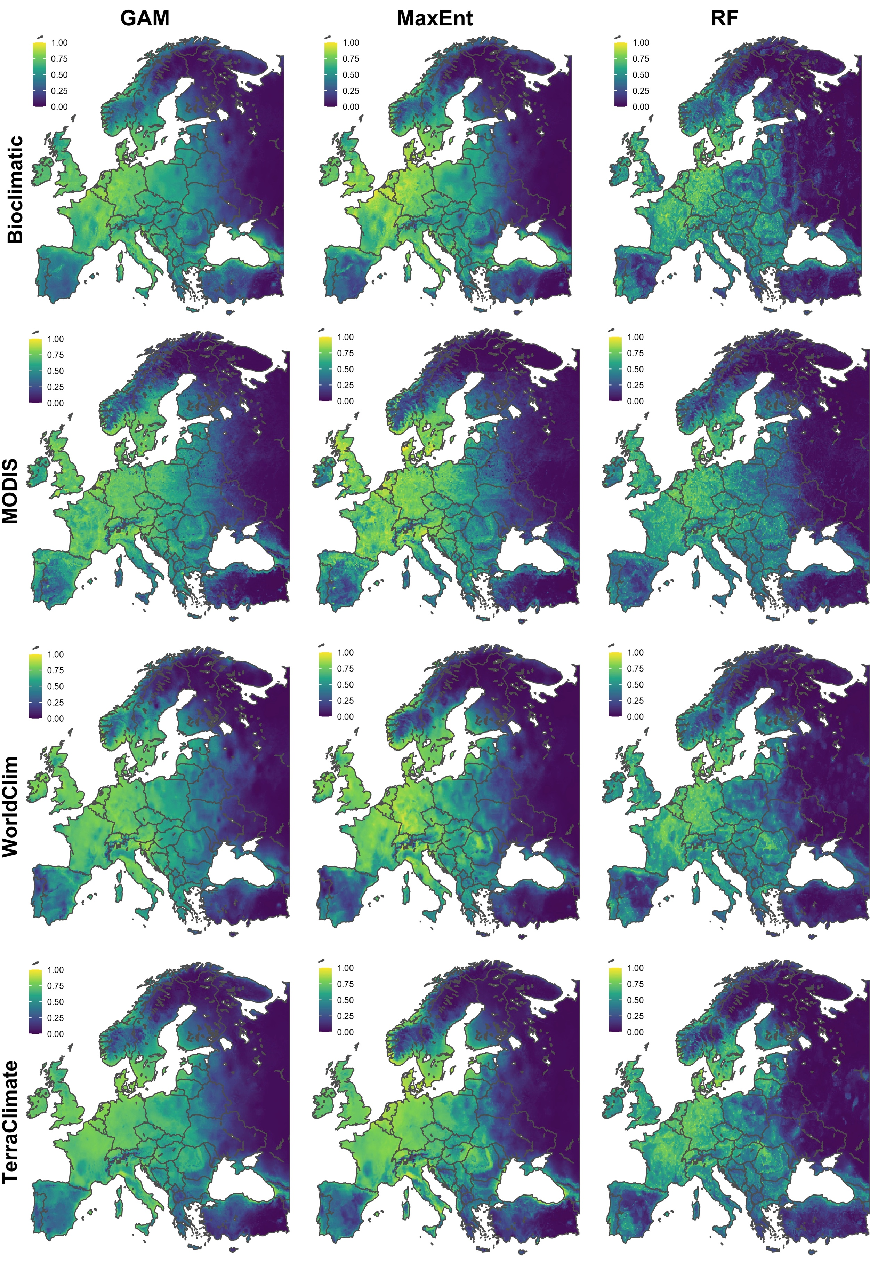
Figure S12. The predicted environmental suitability for Ixodes ricinus in Europe using different modelling approaches, including three modelling algorithms [random forests (RF), maximum entropy (MaxEnt) and generalised additive models (GAM)] and four explanatory variable sets (bioclimatic variables, WorldClim, TerraClimate and MODIS satellite-derived variables) using a training extent the size of Europe.

