Supplemental Information: Western Diet Consumption by Host Vertebrate Promotes Altered Gene Expression on Aedes aegypti Reducing its Lifespan and Increasing Fertility Following Blood Feeding

Supplemental Table 1. Diet Composition.

CHOW (AIN93M) Diet

Corn Starch | 46.200%
Casein | 16.500%
Dextrinized Starch | 13.000%
Sucrose | 10.000%
Soybean Oil | 4.000%
Microcrystalline Cellulose | 5.000%
Mineral Mix specific for AIN 93M diets | 3.500%
Vitamin Mix specific for AIN 93M diets | 1.300%
L-Cystine | 0.250%
Choline Bitartrate | 0.250%

High-Fat High-Sucrose Diet

Casein | 20.950%
Sucrose | 27.050%
Soybean Oil | 4.000%
Microcrystalline Cellulose | 5.000%
AIN 93G Mineral Mix | 3.500%
AIN 93 Vitamin Mix | 1.300%
L-Cystine | 0.300%
Choline Bitartrate | 0.250%
Lard | 37.650%

Supplemental Table 2. Primer List

Gene | Description | Forward | Reverse
- | 16S | TCCTACGGGAGGCAGCAGT | GGACTACCAGGGTATCTAATCCTGTT
AAEL009955 | Apolipophorin 2 | AGGCCCGCTTCTTCGATATG | ATGGAAGGCAGCGTTCTTGA
AAEL007162 | ATG8/LC3 | TAGTCCCGTCCGACCTAACC | CCGAGTAGAGCGAACCCATC
AAEL013407-RB | Catalase | CAATGAACTGCACCGACAAC | AGCCTCATCCAGAACACGAC
AAEL012471 | Domeless | CGAAGACTCGCATAGGACCC | CCAGTGCAGAATGACCGAGT
AAEL001194 | Fatty acid Synthase I (FASI) | TATGGCCTGATCGGATGTGC | TGGCGATCAACGAACTGGAA
AAEL019672 | Forkhead box O (FoxO) | TCGAAGCGATACGACAGCAG | GTCGGGGGACAGTTGAAAGT
AAEL012069 | Glutathione Peroxidase | ACCAGTTCGGGTTCTCAAATG | ACATTGACCCGAGCAAAA AC
AAEL004221 | Glycogen Synthase | CACGCCATGGCAAAGGAAAA | GTCAGCACCCTTGTTCGAGA
AAEL002317 | Insulin Receptor | GAAGTCATGTGGGGTCGGTT | TTGACGGGCCTCAACACTAC
AAEL008622 | JNK | CGTAACGCGAGGGATATGCT | TGACTTCCGCCTCATCCAAC
AAEL008634 | JNK | ACCCCGCGGTAGAAATCATC | CCAAACGCTCTTCGCACAAA
AAEL008953 | Kayak | TTCCCGTCGTAACATGGGTG | CGAGCTCGTTGGTGTGATCT
AAEL010067 | Keren | GTGCCATTGTCGCATTGGTT | CACCGTTCTAAGCACTCCGT
AAEL005951 | LSD1 | AACTGATTGCCACCAACCCA | TCGTCAGTAGGACCACCAGT
AAEL006820 | LSD2 | GGAGTACGTCGTCACGTTGATTG | GCAGGGGCGGGCTGA
AAEL021746 | Oxidation Resistance 1 | ATCCGGGATCCCAATACACT | AGGAGGTTCTCGCTGAACTG
AAEL015099 | PIAS | AGCGAACTGATCGAACGTGT | GGAGTCTCTGCTGCTTGCTT
AAEL011594 | Pink 1 | GCGCTACCCCCTCGAATAAA | AAACAACAAGATCCGCGTGC
AAEL014913 | Pyruvate Kinase | ATACCACGCCAACACGATCA | TCGATCAGCCCAGTACGGAT
AAEL009692 | STAT | GGAAAAGAAGGGCACCGAGA | CACCGGAAGTGAGATCGTCC
AAEL020638 | TOR | TGGTCAACACGACGACTCAG | GGCTAACTTGACGAGCACCT
AAEL012977 | Vein | CCCGATACGTCTACCAACCG | AGCAGTAACGGCGAGTTTGA
AAEL010434 | Vitellogenin A1 | GAACTACGTTCGTCCTGGCA | CAGCAGAGGCTTGTACTGCT
AAEL003396 | RP49 | GCTATGACAAGCTTGCCCCCA | TCATCAGCACCTCCAGCT

Supplemental Figures

Additional File 1: Supplemental Figure 1. Mice were fed with either a CHOW or an HSHF diet for 20 weeks. Over the course of the experiment, metabolic syndrome was followed by tracking weight gain, glucose, and insulin sensitivity. Following, Aedes mosquitoes were allowed to feed on anesthetized mice, and whole-body relative expression levels of (A) Fat Acid Synthase I, (B) LSD1, (C) LSD2, (D) Pyruvate Kinase, (E) Glycogen Synthase, (F) Pink1 were measured by qRT-PCR 1 and 4 days pbm. Sugar-fed (SF) mosquitoes were used as a baseline for gene expression. Four biological replicates were prepared using independent mosquito hatches and dietary protocols. (A) Unpaired T-test and (B-F) One-Way ANOVA followed by Tukey’s multiple comparison tests were performed. ns: non-significant, * P <0.05.

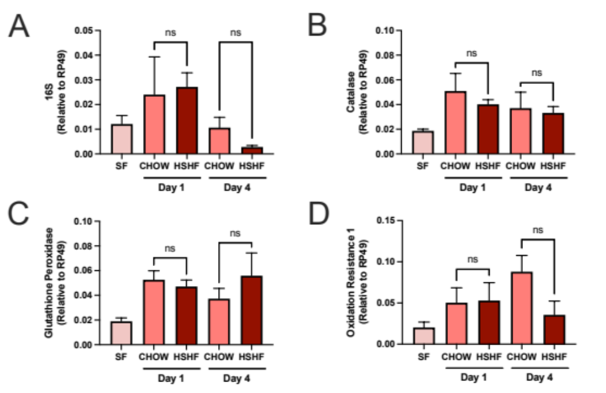

Additional File 2: Supplemental Figure 2. Mice were fed with either a CHOW or an HSHF diet for 20 weeks. Over the course of the experiment, metabolic syndrome was followed by tracking weight gain, glucose, and insulin sensitivity. Following, Aedes mosquitoes were allowed to feed on anesthetized mice, and whole-body relative expression levels of (A) 16S, (B) Catalase, (C) Glutathione Peroxidase, (D) Oxidation Resistance 1 (A-D). Sugar-fed (SF) mosquitoes were used as a baseline for gene expression. Four biological replicates were prepared using independent mosquito hatches and dietary protocols. One-Way ANOVA followed by Tukey’s multiple comparison tests were performed. ns: non-significant.

