Mapping the distribution of Amblyomma americanum in Georgia, USA

Additional file Tables and Figures

Table S1. Table of collinearity (VIF) in the training set (after initial backward selection but before dropping variables due to collinearity)

Variable | Variance Inflation Factor (VIF)
Bc1 | 11186.68
Bc2 | 536.32
Bc3 | 299.96
Bc4 | 7332.95
Bc5 | 261.50
Bc9 | 2.96
Bc10 | 8352.62
Bc11 | 24674.82
Bc13 | 181.44
Bc14 | 73.42
Bc16 | 263.58
Bc17 | 89.44
Bc19 | 30.54
elevation | 81.11
J1NDVI | 1.58
t | 2.50
Abbreviations: bc# - Bioclim # variable from WorldClim, J1NDVI – NDVI value on January 1, 2022, t – temperature on date of sampling at transect location

Figure S1. Predicted effect of bioclimatic variable isothermality (bioclim3/bc3) on the presence of A. americanum in Georgia (ama_bin), after accounting for additional factors in the model. The band represents the 95% CI of the linear estimate (line). Presence is expressed as probability of detection.

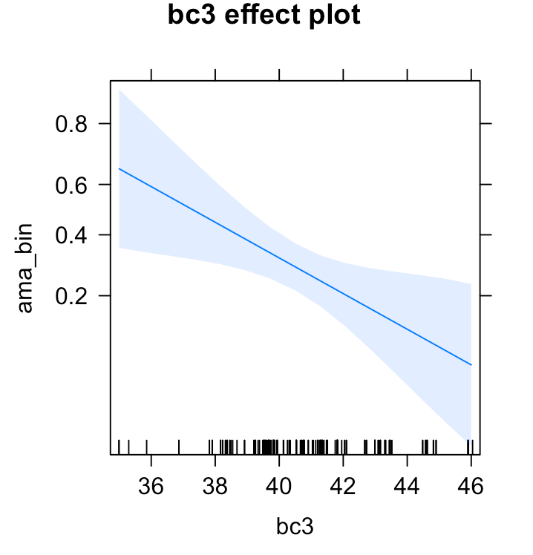

Figure S2. Map of isothermality (bc3/bioclim3) across Georgia. Darker colors indicate higher values for isothermality.

