Additional file 1
Table S1: Study sites in Ethiopia, 2021-2023.
Study site | Region | Altitude (masl) | Latitude | Longitude
Akaki | Addis Ababa | 2350 | 8.861858 | 38.786833
Afambo | Afar | 356 | 11.518777 | 41.587164
Dubti | Afar | 367 | 11.733201 | 41.082054
Ataye | Amhara | 1458 | 10.346294 | 39.955860
Woreta | Amhara | 1830 | 11.894478 | 37.676753
Dembiya | Amhara | 1832 | 12.421638 | 37.324065
Harbu | Amhara | 1479 | 10.923906 | 39.780413
Jiga | Amhara | 1630 | 10.671131 | 37.372587
Kombolcha | Amhara | 1798 | 11.078880 | 39.734166
Metemma | Amhara | 713 | 12.948649 | 36.163057
Shoa Robit | Amhara | 1278 | 10.002236 | 39.894093
Bambasi | Benishangul Gumuz | 1468 | 9.748421 | 34.739811
Assosa town | Benishangul Gumuz | 1572 | 10.055242 | 34.549032
Gambella | Gambella | 445 | 8.232059 | 34.579175
Babile | Oromia | 1648 | 9.228092 | 42.334374
Modjo | Oromia | 1788 | 8.585457 | 39.133908
Yabelo | Oromia | 1857 | 4.809572 | 36.054702
Asendabo | Oromia | 1740 | 7.762966 | 37.226017
Arba Minch | SNNPR | 1285 | 6.055508 | 37.556389
Dilla | SNNPR | 1570 | 6.399215 | 38.303658
Omorate | SNNPR | 371 | 4.809102 | 36.053733
Salamago | SNNPR | 509 | 6.221887 | 36.129891
Danan | Somalia | 435 | 6.513210 | 43.492950
Kebri Beyah | Somalia | 1609 | 9.100243 | 43.174230
Kebri Dehar | Somalia | 532 | 6.726662 | 44.276125
Bonga | SWE | 1600 | 7.291270 | 36.234960
Keys: masl: meters above sea level, SNNPR: Southern Nations, Nationalities, and Peoples' Region, SWE: South West Ethiopia Peoples' Region

Table S2: Occurrence and abundance of An. stephensi across eight positive urban centers by round and stage of collection, Ethiopia, 2021-2023.
Positive sites | Mosquito stages | Habitat type/Collection method |  | Rounds of mosquito collection |  |  |  | Total/site
Positive sites | Mosquito stages |  | I |  | II | III | IV
Assosa | Reared adults | Artificial (n) | - |  | - | - | - |  | -
Assosa | Reared adults | Natural (n) | - |  | - | - | - |  | -
Assosa | Wild caught adults | CDC, n(ct) | - |  | - | 1 (0.05) | - |  | 1 (0.01)
Assosa | Wild caught adults | PRO, n(ct) | - |  | - | - | - |  | -
Ataye | Reared adults | Artificial (n) | - |  | - | - | - |  | -
Ataye | Reared adults | Natural (n) | 1 |  | - | - | - |  | 1
Ataye | Wild caught adults | CDC, n(ct) | - |  | - | - | - |  | -
Ataye | Wild caught adults | PRO, n(ct) | - |  | - | - | - |  | -
Babile | Reared adults | Artificial (n) | 20 |  | - | - | - |  | 20
Babile | Reared adults | Natural (n) | - |  | - | - | - |  | -
Babile | Wild caught adults | CDC, n(ct) | - |  | - | - | - |  | -
Babile | Wild caught adults | PRO, n(ct) | - |  | 3 (0.3) | - | - |  | 3 (0.08)
Danan | Reared adults | Artificial (n) | 9 |  | 58 | 67 | 16 |  | 150
Danan | Reared adults | Natural (n) | - |  | - | - | - |  | -
Danan | Wild caught adults | CDC, n(ct) | 2 (0.1) |  | 1 (0.05) | - | 1 (0.05) |  | 4 (0.05)
Danan | Wild caught adults | PRO, n(ct) | 4 (0.4) |  | 1 (0.1) | 1 (0.1) | 5 (0.5) |  | 11 (0.28)
Dubti | Reared adults | Artificial (n) | 5 |  | 226 | 126 | 28 |  | 385
Dubti | Reared adults | Natural (n) | - |  | 13 | - | - |  | 13
Dubti | Wild caught adults | CDC, n(ct) | - |  | 6 (0.3) | 1 (0.05) | - |  | 7 (0.09)
Dubti | Wild caught adults | PRO, n(ct) | - |  | - | - | - |  | -
Jiga | Reared adults | Artificial (n) | - |  | - | - | - |  | -
Jiga | Reared adults | Natural (n) | - |  | 2 | - | 5 |  | 7
Jiga | Wild caught adults | CDC, n(ct) | 1 (0.05) |  | 1 (0.05) | 2 (0.1) | 3 (0.15) |  | 7 (0.09)
Jiga | Wild caught adults | PRO, n(ct) | - |  | - | - | - |  | -
Kabri Dehar | Reared adults | Artificial (n) | 36 |  | 40 | 20 | 20 |  | 116
Kabri Dehar | Reared adults | Natural (n) | - |  | - | - | - |  | -
Kabri Dehar | Wild caught adults | CDC, n(ct) | 2 (0.1) |  | - | 2 (0.1) | 1 (0.05) |  | 5 (0.06)
Kabri Dehar | Wild caught adults | PRO, n(ct) | 3 (0.3) |  | 2 (0.2) | 8 (0.8) | 2 (0.2) |  | 15 (0.38)
Modjo | Reared adults | Artificial (n) | 66 |  | 70 | 46 | - |  | 182
Modjo | Reared adults | Natural (n) | - |  | - | - | - |  | -
Modjo | Wild caught adults | CDC, n(ct) | - |  | - | - | - |  | -
Modjo | Wild caught adults | PRO, n(ct) | - |  | 91 (9.1) | - | - |  | 91 (2.28)
Total/round | Reared adults | Artificial (n) | 136 |  | 394 | 259 | 64 |  | 853
Total/round | Reared adults | Natural (n) | 1 |  | 15 | - | 5 |  | 21
Total/round | Wild caught adults | CDC, n(ct) | 5 (0.03) |  | 8 (0.05) | 6 (0.04) | 5 (0.03) |  | 24 (0.04)
Total/round | Wild caught adults | PRO, n(ct) | 7 (0.09) |  | 97 (1.21) | 9 (0.11) | 7 (0.09) |  | 120 (0.38)
Keys: n: number of catches, CDC: Centre for disease control and prevention light trap, PRO: Prokopack aspirator: ct: mean number of An. stephensi catch/trap, and I (Jan-May), II (Jun-Nov), III (Oct-Nov) and IV (Dec-Jan): rounds and months of mosquito collection.

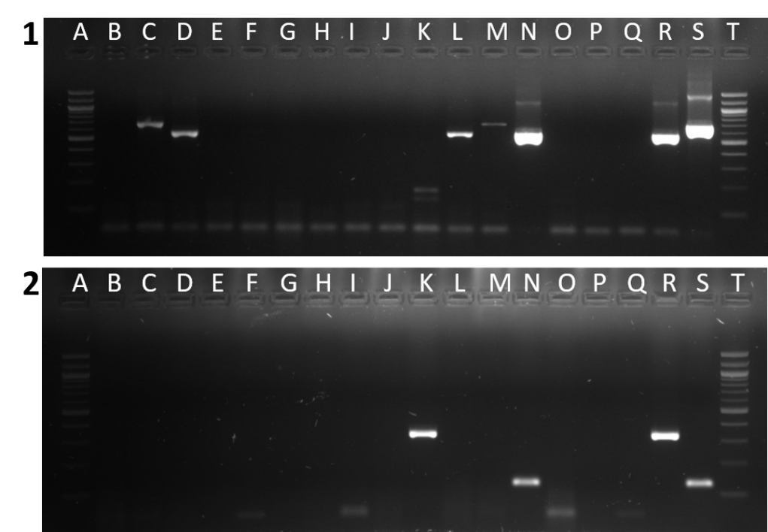
Figure S1: Multiplex PCR for blood meal source detection in freshly fed wild-caught female Anopheles mosquitoes. (1) A and T are 100 bp ladders; Q, negative control; R, cow positive control; S, dog positive control; B-P, DNA samples with C and M, positive for dog blood, whereas D, L and N are positive for cow blood. (2) A and T were ladders 100 bp, Q, extraction negative control; R, human positive control; S, goat positive control; B-P DNA samples with K positive for human blood whereas N positive for goat blood.
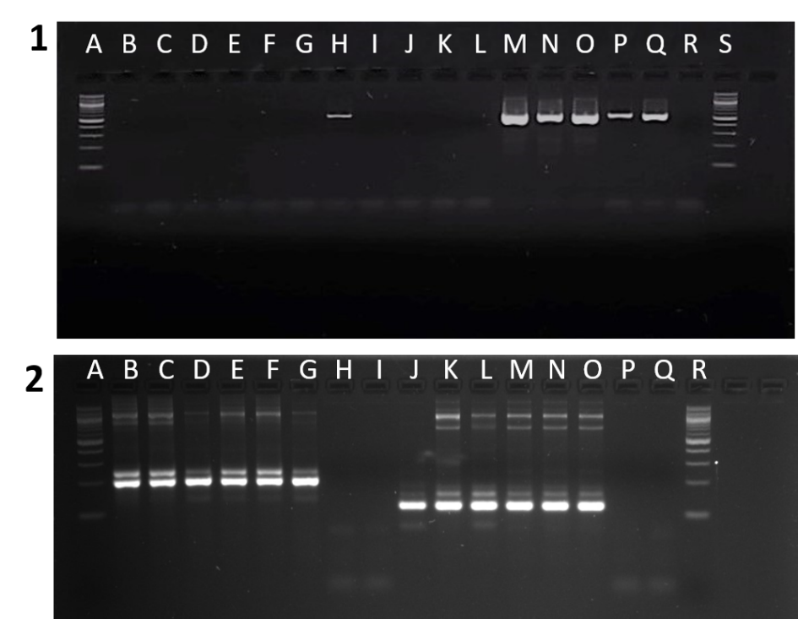
Figure S2: Gel images of COX1 and nested PCR for detecting Plasmodium infection. (1) COX1 PCR; A and S are 100 bp ladders; M-Q are extraction positive controls (membrane-fed mosquitoes on gametocyte-positive P. vivax clinical patients with an infectivity rate of 89%); R, extraction negative control (mosquitoes head and thorax from reared adults from immature collection); and B-L, samples with H positive for Plasmodium. (2) From nested PCR optimization, A and R are 100 bp ladders, B-G is a P. falciparum positive control, H-I and P-Q are negative controls and J-O are P. vivax positive controls.

