Additional File 1

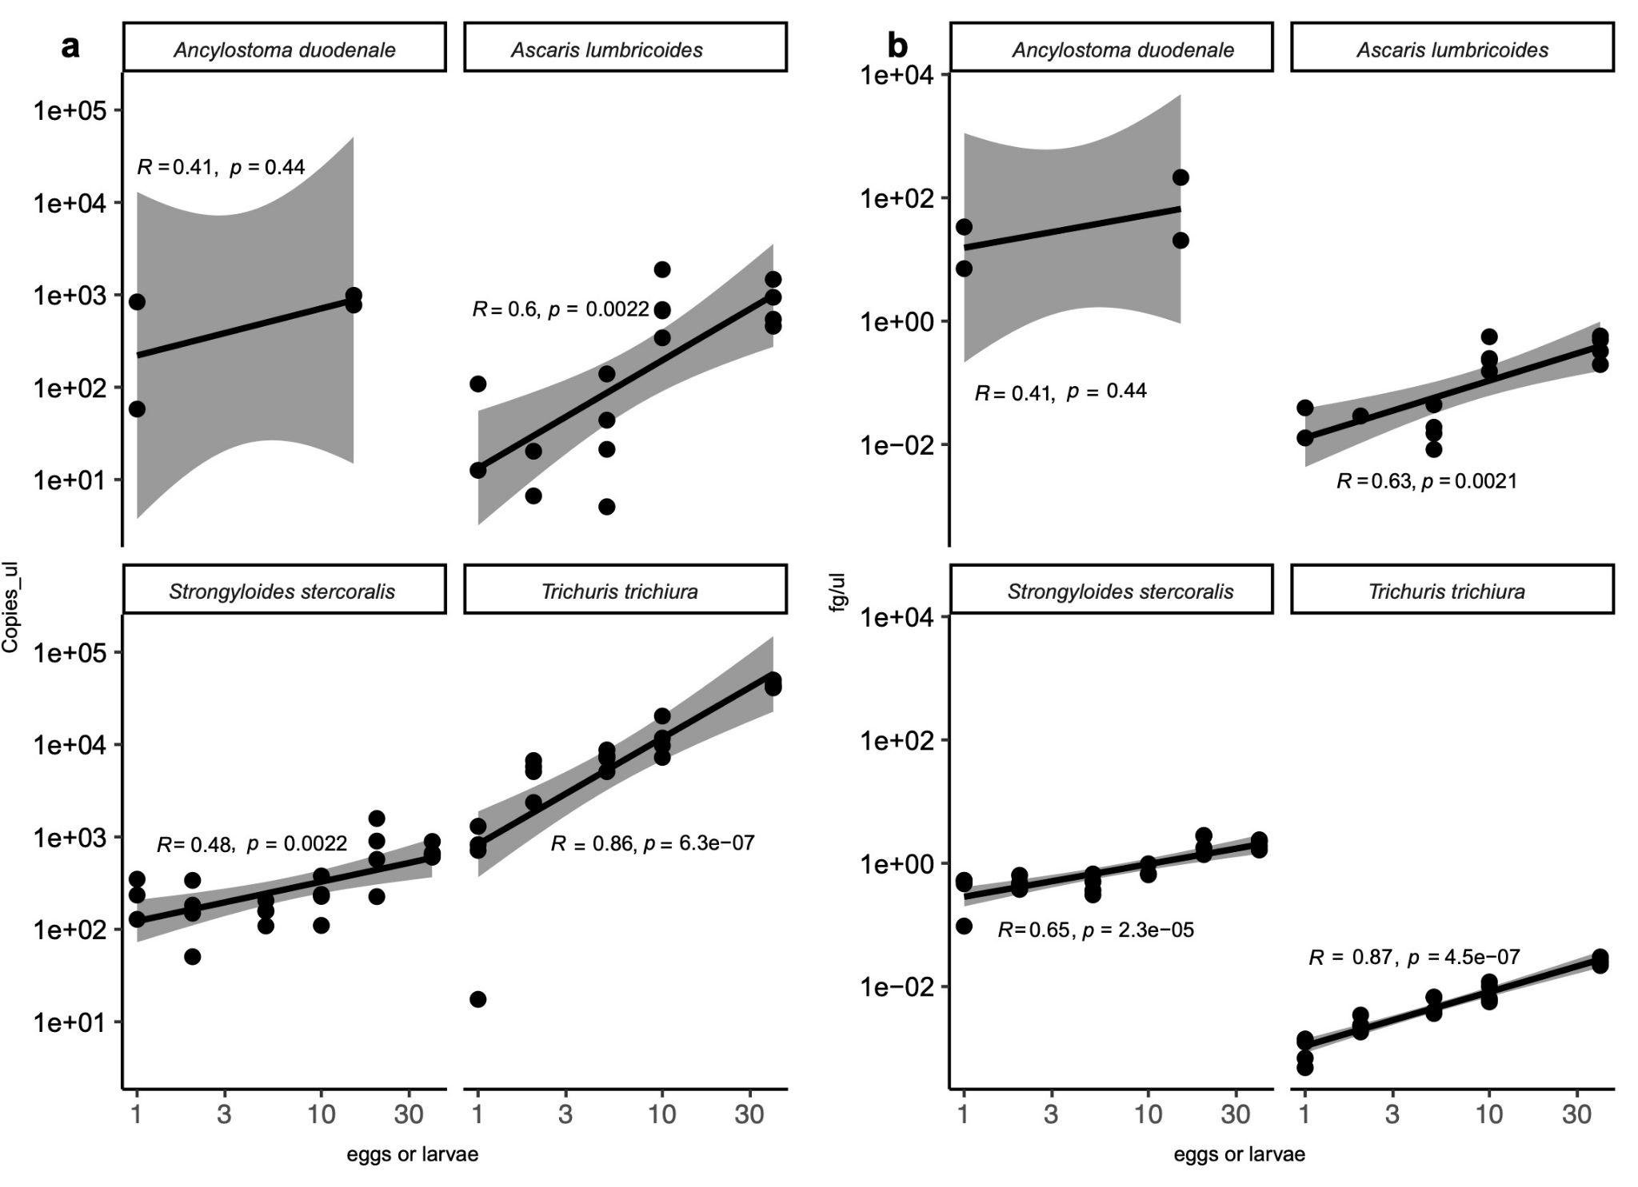
Figure S1. Correlation between egg/larvae in spiked samples and qPCR method of quantitation. a, Correlation between copies/µl and eggs/larvae-spiked samples for the NHM assays and b, correlation between fg/µl and eggs/larvae-spiked samples for the BCM assays. Correlations were calculated by the Kendall rank correlation test, with Kendall Tau-b values ranging between −1 (all pairs discordant) and 1 (all concordant); a higher Tau-b value indicates more concordance than discordant pairs of individual egg counts, and therefore, higher overall correlation. Interpretation as < + or −0.10: very weak; + or −0.10 to 0.19: weak; + or −0.20 to 0.29: moderate; and + or −0.30 or above: strong

