Supplementary Material

Table S1. Nucleotide sequences of Songling virus utilized for the design of specific LAMP primers.
Number | GenBank Accession | Strain | Host | Location
1 | NC079002 | HLJ1202 | Homo sapiens | Lanxi, Heilongjiang, China
2 | ON408081 | NE-TH2 | Haemaphysalis conicinna | Tahe, Heilongjiang, China
3 | ON408078 | NE-TH1 | Haemaphysalis conicinna | Tahe, Heilongjiang, China
4 | MT328780 | YC585 | Haemaphysalis longicornis | Yichun, Heilongjiang, China

Table S2. The Songling virus specific LAMP primers designed based on the nucleocapsid protein gene.
Primer No. | Primer name | Sequence (5'→3')
1 | SGLV-FIP-1 | AGGCGCACTCATACACAGGTGCTGAGATTGCCAGGCTCATG
1 | SGLV-BIP-1 | TGATGGCATCGTCAGGAGAAGCCGTACTCCTTGGACCACTTC
1 | SGLV-F3-1 | GCCTCGACATCAAGTCTGC
1 | SGLV -B3-1 | TGGTCAGAAGAAGGAACTGC
1 | SGLV -LF-1  SGLV -LB-1 | TGTCCTTCAGCCGTTCGTG  TTCGACTGGTTTGAGAAGAACAAG
2 | SGLV-FIP-2 | AGGCGCACTCATACACAGGTGGAGATTGCCAGGCTCATGC
2 | SGLV-BIP-2 | CGTCAGGAGAAGCTTCGACTGGGGCTTTCGTACTCCTTGGAC
2 | SGLV-F3-2 | CCTCGACATCAAGTCTGCC
2 | SGLV-B3-2 | GGTCAGAAGAAGGAACTGCC
2 | SGLV-LF-2 | TGTCCTTCAGCCGTTCGT
2 | SGLV-LB-2 | TTTGAGAAGAACAAGGACCACAAG
3 | SGLV-FIP-3 | TCCAGGCGCACTCATACACAGGATTGCCAGGCTCATGCA
3 | SGLV-BIP-3 | GCATCGTCAGGAGAAGCTTCGAGGCTTTCGTACTCCTTGGAC
3 | SGLV-F3-3 | GACATCAAGTCTGCCAGCA
3 | SGLV-B3-3 | GGTCAGAAGAAGGAACTGCC
3 | SGLV-LF-3 | CATGTCCTTCAGCCGTTCG
3 | SGLV-LB-3 | CTGGTTTGAGAAGAACAAGGACCA
4 | SGLV-FIP-4 | GGATGTCCAGGCGCACTCATAGGCTCATGCACGAACG
 | SGLV-BIP-4 | TGATGGCATCGTCAGGAGAAGCCGTACTCCTTGGACCACTTC
 | SGLV-F3-4 | GGGAGAAGGACGCTGAGAT
 | SGLV-B3-4 | TGGTCAGAAGAAGGAACTGC
 | SGLV-LF-4 | ACAGGTGCCATGTCCTTCAG
 | SGLV-LB-4 | TTCGACTGGTTTGAGAAGAACAAG

Supplement Figure 1

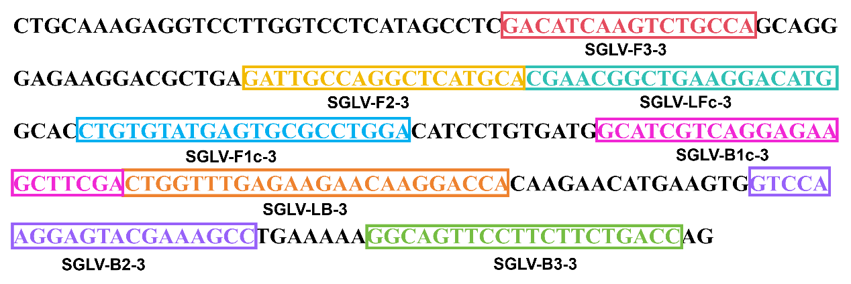

Fig S1. Locations of the designed Songling virus specific LAMP primer sets based on the conserved fragment of SGLV nucleocapsid protein gene.

Supplement Figure 2

Fig S2. Songling virus specific LAMP assay examined using the optimal primer set with amplification curve of 8 repeated.

