Supplementary materials for:
Mosquito vector competence for Japanese encephalitis virus: A systematic review and meta-analysis update
Stephen Edache, Andrea L. Dixon, Ana R.S. Oliveira, Lee W. Cohnstaedt, Dana Mitzel, Chad E. Mire, Natalia Cernicchiaro

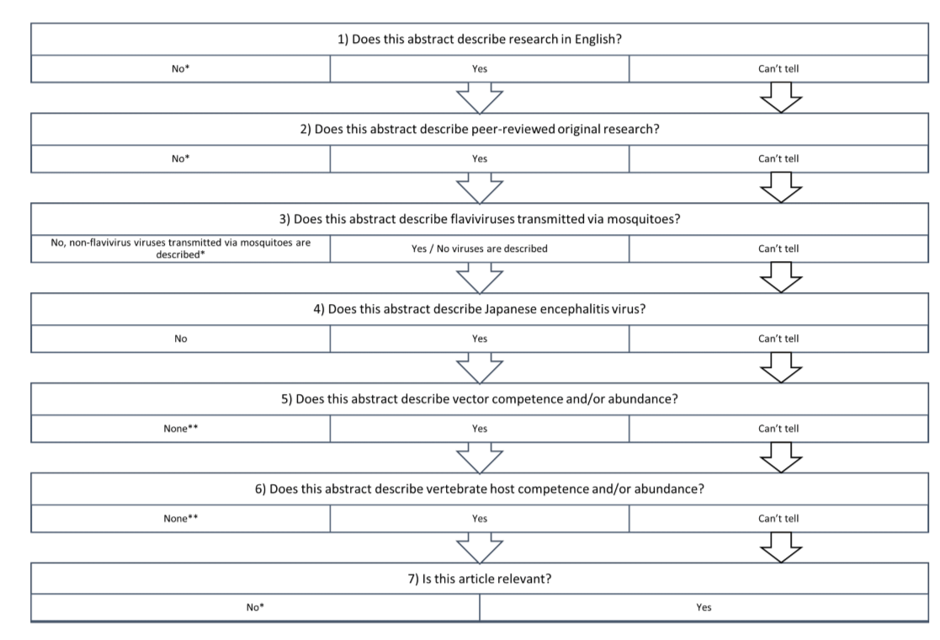
Suppl. Figure 1. Flowchart of relevance screening adapted from the 2018 systematic review [1]. (*) If the answer to question 1-4 or 7 was “No”, the record was excluded. (**) If the answers to question 5 and 6 were “None”, the record was excluded.
Suppl. Table 1. Sub-group meta-analysis of studies reporting the pooled estimates of the infection rate of JEV for individual mosquito species from the 2018 meta-analysis [2], with no new studies from this update. The number of studies and reports, measure of effect size and 95% confidence interval (CI), prediction interval, and heterogeneity (I²) are reported.
Mosquito species | Number of studies (reports) | Infection rate  (95% CI) | Prediction interval | I² (%)
Aedes alcasidi | 1 (1) | 0.29 (0.07 – 0.67) | 0.07 – 0.67 | -
Aedes dorsalis | 1 (1) | 0.03 (0.00 – 0.20) | 0.00 – 0.20 | -
Aedes nigromaculis | 1 (1) | 0.02 (0.01 – 0.05) | 0.01 – 0.05 | -
Aedes togoi | 4 (1) | 0.44 (0.21 – 0.70) | 0.21 – 0.70 | 0.00
Aedes vexans nipponii | 1 (1) | 0.45 (0.25 – 0.66) | 0.25 – 0.66 | -
Armigeres flavus | 1 (1) | 0.07 (0.01 – 0.35) | 0.01 – 0.35 | -
Ochlerotatus kochi | 1 (1) | 0.21 (0.10 – 0.40) | 0.10 – 0.40 | -
Ochlerotatus notoscriptus | 2 (1) | 0.26 (0.09 – 0.58) | 0.09 – 0.58 | 0.00
Ochlerotatus vigilax | 3 (1) | 0.23 (0.06 – 0.59) | 0.03 – 0.73 | 27.91
Opifex fuscus | 1 (1) | 0.74 (0.60 – 0.84) | 0.60 – 0.84 | -
Verrallina funereal | 1 (1) | 0.57 (0.46 – 0.68) | 0.46 – 0.68 | -
Culex pipiens molestus | 2 (2) | 0.05 (0.00 – 1.00) | 0.00 – 1.00 | 90.17
Culex tarsalis | 1 (1) | 0.01 (0.00 – 0.05) | 0.00 – 0.05 | -
Culiseta incidens | 1 (1) | 0.04 (0.01 – 0.12) | 0.01 – 0.12 | -
Culiseta inornata | 1 (1) | 0.04 (0.01 – 0.11) | 0.0.1 – 0.11 | -
Mansonia septempunctata | 1 (1) | 0.67 (0.46 – 0.82) | 0.46 – 0.82 | -
Random effects sub-group meta-analyses models for the individual species included a random intercept for study and used REML and a Knapp-Hartung estimation procedure. If only one study was available, a Z-test was used instead of the Knapp-Hartung estimation.
Suppl. Table 2. Model-adjusted estimates of the infection rate of JEV from univariable meta-regression models. The predictor and levels, number of studies and reports, measure of heterogeneity, P-values, model-adjusted effect sizes, and 95% confidence interval (CI) are reported. P-values from explanatory variables that were significant (α ≥ 0.1) are in bold.

Variable | Number of studies (reports) | Infection rate (95% CI) | I² (%) | P-value | Overall P-value
Mosquito subfamily/tribe | 450 (41) |  | 89.43 |  | < 0.01
Anophelinae | 3 (2) | 0.30 (0.03 – 0.84) |  | 0.47
Aedini | 88 (16) | 0.30 (0.20 – 0.43) |  | < 0.01
Culicini (Reference) | 301 (35) | 0.52 (0.42 – 0.62) |  | -
Culisetini | 8 (2) | 0.38 (0.12 – 0.72) |  | 0.44
Mansoniini | 4 (1) | 0.18 (0.04 – 0.55) |  | 0.06
Toxorhynchitini | 46 (1) | 0.40 (0.07 – 0.86) |  | 0.69
Administration route | 450 (41) |  | 89.70 |  | 0.21
Intrathoracic inoculation (Reference) | 64 (3) | 0.55 (0.28 – 0.80) |  | -
Oral feeding | 339 (36) | 0.48 (0.38 – 0.58) |  | 0.61
Vertical transmission | 47 (5) | 0.25 (0.10 – 0.51) |  | 0.11
Diagnostic method | 450 (41) |  | 89.83 |  | 0.21
PCR (Reference) | 74 (14) | 0.46 (0.30 – 0.63) |  | -
Virus isolation (cell culture techniques or insect bioassays) | 156 (13) | 0.33 (0.19 – 0.51) |  | 0.27
Virus isolation (with immunofluorescence, HAI, or neutralization test) | 220 (14) | 0.54 (0.38 – 0.69) |  | 0.53
Length of incubation | 341 (34) |  | 91.11 |  | 0.07
≤ 7 days | 123 (17) | 0.41 (0.29 – 0.54) |  | 0.04
8 – 14 days (Reference) | 156 (29) | 0.51 (0.39 – 0.62) |  | -
≥ 14 days | 62 (12) | 0.41 (0.27 – 0.58) |  | 0.19
Incubation temperature | 394 (38) |  | 91.52 |  | 0.74
≤ 26 °C | 133 (19) | 0.48 (0.35 – 0.62) |  | 0.49
27 – 28 °C (Reference) | 222 (16) | 0.42 (0.28 – 0.57) |  | -
≥ 28 °C | 39 (6) | 0.51 (0.29 – 0.72) |  | 0.50
Standard inverse-variance approach random-effects meta-regression model using the restricted maximum likelihood (REML) method.
Suppl. Table 3. Sub-group meta-analysis of studies reporting the pooled estimates of the dissemination rate of JEV for individual mosquito species from the 2018 meta-analysis [2], with no new studies from the updated systematic review. The number of studies and reports, measure of effect size and 95% confidence interval (CI), prediction interval, and heterogeneity (I²) are reported.

Mosquito species | Number of studies (reports) | Dissemination rate (95% CI) | Prediction interval | I² (%)
Ochlerotatus detritus | 6 (1) | 0.76 (0.54 – 0.90) | 0.20 – 0.98 | 46.40
Ochlerotatus notoscriptus | 2 (1) | 0.08 (0.05 – 0.13) | 0.05 – 0.13 | 0.00
Ochlerotatus vigilax | 2 (1) | 0.25 (0.00 – 1.00) | 0.00 – 1.00 | 62.14
Opifex fuscus | 1 (1) | 0.70 (0.54 – 0.82) | 0.54 – 0.82 | -
Culex annulirostris | 5 (2) | 0.40 (0.10 – 0.80) | 0.01 – 0.97 | 88.61
Culex gelidus | 1 (1) | 0.23 (0.16 – 0.32) | 0.16 – 0.32 | -
Culex sitiens | 4 (1) | 0.19 (0.05 – 0.49) | 0.02 – 0.71 | 50.73
Random effects sub-group meta-analyses models for the individual species included a random intercept for study and used REML and a Knapp-Hartung estimation procedure. If only one study was available a Z-test was used instead of the Knapp-Hartung estimation.
Suppl. Table 4. Sub-group meta-analysis of studies reporting the pooled estimates of the transmission rate of JEV in mosquito species from the 2018 meta-analysis [2], with no new studies from this update. The number of studies and reports, measure of effect size and 95% confidence interval (CI), prediction interval, and heterogeneity (I²) are reported.

Mosquito species | Number of studies (reports) | Transmission rate (95% CI) | Prediction interval | I² (%)
Aedes aegypti | 1 (1) | 0.25 (0.16 – 0.37) | 0.16 – 0.37 | -
Aedes japonicus | 2 (1) | 0.75 (0.41 – 0.93) | 0.41 – 0.93 | 0.00
Aedes vexans nipponii | 1 (1) | 0.33 (0.08 – 0.73) | 0.08 – 0.73 | -
Ochlerotatus detritus | 6 (1) | 0.33 (0.12 – 0.64) | 0.04 – 0.86 | 60.03
Ochlerotatus notoscriptus | 2 (1) | 0.25 (0.03 – 0.75) | 0.03 – 0.75 | 0.00
Ochlerotatus vigilax | 2 (1) | 0.12 (0.04 – 0.32) | 0.04 – 0.32 | 0.00
Verrallina funerea | 1 (1) | 0.17 (0.05 – 0.41) | 0.05 – 0.41 | -
Culex annulirostris | 5 (2) | 0.47 (0.17 – 0.79) | 0.03 – 0.96 | 70.36
Culex fuscocephala | 4 (1) | 0.16 (0.09 – 0.27) | 0.09 – 0.27 | 0.00
Culex gelidus | 10 (4) | 0.33 (0.19 – 0.51) | 0.05 – 0.83 | 82.96
Culex pipiens molestus | 3 (1) | 0.80 (0.72 – 0.86) | 0.72 – 0.86 | 0.00
Culex sitiens | 4 (1) | 0.24 (0.02 – 0.82) | 0.00 – 0.99 | 75.33
Coquillettidia xanthogaster | 2 (1) | 0.07 (0.03 – 0.14) | 0.03 – 0.14 | 0.00
Mansonia septempunctata | 1 (1) | 0.54 (0.35 – 0.72) | 0.35 – 0.72 | -
Random effects sub-group meta-analyses models for the individual species included a random intercept for study and used REML and a Knapp-Hartung estimation procedure. If only one study was available a Z-test was used instead of the Knapp-Hartung estimation.

References

1. Oliveira ARS, Strathe E, Etcheverry L, et al. Assessment of data on vector and host competence for Japanese encephalitis virus: A systematic review of the literature. Prev Vet Med. 2018;154:71-89. doi:10.1016/j.prevetmed.2018.03.018
2. Oliveira ARS, Cohnstaedt LW, Strathe E, et al. Meta-Analyses of Japanese encephalitis virus infection, dissemination, and transmission rates in vectors. Am J Trop Med Hyg. 2018;98(3):883-890. doi:10.4269/ajtmh.17-0622

