Supplementary Material
Additional File 1: Text S1
Output of the RStudio software for Model 1:
Call: randomForest (formula = Inf_density ~ A + B + C + D + E + F, data = DB, mtry = 2)
Type of random forest: regression
Number of trees: 500
No. of variables tried at each split: 2
Mean of squared residuals: 0.04681075
% Var explained: 94.73
Variable Definitions: (Inf_density) Infestation density; (A) Household density within the settlement (households/km²); (B) Perimeter of deforested area (meters); (C) Years of deforestation; (D) Percentage of deforested area; (E) Average distance to deforested areas (meters); (F) Distance to main roads (meters); (DB) Database
Additional File 2: Fig. S1
Figure S1. Bar graph ranking the variables used in model 1 of the random forest analysis based on the value of Node Purity.
Additional File 3: Text S2
Output of the RStudio software for Model 2:
Call: randomForest (formula = Inf_density ~ A + B + C, data = DB, mtry = 2)
Type of random forest: regression
Number of trees: 500
No. of variables tried at each split: 2
Mean of squared residuals: 0.1358922
% Var explained: 83.05
Variable Definitions: (Inf_density) Infestation density; (A) Household density within the settlement; (B) Weighted deforestation; (C) Domestic animal density; (DB) Database
Additional File 4: Fig. S2
Figure S2. Bar graph ranking the variables used in model 2 of the random forest analysis based on the value of Node Purity.
Additional File 5: Figure S3
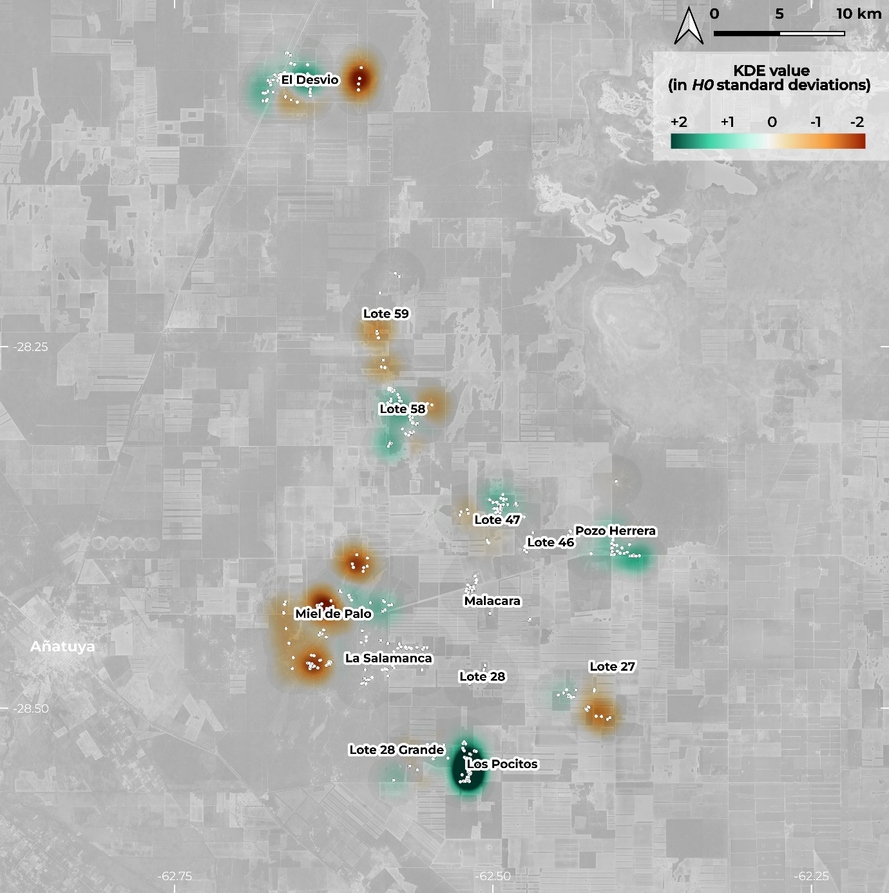
Figure S3. Map of weighted animal density estimated using kernel density estimation (KDE). Values represent deviations from the expected density (H0), with positive values indicating higher than expected density and negative values indicating lower than expected density. Created using QGIS with background imagery from Google Maps via the QuickMapServices plugin (version 0.19.36). © 2024 Google. Map data 2024 Google.

