Additional file for the Manuscript:
Triatoma dimidiata, domestic animals and acute Chagas disease: A 10 year follow-up after an eco-bio-social intervention
Files included:
- Results S1
- Figure S1

Results S1
El Anonito: T. dimidiata collection and infection with T. cruzi TcI strain
The findings from a home in El Antonio are included as supplemental as this home was not part of the follow-up study. A total of 29 T. dimidiata specimens were collected in this household, with 28 nymphs and 1 adult. Specimens were collected in the peridomicile, in a storage room for firewood. All nymphs from 1st (7), 2nd (9) and 3rd (3) instars were processed as described in the main manuscript. We collected one fourth instar nymph, 2 fifth instar nymphs and 1 adult male which were allowed to develop to use for colony establishment at UVG medical entomology laboratory. We detected 15 T. cruzi positive triatomines, of which 13 were determined as TcI strain. Infection was detected as early as 1st instar, with 2nd, 3rd and 4th also being T. cruzi positive.

El Anonito: Bloodmeal analysis
We detected a positive bloodmeal from 14 of the 25 nymphs stored in the field. The most frequent meal was Rattus rattus (12 one-host bloodmeals and 2 two-host bloodmeals) followed by Gallus gallus (1 one-host and 1 two-host bloodmeals). We detected a 2nd instar with a positive human bloodmeal with a dual feeding with Rattus rattus, this specimen was also positive for T. cruzi.

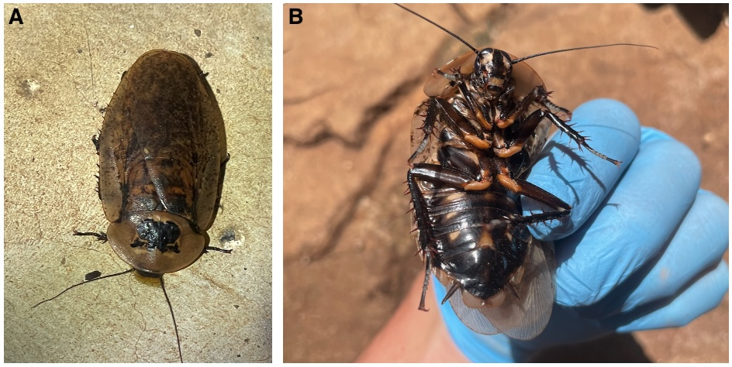
Figure S1. Archimandrita sp. cockroach found in a household of Comapa, Juatiapa were T. dimidiata was collected. A) Dorsal view. B) Ventral view. Archimandrita sp. was detected in the bloodmeal analysis procedure of triatomines suggesting triatomine feeding on hemolymph of this species.

