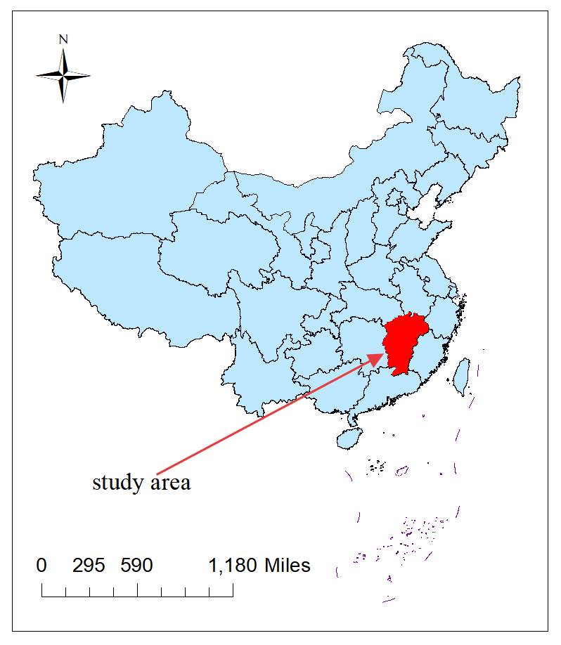
Figure S1 The research area of this study
Table S1 Sources of data on factors influencing ST
Variable category | Variable | Sources
Socioeconomic | Urbanization rate(%) | Statistical yearbooks for various cities in
 | Population density | Statistical yearbooks for various cities in
 | GDP per capita | Statistical yearbooks for various cities in
 | percentage of agricultural GDP (%) | Statistical yearbooks for various cities in
 | percentage of forestry GDP (%) | Statistical yearbooks for various cities in
Climate | Temperature (°C) | Resource and Environment Science  and Data Center  (www.resdc.cn)
 | Relative humidity (%)
 | Wind speed (m/s)
 | Precipitation (mm)
 | Pressure (kpa)
land cover | Farmland area proportion (%) | Zenodo  (https://zenodo.org/records/12779975)
 | Forest area proportion (%) | Zenodo  (https://zenodo.org/records/12779975)
 | Water area proportion (%) | Zenodo  (https://zenodo.org/records/12779975)
 | Elevation (m) | Geospatial data cloud (www.gscloud.cn)
 | NDVI | Resource and Environment Science and Data Center (www.resdc.cn)

Table S2 Standard deviation ellipse parameters of ST in Jiangxi, 2014-2023
Year | Ellipse area (10,000 km²) | Long axis (km) | Short axis (km) | Angle (degree)
2014 | 3.958 | 183.485 | 68.672 | 27.430
2015 | 3.590 | 176.873 | 64.609 | 23.042
2016 | 4.008 | 219.151 | 67.590 | 24.866
2017 | 4.585 | 194.347 | 75.108 | 21.368
2018 | 4.970 | 202.308 | 78.202 | 19.910
2019 | 5.217 | 197.167 | 84.228 | 13.762
2020 | 5.466 | 208.501 | 83.452 | 21.145
2021 | 6.505 | 229.768 | 90.129 | 14.657
2022 | 6.783 | 217.818 | 99.136 | 12.338
2023 | 7.615 | 224.298 | 108.079 | 12.861

