Supplementary Materials
Trial 1: Modification to eave baffle size of East African style huts
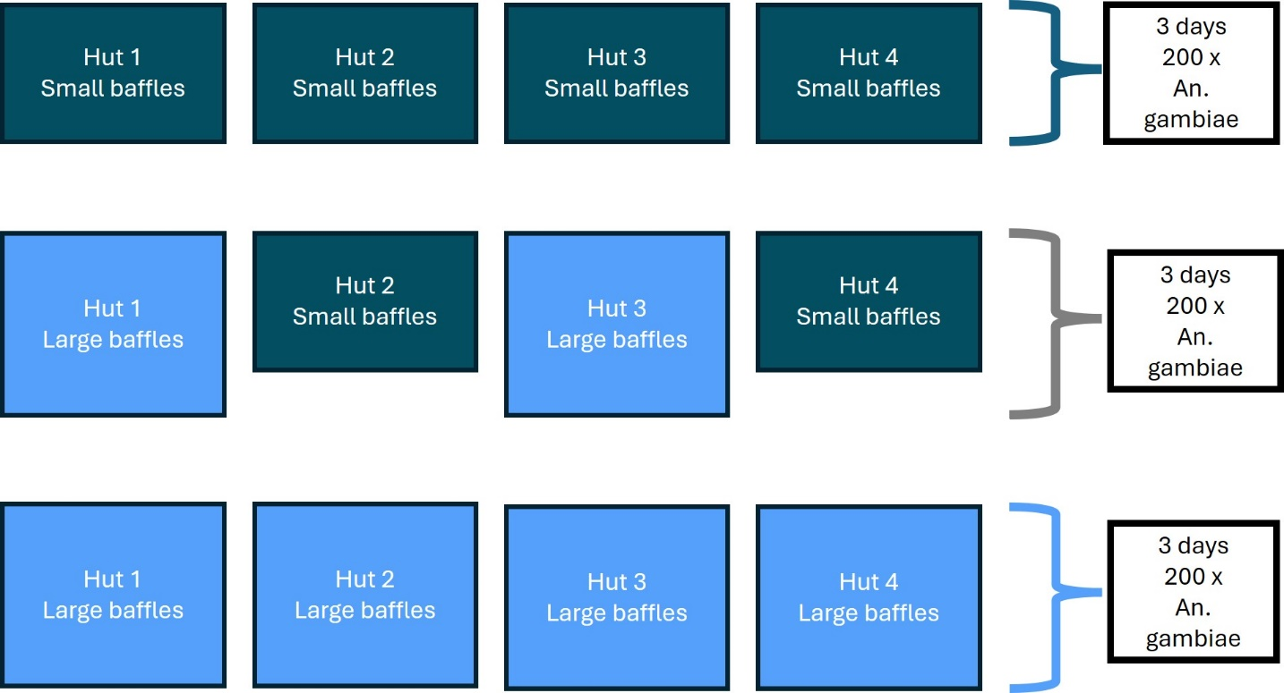
Figure S1: Study design illustration. There were three groups, first group - all huts had small baffles (dark blue), the second group - half the huts had large baffles (light blue) and the other half small (dark blue) and the third group – all huts had large baffles (light blue). There were three days of releases per group where 50 An. gambiae mosquitoes were released per hut.

Table S1: Measures of association between treatment arms, entry and blood feeding rate.
 | UOR (95% CI) | p-value | AOR (95% CI) | p-value
Entry | 2.2 (1.5-3.2) | < 0.001* | 2.1 (1.2-3.8) | 0.01*
Blood-feeding rate | 14.1 (4.4-45.2) | < 0.001* | 16.9 (4.9-59.0) | < 0.001*
UOR is unadjusted odds ratio; AOR is adjusted odds ratio for random effects; CI is confidence interval. Asterisk is significance where p<0.05.

Tables S2: Measures of association between treatments arms, wingsize data, entrance and blood feeding rate.
Reference | UOR (95% CI) | p-value | AOR (95% CI) | p-value
Wingsize data | 1.06 (1.04-1.07) | < 0.001* | 1.08 (1.06 -1.1) | < 0.001*
Wingsize data and entry | 1.00 (0.99-1.0) | 0.68 | 1.02 (0.2-1.0) | 0.22
Wingsize data and blood-feeding rate | 1.03 (1.0-1.1) | 0.046 | 1.03 (1.00-1.07) | 0.08
UOR is unadjusted odds ratio; AOR is adjusted odds ratio for random effects; CI is confidence interval. Asterisk is significance where p < 0.05.

Trial 2: Evaluation of the application of a sticky material trap to the outside of East-African experimental huts
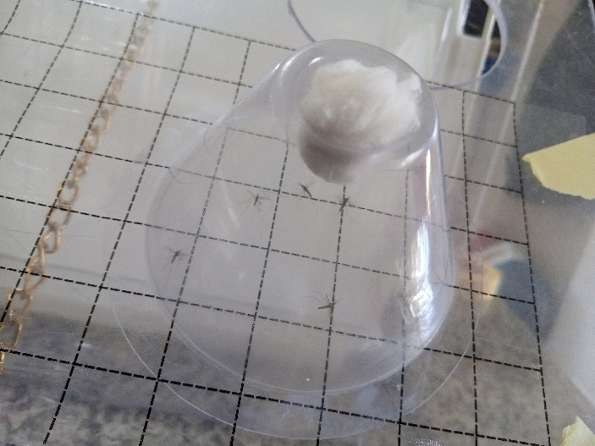

Figure S2: Preliminary assessment of stickiness Luminos 4 adhesive rolls-gridded material. A cone assay apparatus was used to evaluate the adhesive properties of the test material. Five Anopheles gambiae Kisumu mosquitoes were introduced into the cone and exposed to the material for 24 hours. Mosquito adherence to the material was observed as a measure of stickiness.

Table S3: Measures of association between treatment arms and entry.
Species | UOR (95% CI) | p-value | AOR (95% CI) | p-value
An. arabiensis | 0.08 (0.034-0.19) | < 0.001* | 0.057 (0.015-0.022) | < 0.001*
An. gambiae Kisumu | 0.70 (0.54-0.99) | 0.005 | 0.70 (0.44-1.10) | 0.12
UOR is unadjusted odds ratio; AOR is adjusted odds ratio for random effects; CI is confidence interval. Asterisk is significance where p<0.05.

Table S4: Measures of association between treatment arms and exophily.
Species | UOR (95% CI) | p-value | AOR (95% CI) | p-value
An. arabiensis | 0.88 (0.72-1.08) | 0.21 | 0.98 (0.62-1.55) | 0.93
An. gambiae Kisumu | 0.79 (0.60-1.05) | 0.110 | 0.83 (0.49-1.38) | 0.47
UOR is unadjusted odds ratio; AOR is adjusted odds ratio for random effects; CI is confidence interval. Asterisk is significance where p<0.05.

Table S5: Measures of association between treatment arms and blood-feeding rate.
Species | UOR (95% CI) | p-value | AOR (95% CI) | p-value
An. arabiensis | 0.66 (0.53-0.82) | < 0.001* | 0.59 (0.38-0.92) | 0.02
An. gambiae Kisumu | 0.55 (0.42-0.71) | < 0.001* | 0.53 (0.34-0.81) | 0.004
UOR is unadjusted odds ratio; AOR is adjusted odds ratio for random effects; CI is confidence interval. Asterisk is significance where p < 0.05.

Table S6: Pearson chi-squared test and Fishers exact test to assess if there was an association landing position of mosquitoes on the sticky material panel (quarters 1,2,3 or 4). Asterisk is significance where p < 0.05.
Reference | Pearson chi-squared | p-value | Fisher’s exact
An. gambiae Kisumu | 174 | 0.42 | 1.0
An. arabiensis | 174 | 0.42 | 1.0

Table S7: Pearson chi-squared test and Fishers exact test to assess if there was an association with the landing position of mosquitoes on the sticky material panel (distance from eave gaps 0-10cm, 11-20cm or 21-30cm). Asterisk is significance where p < 0.05.
Reference | Pearson chi-squared | p-value | Fisher’s exact
An. gambiae Kisumu | 116 | 0.43 | 1.0
An. arabiensis | 124 | 0.43 | 1.0

