Supplementary information
Additional file 1: Fig. S1. Procedure for preparing the fruits solution.
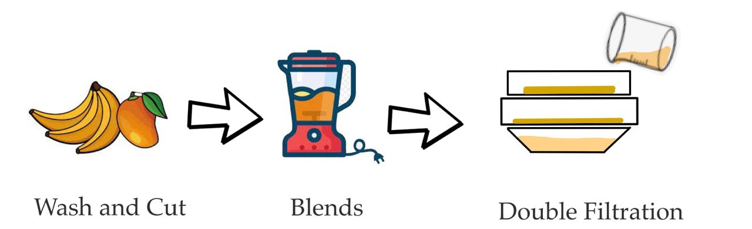
Fig. S2. Schematic diagram of the modified Y-olfactometer used to evaluate Aedes mosquito responses to attractants.
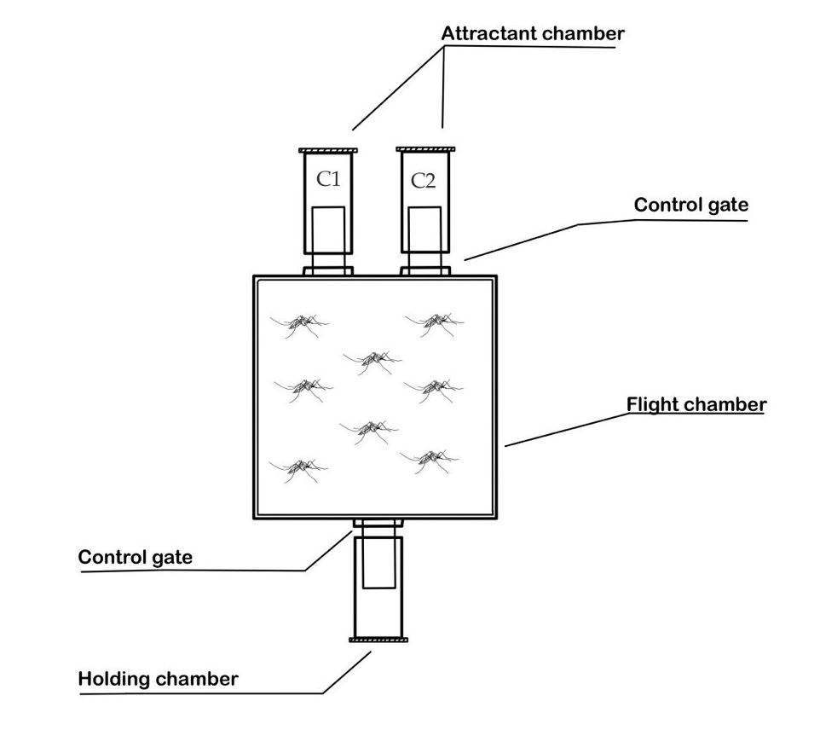

Fig. S3. Bar graphs showing the mean PI ± SE of Aedes aegypti (males and females) in response to five sets of attractants (a) mango vs. sucrose, (b) banana vs. sucrose, (c) mango vs. banana, (d) mixed vs. mango, and (e) mixed vs. banana. Positive PI values indicate attraction, whereas negative PI values indicate repellency.

Fig. S4: Bar graphs showing the mean PI ± SE of Aedes albopictus (males and females) in response to five sets of attractants (a) mango vs. sucrose, (b) banana vs. sucrose, (c) mango vs. banana, (d) mixed vs. mango, and (e) mixed vs. banana. Positive PI values indicate attraction, whereas negative PI values indicate repellency.

